Tolerance of Castanea sativa cultivars to Dryocosmus kuriphilus
T. Panzavolta, Department of Agri-food Production and Environmental Sciences, University of Florence, Italy
M Bracalini, Department of Agri-food Production and Environmental Sciences, University of Florence, Italy
F Croci, Department of Agri-food Production and Environmental Sciences, University of Florence, Italy
A Turchi, Department of Agri-food Production and Environmental Sciences, University of Florence, Italy
E Giordani, Department of Agri-food Production and Environmental Sciences, University of Florence, Italy
R Tiberi, Department of Agri-food Production and Environmental Sciences, University of Florence, Italy
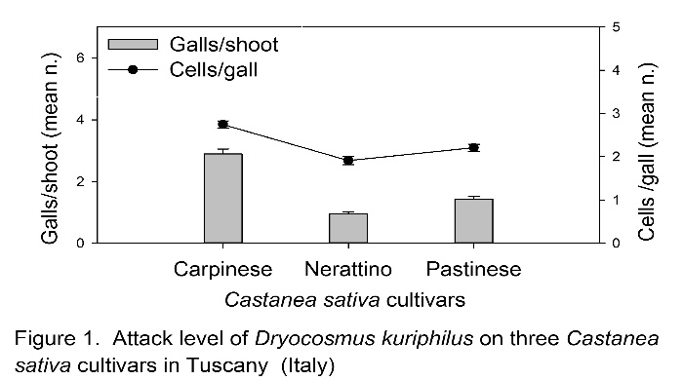

Abstract (300 word limit)
The invasive Asian chestnut gall wasp (ACGW) (Dryocosmus kuriphilus Yasumatsu) is a major insect pest in chestnuts (Castanea spp.), in all its areas of distribution (6). ACGW gall formation can cause heavy reductions in plants’ growth rates and fruiting, severely damaging the chestnut market (5). Some chestnut species and hybrids have proven to be tolerant of ACGW (4) (1). This was probably due to a hypersensitive response to ACGW attack (3). Some C. sativa Mill. cultivars showed different tolerance levels to the ACGW (4). The purpose of this study is to extend current knowledge about the tolerance of C. sativa cultivars to ACGW. Methodology & Theoretical Orientation: Some C. sativa cultivars grown in the municipality of Pistoia (Tuscany, Italy) were morphologically and genetically analyzed. Current-year shoots were collected from the same trees to determine ACGW attack levels, since the number of galls per shoot is related to nut yield losses (2). Findings: Three C. sativa cultivars were identified, each showing significantly different tolerance levels to the ACGW: Carpinese, Nerattino and Pastinese. More specifically, Carpinese showed the highest level of attack, with an infested shoot rate of 84.38%, the highest number of galls per shoot, as well as bigger galls. On the contrary, Nerattino had the lowest attack rate, with only 53% of shoots affected, the lowest number of galls per shoot, and the smallest galls. Pastinese parameters were in between. Conclusion & Significance: All the cultivars studied were attacked by the ACGW, however they had different tolerances to the insect. More research on this field will help in creating a list of the more highly tolerant cultivars, which can be used for new plantations and graft nurseries.

Image

Recent Publications (minimum 5)
- Anagnostakis S, Clark S, McNab H (2011) Resistance of chestnut trees to Asian chestnut gall wasp. 101st Annual Report of the Northern Nut Growers Association, Inc. Wooster, Ohio: July 18 - 21, 2010.
- Battisti A, Benvegnù I, Colombari F, Haack RA (2014) Invasion by the chestnut gall wasp in Italy causes significant yield loss in Castanea sativa nut production. Agricultural and Forest Entomology 16: 75-79.
- Botta R, Sartor C, Marinoni DT, Quacchia A, Alma A (2009) Differential gene expression in chestnut buds following infestation by Gall-Wasp (Dryocosmus kuriphilus Yasumatsu, Hymenoptera: Cynipidae). Acta Horticulturae 844: 405-409.
- Botta R, Sartor C, Marinoni DT, Dini F, Beccaro GL, Mellano MG, Quacchia A, Alma A (2010) Risposta di genotipi di castagno al cinipide galligeno e strategie di lotta basate su meccanismi di resistenza. Atti Accademia Nazionale Italiana di Entomologia VIII: 105-108.
- Francati A, Alma A, Ferracini C, Pollini A, Dindo ML (2015) Indigenous parasitoids associated with Dryocosmus kuriphilus in a chestnut production area of Emilia Romagna (Italy). Bulletin of Insectology 68: 127-134.
- Zhang ZY, Tarcali G, Radócz l, Feng YQ, Shen YY, (2009) Chestnut gall wasp, Dryocosmus kuriphilus Yasumatsu in China and in Hungary. Journal of Agricultural Sciences 38: 123-128.

Biography (150 word limit)
Tiziana Panzavolta is a researcher at the Department of Agri-food Production and Environmental Sciences of the University of Florence (Italy). Her field of expertise is bio-ecology and control strategies of forest and urban insect pests, as well as of invasive insect pests. Among her interests are tritrophic interactions (plant-phytophagous insect-natural enemy), particularly the role of pine terpenes in host selection and oviposition by Pine Processionary Moth and its egg parasitoids, as well as the effects of pine monoterpenes and insect pheromones on predators of saproxylic insects.

Email: tpanzavolta@unifi.it Contact No: +390552755552
Notes/Comments:
Project funded by Fondazione Cassa di Risparmio di Pistoia e Pescia

