Effect of Accumulated Temperature on the Growth and Development of Tomato Fruits in Flowering Clusters
Ju Young Lee PhD, Center for SFS Con., KIST, Korea
Hyung Seok Kim PhD, Center for SFS Con., KIST, Korea
Un Seok Lee PhD, Center for SFS Con., KIST, Korea

Abstract (300 word limit)
Tomato fruits ripened 57 in the first, 71 in the second, 78 in the third, 57 in the forth, 58 in the fifth, 58 in the sixth, 48 in the seventh, 51 in the eighth, and 51d in the ninth flower cluster after fruit set when plants were grown under environmental conditions at whole growing season. The different response to accumulated temperature were observed when the accumulated temperatures gave to the individual clusters while the plants were grown in the greenhouse. These data were used to develop a individual clustering thermal model for fruit maturation. In previous model, the overall clustering thermal model was a poor predictor of the time of ripening. However, this thermal model was made by individual cluster. The seed of tomato (Lycopersicon esculentum Mill ‘Tabor’) were sown in to seed trays containing a peat based seed and were germinated in the place of raising seeding in a minimum 24℃. Then, plants were moved to greenhouse (Chun-An City, South Korea) in which experimental treatment were applied. In the field experiment, 100 plants of tomato were selected during total growth period (1st-9th flower cluster). Every week, the height and diameter of tomato were measured at individual cluster after fruit set. The volume of tomato was estimated according to the relationship between theoretical volume and actual volume. For this relationship, the height and diameter of 2000 fruits were measured and the relationship was a “y=1.1122x+12.545 (r²=0.9534)”
Here, the relationships between accumulated temperature and fruit volume were obtained based on average fruit volume in individual cluster.

Image
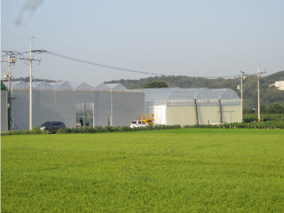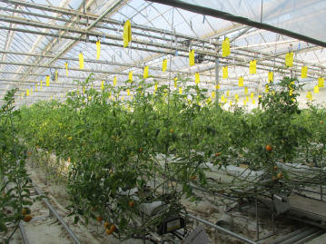

Figure 1: Greenhouse in the city of Chun An, Korea
Cultivated area (4,224m²), A planted area (2.47 plants/m²)

Recent Publications (minimum 5)
- Li L, Li J, Gao Q, Chen JX (2015) Effects of day and night temperature difference on growth. Development, yield and fruit quality of tomatoes Yingyong Shengtai Xuebao 26:2700-2706.
- Khairi AN, Falah MAF, Suyantohadi A, Takahashi N, Nishina H (2015) Effect of Storage Temperature on color of tomato fruit cultivated under moderate water stress treatment. Agriculture and Agricultural Science Procedia 3:178-183.
- Camelo L, Gomez AF (2004) Comparison of color indexes for tomato ripening. Horticultura Brasileira 22:534-537.
- Adams SR, Valdes, VM, Cave CRJ (2001) the impact of changing light levels and fruit load on the pattern of tomato yields. Journal of Horticultural Science and Biotechnology. 76: 368-373.
- Adms SR, Cockshull KE, Cave, CRJ (2001) Effect of Temperature on the Growth and Development of Tomato Fruits. Annals of Botany 88: 869-877.

 Ju Young Lee has a strong background in ecological engineering field based on statistical and mathematical modeling about plant growth and yield model. Now He has served in main positions for Smart Farm Projects with governmental funds.
Email: jyl7318@kist.re.kr Contact No:

Notes/Comments:

