Sustainable agriculture through vermicomposting technology in India
Prof. P. S. Chaudhuri, PhD, Tripura University, India
Abstract (300 word limit) Image
E-mail: priya_1956@rediffmail.com, contact No: 9863312480
Biography (150 word limit)
Dr. Priyasankar Chaudhuri (b. 1957), Professor of Zoology, Tripura University (A Central University) did his PG and Ph. D from the Calcutta University, Kolkata. He is an eminent earthworm scientist with more than 80 research papers in National and International Journals of repute. He is the author of the book “Kenchor Jeevan Baichitra: Kencho Prajukti (2006)” written in Bengali on the Biology and Ecology of earthworms in North-East India with special emphasis on vermiculture and vermicomposting. He has participated in more than 25 National and International Symposia and visited Avignon (France) 1990, Vigo (Spain) in 1998, Cardiff (U. K) 2002 and Shanghai (China) 2016 to present his research papers in International symposia on Earthworm Ecology and Agricultural Sciences. Dr. P.S. Chaudhuri was elected as the Fellow of Zoological Society (FZS), Kolkata (1998) and Fellow of the Society of Applied Sciences, India (2010). His biography has been cited in the Who’s Who in Science and Engineering 2006-2007 (Marquis, USA). The Academic Forum of the Society of Earthworm Ecology and Environmental Research (SEEER) awarded Certificate of Appreciation to him as an Earthworm Biologist in 2012. Dr. P.S. Chaudhuri was selected as one of the “Inspiring Teacher of Tripura University, Tripura in 2013. Professor Chaudhuri has been honoured with “Science Excellence Award” in 2015 and “Bharat Siksha Ratan Award” in 2016.
Fig 1: Physico-chemical changes in the soil following application of vermicompost ( increase).
Statement of the problem: Green revolution in India (1967-1987) made the country self sufficient in food grain production. However, indiscriminate use of chemical fertilizers and pesticides for the last few decades made the soil unproductive with loss of biodiversity and the environment polluted. So rejection or reduced use of chemicals and practise of organic farming for recovery of soil health, increase in food grain production and biodiversity conservation have been suggested. Methodology and Theoretical Orientation: Epigeic earthworms such as Eisenia, Eudrilus and Perionyx have been successfully cultured in organic wastes kept in cemented tanks under suitable temperature (26°C-30°C) and moisture (50%- 60%) conditions for production of vermicompost. Different doses (@2.5 tonnes/ha – 20 tonnes/ha) of harvested vermicompost were applied (RBD technique) in the soils of paddy, pineapple and tea plantations in Tripura. Findings: Vermicompost, rich in plant-available nutrients (avN, avP, avK etc.) and plant growth factors, when applied to soils, improved soil aggregation, water use efficiency, nutrient uptake etc. Dramatic yields of paddy, pineapple and tea were recorded following application of 10-20 tonnes of vermicompost/ha. A significant (p<0.05) and gradual increase in density and biomass of earthworms were also noticed with increase in amount of vermicompost applied. Conclusion & Significance: Crop yield was very much related to the particular concentration of vermicompost, beyond the level of which production declined. Vermicomposting and its application to soils has several advantages: i) consists of higher level of available plant nutrients, ii) reduce organic pollution, iii) produces organic manure for application in agro-ecosystems, iv) increases biodiversity, v) production of high quality earthworm proteins from wastes and its utilization as feed for poultry birds and fishes.

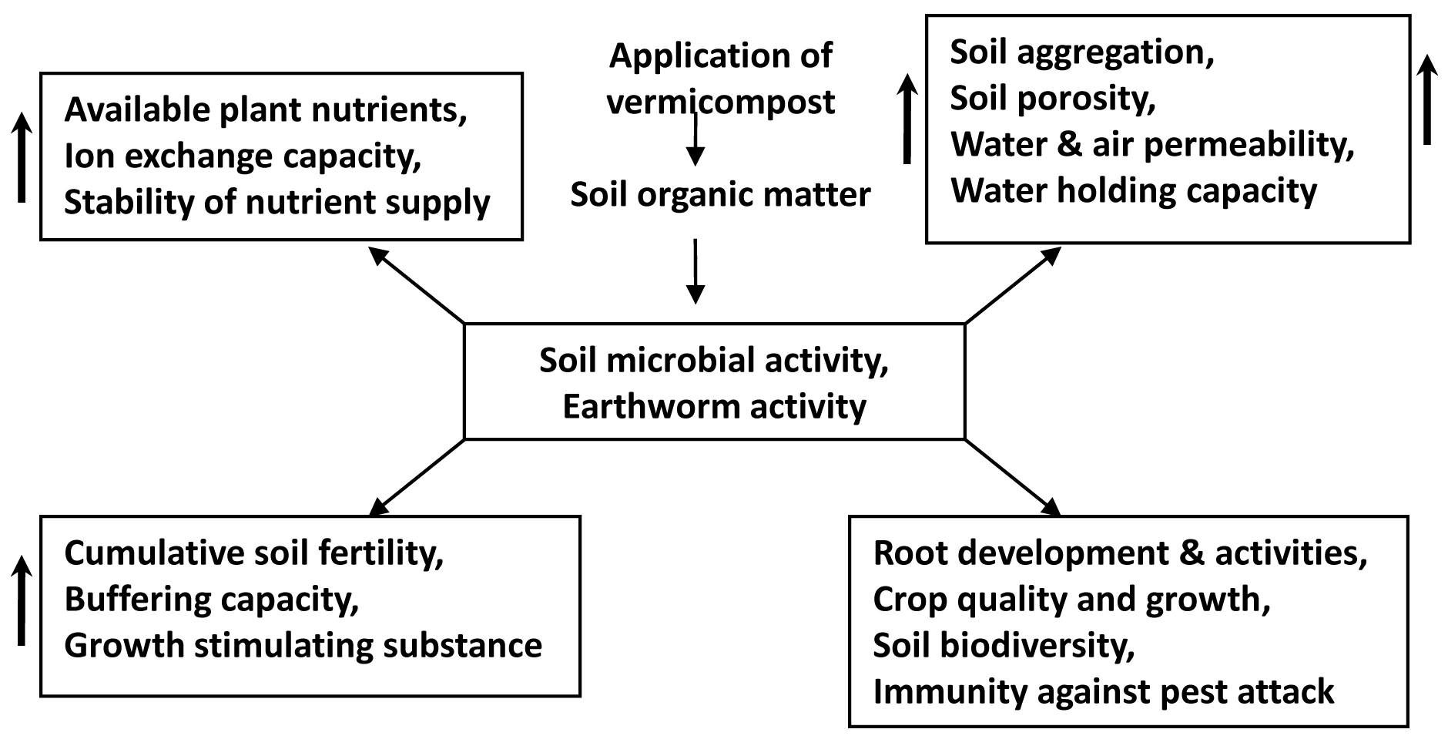

Recent publications (minimum 5)
- Banik D, Chaudhuri P S (2016). Neuroendocrine control of posterior regeneration in tropical earthworm, Eudrilus eugeniae (Kinberg). Journal of Life Sciences 10, 289-297.
- Chaudhuri P S, Banik D (2015). Cytology and Histology of the cerebral neurosecretory systems in some tropical earthworm species. Cytology & Histology 6(6), 1-7.
- Chaudhuri P S, Paul T K, Dey A, Datta M, Dey S K (2016). Effects of rubber leaf litter vermicompost on earthworm population and yield of pineapple (Ananas comosus) in West Tripura, India. Int. J. Recycl. Org. Waste Agricult. (2016) 5: 93-103
- Chakraborty S, Chaudhuri P S (2016). Earthworm communities in the bamboo plantations of West Tripura (India) Proc Zool Soc. DOI 10.1007/s.12595-015-0164-5.
- Jamatia SKS, Chaudhuri P S (2017). Earthworm community structure under tea plantation (Camellia sinensis) of Tripura (India) Tropical Ecology 58(1) (In press).
- Dey A, Chaudhuri P S (2013). Quantifying earthworm species richness in the pineapple and mixed fruit plantations of west Tripura, India - A non parametric approach. European Journal of Soil Biology 59, 31-35.

