Plant extract formulations improved the expression of pathogenesis-related proteins in the apoplast of maize leaves in response to Fusarium oxysporum
Naz, R, PhD, CIIT, Pakistan

Abstract (300 word limit)
Maize (Zea mays L.) is one of the important food crops for human and animal in Pakistan as well as in the world. Fusarium oxysporum is one of the major wilt causing fungal pathogen in maize that affects its productivity. Current study is an approach towards the development of eco-friendly biofungicide. To achieve the objective, in vitro antifungal potential of selected plant extracts was conducted against Fusarium oxysporum. Tribulus terrestris fruit and leaf extracts and Cuscuta pedicellata reduced fungal growth by 98%, 94% and 93% respectively. Antifungal potency of plant extract formulations was compared with chemical fungicides (Mancozeb) and chemical elicitors (Chitosan and Methyl jasmonate) in glasshouse experiment. Results showed that the combined bioformulations of Tribulus terrestris fruit and Cuscuta pedicellata stem extracts with chitosan reduced disease severity by 91% and 84% respectively. Bioformulations of Tribulus terrestris and Cuscuta pedicellata in combination with chitosan and methyl jasmonate significantly promoted the maize seedling growth, increased chlorophyll a, b, phenolic, protein contents and induce high activities of antioxidant defensive enzymes i.e. CAT, POD, SOD, PPO, PAL, β-1,3- glucanase and chitinase in the leaf apoplast. The same formulation significantly upregulated the expression of genes in the leaves encoding chitinase, glucanase, PAL, and pathogenesis-related proteins PR-1, PR-5 and PR-10, 24 h after inoculation. Electrophoretic pattern of proteins demonstrated that Tribulus terrestris and Cuscuta pedicellata in combination with chemical elicitors exhibited up regulation and induction of several new proteins that can be associated with resistance to Fusarium oxysporum infection in maize seedlings. This study indicates that the botanical extracts (Tribulus terrestris and Cuscuta pedicellatai) in combination with chemical elicitors could be a good alternative in developing a potent biofungicide which can be used in organic farming for the management of Fusarium oxysporum.

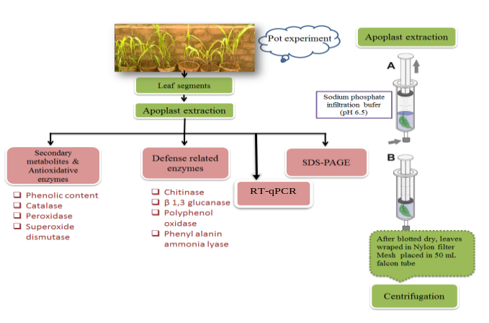

Image

Figure: Overall scheme of the study

Recent Publications (minimum 5)
- A. Nosheen, A. Bano, H. Yasmin, R. Keyani, R. Habib, R. Naz, S. T. A. Shah. 2016. Protein quantity and quality of safflower seed improved by NP fertilizer and rhizobacteria (Azospirillum and Azotobacter spp.). Frontiers in Plant Sciences. doi: 10.3389/fpls.2016.00104.
- R. Naz, A. Bano 2015. Molecular and Physiological responses of Sunflower (Helianthus annus L.) to PGPR and SA under Salt Stress. Pak. J. Bot., 47(1): 35-42.
- R. Naz, A. Bano, N.L. Wilson, D. Guest, T.H. Roberts. 2014. Pathogenesis-Related Protein Expression in the Apoplast of Wheat Leaves Protected Against Leaf Rust Following Application of Plant Extracts. Phytopathology. 104 (9), 933-944
- R. Naz, and A. Bano. 2013. Effects of Calotropis procera and Citrullus colosynthis on germination and seedling growth of maize. Allelopathy Journal 31 (1): 105-116.
- R. Naz, A. Bano. 2013. Influence of exogenously applied SA and PGPR inoculation on the growth and physiology of sunflower (Helianthus annus L.) under salt stress. Pak. J. Bot., 45(2): 367-373.
- R. Naz, A. Bano. 2014. Effects of allelochemical extracts from medicinal plants on physiological and biochemical mechanisms of maize (Zea mays L.) seedlings. Int J Agron Agri Res. 5 (2) 31-39.

Biography (150 word limit)
Dr. Rabia Naz is an Assistant Professor in Department of Biosciences, COMSATS, Islamabad. The research areas of Rabia Naz are plant stress physiology, plant pathology/biochemistry, biocontrol, plant microbe interaction, plant leaf and seed Protein/proteome analysis (1DE, 2DE, Mass spectrometry), gene expression analysis (Rt-qPCR)
Email: rabiz_naz@yahoo.com, rabia.naz@comsats.edu.pk

Notes/Comment

