Hey “Ag”… What’s Your Pension Plan?
Raghavan Sampathkumar, Food & Agribusiness Consultant

Abstract (300 word limit)
Globally, agriculture sector has undergone tremendous transformation in the last few decades. Our generation is facing some of the challenges unlike none of our predecessors. Owing to sustained increase in per-capita incomes enhancing life-expectancy, developed countries are ageing faster that nearly a third or more of their population is aged 50 and above. But, the developing world is endowed with a relatively larger share of young people. Perhaps, this ‘work-force’ macro crisis affects all the industries globally. Current median age of farmers from New Zealand to Alaska is between 50 and 60 years or even more in countries like Japan. With exceptions in Asia and Africa, this is a visible global macro trend and is definitely a matter of concern for the humanity.
Instead of succession or transition plan, the word ‘pension plan’ is chosen as the title since relates readily to old age and subtly but strongly emphasizes ageing farmers. Hence the question “if the global food & agriculture industry were a person, what are (or should be) his/her pension plans?” To feed 9 billion people with adequate quantities of safe, nutritious and quality food by 2050, the world needs to produce nearly 60 percent more food. Technological innovations and scientific advancements are helping the industry but shortage of talent and skills has emerged a serious issue. Whether agribusiness is one of the top career paths for the youngsters needs to be examined deeply to ensure the industry continues to attract and retains best creative minds and skilled hands to feed us in future. Apart from improving overall perception on the agri-food industry among youth, it also is necessary to address gender equality appropriately.
This paper is about analyzing the current situation and identifying key issues that need to be addressed in this regard. Also it elicits the crucial roles of different stakeholders including governments, policymakers, private sector and civil societies to collaborate in nurturing young talents.

Image
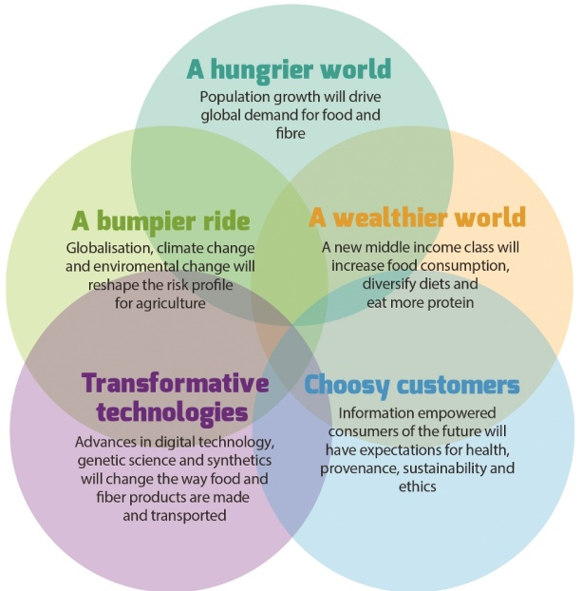
Recent Publications (minimum 5)
- Sampathkumar R (2016) Governmental Food Policy of Specific Regions – Food Policy in India. Reference Module in Food Sciences. Elsevier, pp. 1–8.
- SampathkumarR, VarkCV, HumphreyJ, NicolaidesL, RobinsonP, DucharmeH, LongfieldJ (2013) What to food traceability crises in the North mean for people working in food chains in global South? Food Chain. Vol 3. No 1 & 2.
- Sampathkumar R (2015) Geospatial Technologies for augmenting regional food security. Geospatialworld.net
- Sampathkumar R (2015) Game of Grains: Why India’s agri-food policies need a holistic review? Milling and Grain. August 2015. 34-36
- Sampathkumar R (2015) India’s Pulses sector: Trends, Challenges and Opportunities. International Food Trader. July 2015.

 Biography (150 word limit)
Raghavan Sampathkumar is a seasoned food and agribusiness professional with 360 degree perspective of the complex political, socio-economic, environmental and cultural perspectives of Agri-Food value chain. He has more than 13 years of experience working in various subsectors including agro commodities, international trade, agri-inputs, biotech, and animal nutrition across Asia-Pacific. He graduated with High Distinctions in his Master of Agribusiness degree from University of Adelaide, Australia and is also an alumnus of TNAU, Coimbatore, India. In his career, he has worked in both Corporate and non-profit sectors. As a freelancer, he also worked as a Consultant – International Marketing with Saskatchewan Pulse Growers (SPG), Canada; and also with many reputed consulting companies Promar Consulting, Japan. He regularly speaks at educational institutes including his alma maters in Australia and India; delivers guest lectures and mentors graduating students. He writes regular commentaries/columns related to global agri-food industry trends, food crisis, sustainability, and poverty.

Email: raghavan@smartagbiz.asia Contact No: +65-81647121

Notes/Comments:

