What this world needs is SMARTER FARMERS
Marc van der Sterren, Farming Africa, The Netherlands

Abstract

Smallholder farmers are the most important people in the world. They produce 80 percent of all the food in the world, and almost 100 percent of our healthy food. Nevertheless they are widely neglected by the public, the media and most important: the people and organisations who rule this world.
To keep up the demands for a growing world population and further increases in demand for high-protein food, the FAO estimates that food production will need to increase by about 60 percent. The main increase needs to come from smallholder farmers in developing countries.
80 percent of all hungry people depends on some sort of farming. If those people produce a bit more, the world food problem is solved. For most subsistence farmers in Africa it’s possible to double or even to multiply their production. This means they can even produce for the growing cities in and outside Africa.
In 2016 the United Nations ratified 17 sustainable development goals. The aim is to end all forms of poverty, fight inequalities and tackle climate change, while ensuring that no one is left behind.
With the empowerment of smallholder family farmers through providing them access to independent information we can both keep up the demands for a growing world population and reach all 17 Sustainable Development Goals.
The new publication SMARTER FARMERS is the start of a campaign which urges world leaders to focus on the empowerment of smallholder farmers by access to independent information.
What this world needs, is SMARTER FARMERS..

Image
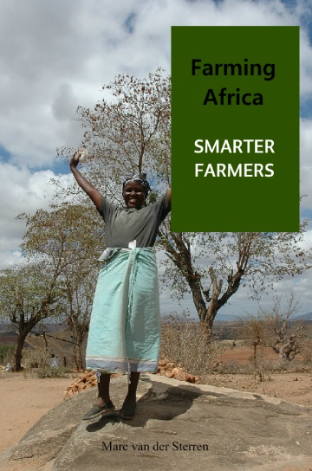
In his essay Smarter Farmers, Marc van der Sterren points out how Africa can become the world’s bread basket; how the world food problem can be solved and all 17 SDG’s can be reached. What’s needed is empowerment of smallholder farmers through providing them access to independent information. This world needs SMARTER FARMERS.

Recent Publications
- Marc van der Sterren (2016) SMARTER FARMERS – an essay
- Marc van der Sterren (2016), Turkeys in Kenya. A market research on poultry in Kenya and turkeys in particular.
- Vork (2015), Met een beetje kennis maakt de kleine boer Afrika groot.
- Vice Versa (2014) ‘Genoeg Calorieën, toch ondervoed’ Vice Versa Leert – Over Voedselketens, jaargang 48, december 2014, page 46.
- Wordt Vervolgd (published by Amnesty International) (2011) Interview with Olivier de Schutter ’Honger heeft zelden iets te maken met voedselschaarste.

Biography (150 word limit)
Marc van der Sterren has more than 15 years of experience as an agricultural journalist. Since three years he runs Farming Africa, which became more than a weblog. He visits Africa on a regular base to visit farms and to write about it. He also gives presentations of farming in Africa. Besides his freelance work he also works for NGO’s like Kuku Somo and the Lalibela Foundation.
For more information visit his Linkedin-profile.
And please visit his weblog FarmingAfrica.net in Dutch and English.
Email: marc@farmingafrica.net Contact No: +31-77-3077777

Notes/Comments:

