Social capital and agricultural technology adoption among Ethiopian farmers
Nizam A. Husen¹, Tim K. Loos¹ and Khalid H. A. Siddig^{1,2}
¹University of Hohenheim, Stuttgart, Germany
²Humboldt University of Berlin, Germany and Khartoum University, the Sudan

Abstract

Despite the recent efforts to increase agricultural productivity in Ethiopia, food insecurity remains a major challenge in the country. Improving smallholders´ productivity requires the adoption of suitable agricultural technologies and practices. Previous researches highlighted the importance of socio-economic factors; but widely overlooked the role of social capital in technology adoption and its potential to create collective actions, reduce transaction costs, relax supply side constraints, and disseminate information. Using socio-economic data of 398 farming households, we assessed social capital, using a probit model, as a determinant for soil and water conservation practices (SWC) such as terraces, bunds and agro-forestry as well as adopting productivity enhancing technologies (PET) such as fertilizers and improved high yielding seed varieties. We found that members of Iddir (informal funeral group) were more likely to adopt SWC (18.2%). For the case of PET, Iddir members were 12.8% less likely to adopt. Being members of Jarsumma (informal conflict resolution) increased the likelihood of SWC and PET adoption by 12.87% and 17.8%, respectively. Therefore, we recommend that technology transfer should consider the different types of social capital as an alternative policy option to the prevailing top down approaches in order to improve smallholder livelihoods.
Image

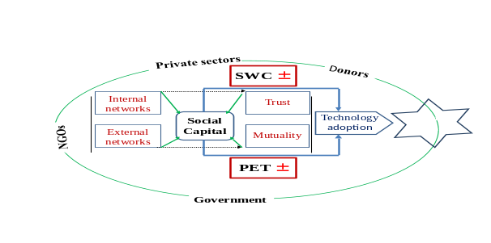Social capital and agricultural technology adoption framework

Recent Publications (minimum 5)
- Value chain development Yabello district of Borana Zone link: https://cgspace.cgiar.org/bitstream/handle/10568/35370/yabello_vca_2013.pdf?sequence=1
- Control of bush encroachment in Borana Zone of southern
Ethiopia: Effects of different control techniques on rangeland
Vegetation and tick populations
Link: http://www.pastoralismjournal.com/content/pdf/s13570-014-0018-1.pdf
http://www.tropentag.de/2015/abstracts/links/Abdu_3mh0BEpH.pdf
- Social capital and agricultural technology adoption among Ethiopian farmers
Link: http://www.tropentag.de/2015/abstracts/links/Abdu_3mh0BEpH.pdf
- Sustainable Pastoralism in Ethiopia: Preliminary Results from Participatory Community Assessments on the North-central Borana Plateau
Link:http://digitalcommons.usu.edu/cgi/viewcontent.cgi?article=1900&context=envs_facpub



Assistant researcher at University of Hohenheim, Germany
.
Email: abbamilki@mail.com Contact No: +4917672650085

