Development of Soilless Production of Graftings
Peter Szabo, University of Pannonia, Faculty of Georgikon, Hungary

Abstract

Several positive results have been published in connection with the production of horticultural crops in soilless, greenhouse conditions (Buttaro et. al, 2012; Di Lorenzo et. al, 2013; Raviv, 2008).

We cannot find sources in technical literature about the role and practice of soilless cultivation in producing vine propagation material. Bigger and more innovative vine producing companies already use containers – to a lesser extent – in practice.

Our research aims to develop a new, innovative vine propagation producing technology that is sustainable, environmentally friendly and the used materials are recyclable. It was also an important goal that the new technology is water and nutriment saving, yet it is possible to achieve high yields. We conducted our experiment in several different ways (soil, peat, rock wool, perlite, etc). After the evaluation, we found that the best results were achieved using perlite as the growing medium.

The conclusion of our research is that the properties of perlite ensure the rooting of plants, help the forming of a rich and healthy root system. It improves water supply and ensures a longer effect of the fertilizer. In the production of propagation material its insulating properties are also advantageous, thus protecting against frost. Its fine structure makes it easier to level the soil and the harvesting is also much simple. It also must be emphasized that perlite – after sterilization – is recyclable, so it is easy to be used in the next production period, as well.
Image
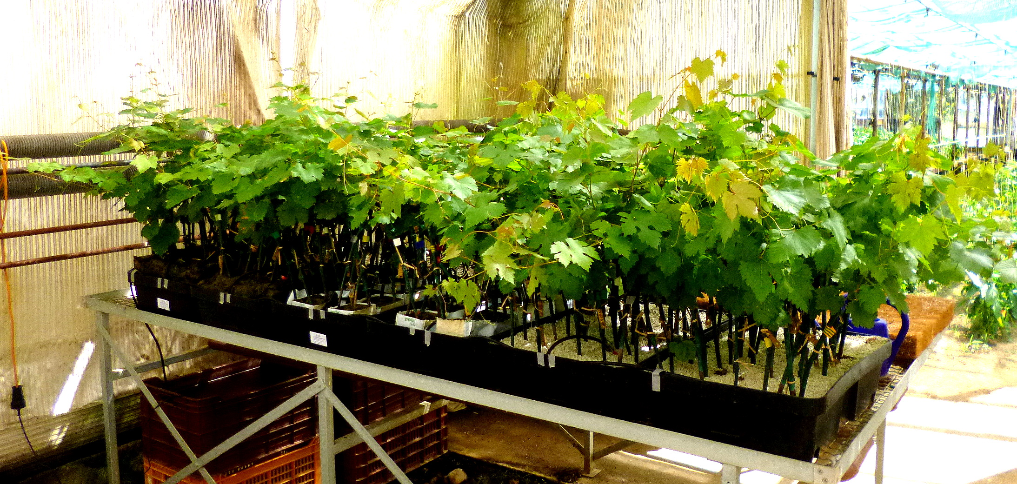
- figure: The experiment

Recent Publications
- Donato Buttaro 1, Francesco Serio 2* and Pietro Santamaria: Soilless greenhouse production of table grape under Mediterranean conditions. Journal of Food, Agriculture & Environment Vol.10 (2): 641-645. 2012.
- Rosario Di Lorenzo, Antonino Pisciotta, Pietro Santamaria, Valentina Scariot: From soil to soil-less in horticulture: quality and typicity. Italian Journal of Agronomy 2013; volume 8:e30.
- Raviv, M. and Lieth, J.H. (2008): Soilless Culture. Elsevier Publ.
- Nazim Grouda, Munoo Prasad, Michael J. Maher (2016): Culture: Soilless. Encyclopedia of Soil Sciences, Edition: Third Edition, Publisher: CRC Press Taylor & Francis Group, Editors: Rattan Lal, pp.533 – 537, Chapter. November 2016
- Di Lorenzo, R., Barbagallo, M.G., Costanza, P., Mafrica, R., Palermo, G. and Di Mauro, B. 2003. Cultivation of table grapes in ‘soilless’ in Sicily. Acta Hortic. 614:115-122.


Biography
Peter Szabo works at University of Pannonia Faculty of Georgikon Department of Horticulture. Peter Szabo has his expertise in development of soilless production of graftings, his research theme also covers the econonomy of grape and wine production. He has extensive experience in grafting production companies all over Europe. He also deals with the issues of forcing technologies of graftings and the evaluation of different types of waxes. He is one of the board member of the European Council of Doctoral Candidates and Junior Researchers.
Email: szabopeter@georgikon.hu Contact No: +36304462391

Notes/Comments:

