Control Of Soybean Stem Fly Melanagromyza sojae (Diptera: Agromyzidae) By Sticky Color Traps In Soybean Field
Hanan Alfy, PhD, Plant Protection Institute, Agriculture Research Center , Egypt.

Abstract

Five color traps were used to study the effect of color upon the attractiveness of Soybean stem fly Melanagromyza sojae (Zehnter),(Diptera: Agromyzidae) in Nubaria Agriculture Research Station’s farm, throughout 2015 and 2016 seasons. White, yellow, red, green and blue sticky traps were used to estimate of attraction to suppress of M. sojae damage in soybean fields. White and yellow traps had great effect in suppressing the damage, there were increasing in seed’s weight by using white and yellow traps which mean the mass trapping of these two color were success in controlling M. sojae , blue trap was low effect and other traps were not effective in captivity the adult.
Image
Figure (3): Comparison between the two seasons according to number of fly
(n = 3)
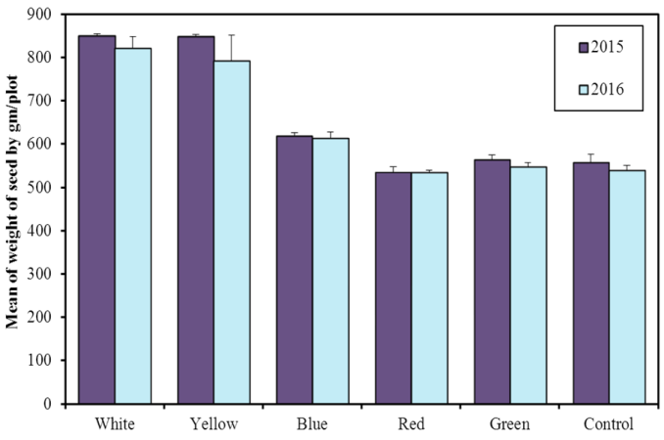
Recent Publications (minimum 5)
- An Agar-Free Insect Rearing Artifical Diet: A New Approach for the Low Cost Mass Rearing of The Egyptian Cotton Leafworm, Spodoptera littoralis (Boisd.)(Lepidoptera: Noctuidae).A.A. Alfazairy1H.A. Sadek2, G.Z. Guirguis2, and H.H. Karam1 Life Science Journal 2012;9(4):4646-4653
- Lepidium sativum L. Seeds as a Multifunctional Adjuvant with a Nucleopolyhedrovirus-or Bacillus thuringiensis-based Biopreparation Alfazairy, A. A.; Hanan Alfy,; Zarif, G.; Karam, Hedaya H. Egyptian Journal of Biological Pest Control;2014, Vol. 24 Issue 1, p101.
- Biopreparations - Based on Economic Mass Propagation of Certain Entomopathogens Alfazairy, A. A.; Hana Alfy, n; Karam, Hedaya H.; Zarif, G. Egyptian Journal of Biological Pest Control;2014, Vol. 24 Issue 1, p113.
- Suppress Of Soybean Stem fly Melanagromyza sojae (ZEHNT.) By Spraying Potassium, Micronutrients And Their Combinations As Foliar Applications On Four Soybean Varieties. Hanan Alfy, Rasha A. El-Hosary, Yacoub SH.S., A. E. Abd El-All and Mervat S.A.AlShaabeny. J. Plant Prot. And Path.,Mansoura Univ., 2016; Vol.7(2):105-114
- Influence of potassium, micronutrients and their combinations as foliar applications to suppress soybean stem fly Melanagromyza sojae (Diptera: Agromyzidae) on four soybean common varieties. Hanan Alfy• Conference Paper. 2016 xxv international congress of Entomology, Orlando,Florida, USA September 25-30


Hanan Alfy Sadek Tadros, PhD, field crop pests department, plant protection institute, agriculture research center, Egypt.
(Mobile): 002-(012) 925-7322

Emailalfyhanan@gmail.com
Contact No: 123456xxxxx

Notes/Comments: recorded for two patents for induce bio- insecticide

