Biscogniauxia rosacearum new fungal pathogen of rosaceous trees

Antonia Carlucci, Plant Pathology PhD, Universita' degli Studi di Foggia SAFE, Via Napoli 25 - 71122 Foggia Italy
Francesco Lops, Plant Pathology PhD, Universita' degli Studi di Foggia SAFE, Via Napoli 25 - 71122 Foggia Italy
Maria Luisa Raimondo, Plant Pathology PhD, Universita' degli Studi di Foggia SAFE, Via Napoli 25 - 71122 Foggia Italy

Abstract
Statement of the Problem: The genus Biscogniauxia is paraphyletic to Xylariaceae and includes at least 52 species to date that are mainly pathogens of dicotyledonous angiosperm trees. Most of these are forest trees, such as Acacia, Acer, Alnus, Eucalyptus, Fraxinus, Populus, Quercus and other species of minor importance. Biscogniauxia species have been reported as endophytes or secondary invaders that attack only stressed forest plants. During a survey in rosaceous orchards in southern Italy, several charcoal cankers were observed and stroma samples were collected.
The purposes of this study are to characterize a collection of Biscogniauxia isolates from rosaceous hosts and to ascertain their virulence on rosaceous hosts by pathogenicity tests.
Methodology & Theoretical Orientation: By molecular tools the ITS region and the β-tubulin and actin gene were amplified and sequencing to perform the phylogenetic analyses. A detailed morphological study was also carried out. Four isolates of B. rosacearum were used in the pathogenicity tests performed on wood stems of about 15–20-year-old pear, plum and quince trees in open fields in orchards.
Findings: Combining morphological and molecular data, a new species of Biscogniauxia was foud and described as B. rosacearum. This new species was isolated for the first time from rosaceous hosts in Apulia. Pathogenicity tests showed that it causes symptoms on stems when artificially inoculated and produces stromata on the bark surface.
Conclusion & Significance: The phylogenetic reconstruction based on ITS and TUB/ACT gene sequences has allowed us to distinguish a new species within the Biscogniauxia genus. The presence of charcoal stromata from fruit hosts such as quince, plum and pear is very uncommon. In any case, on the basis of pathogenicity tests, it was possible to assess the ability of B. rosacearum isolates to infect quince, plum and pear stems.

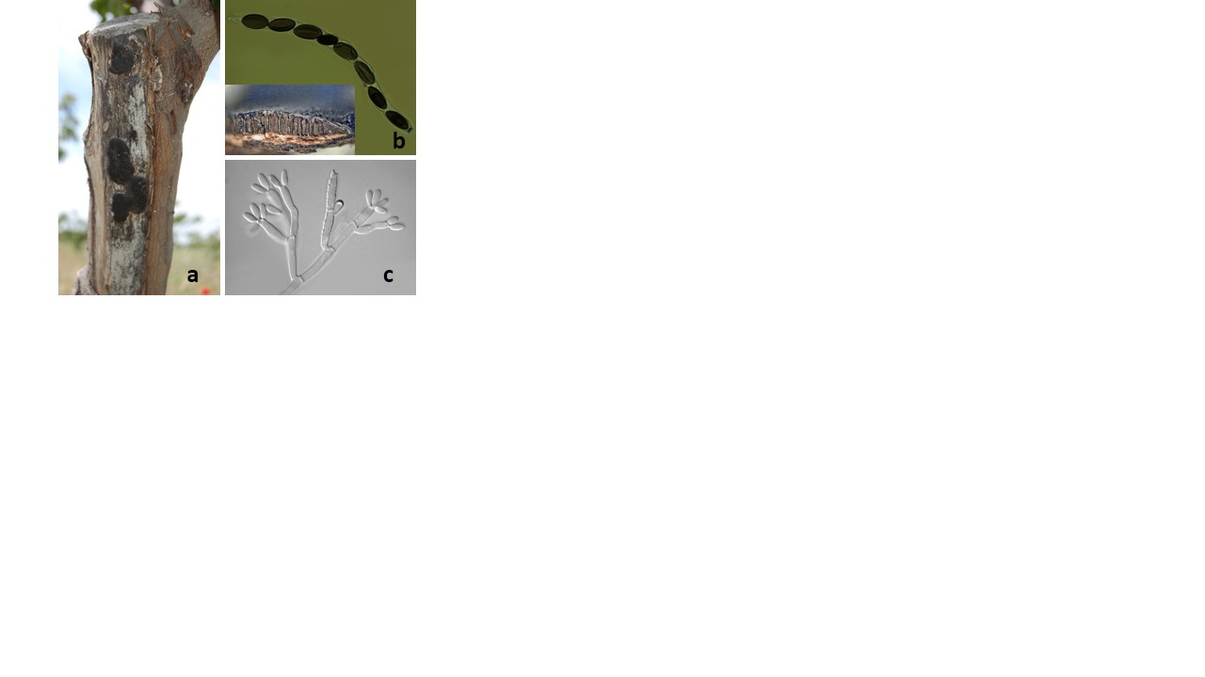

Biscogniauxia rosacearum fruiting body on bark of pear tree (a); Asci and ascospores b); Coidiophores of imperfect stage (c).

Recent Publications
- Raimondo M. L., F., Lops ., Carlucci A., 2016. Charcoal canker of pear, quince and plum trees caused by Biscogniauxia rosacearum sp. nov. in southern Italy. Plant Disease, 100 (9), 1813-1822.
- Ju, Y. M., and Rogers, J. D. 2001. New and interesting Biscogniauxia taxa, with a key to the world species. Mycol. Res. 105:1123–1133.
- Ju, Y. M., Rogers, J. D., San Martìn Gonzalez, F., and Granmo, A. 1998. The genus Biscogniauxia. Mycotaxon 66:1–98.
- Peláez, F., González, V., Platas, G., Sánchez-Ballesteros, J., and Rubio, V. 2008. Molecular phylogenetic studies within the family Xylariaceae based on ribosomal DNA sequences. Fungal Div. 31:111–134.
- Sanchez-Ballesteros, J., Gonzalez, V., Salazar, O., Acero, J., Portal, M. A., Julian, M., Rubio, V., Bills, G. F., Polishook, J. D., Platas, G., Mochales, S., and Pelaez, F. 2000. Phylogenetic study of Hypoxylon and related genera based on ribosomal ITS sequences. Mycologia 92:964–977.

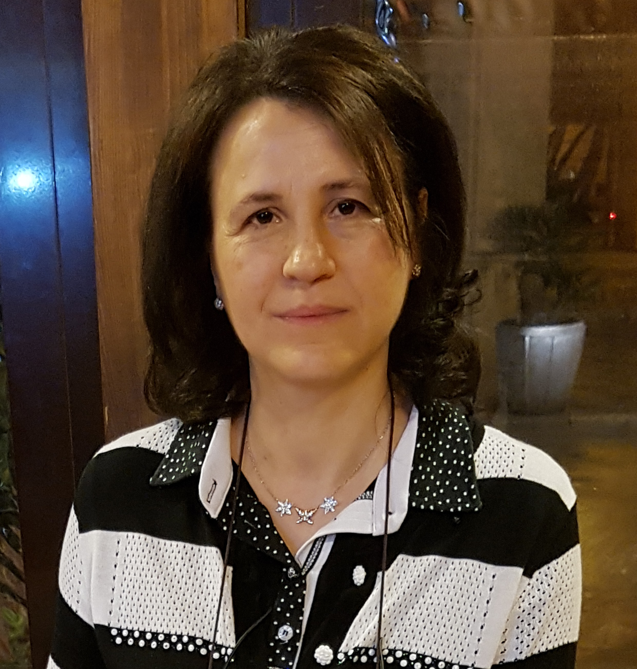

Biography
Dr. Antonia Carlucci is a Researcher in the Department of Sciences of Agriculture, Food and Environment in Foggia, Italy. She is also head of plant pathology and diagnosis laboratory for quarantine fungal and bacterial pathogens in University of Foggia. Dr. Carlucci received her PhD in Biotechnology of agricultural and food products from University of Bari, Italy. She is expert of morphological and molecular characterization of fungi by phylogenetic studies. She has been involved in many research projects related to Plant Pathology and described ten novel fungal species by molecular approaches. Dr. Carlucci has been interesting to research and study new control means regarding the solarization practice, use of biostimulants, resistance inducers, fungal antagonists and biocides substances.
Email: antonia.carlucci@unifg.it Contact No: +39 3204394552

Notes/Comments: Track 3-3Plant pathology and plant-micro-biology

