Pathogenicity assessment of different Plectosphaerella species on basil, pepper and tomato crops in southern Italy
Maria Luisa Raimondo, Plant Pathology PhD, Universita' degli Studi di Foggia SAFE, Via Napoli 25 - 71122 Foggia Italy.
Antonia Carlucci, Plant Pathology PhD, Universita' degli Studi di Foggia SAFE, Via Napoli 25 - 71122 Foggia Italy.

Abstract
Statement of the Problem: Plectosphaerella species have been isolated from different hosts throughout the world such as basil, tomato, sunflower, soybean, cucurbits, pumpkin, endive, rocket, and Lamb lettuce. To date Plectosphaerella genus consists of 12 species such as Pa. alismatis, Pa citrulli, Pa. cucumerina, Pa. delsorboi, Pa. melonis, Pa. oligotrophica, Pa. oratosquillae, Pa. pauciseptata, Pa. plurivora, Pa. populi, Pa. ramiseptata and Pa. sinensis. The most common and known species of Plectosphaerella is Pa. cucumerina, which has been reported as pathogen and endophyte from different horticultural crops as well as biological agent to control of Galium spurium, Sagittaria trifolia and nematodes of potato.
The purpose of this study is to ascertain the role that these fungi play in affected horticultural crops by pathogenicity tests.
Methodology & Theoretical Orientation: Nine Plectosphaerella species were artificially inoculated on three different hosts (basil, pepper and tomato) to perform pathogenicity tests in-vitro (detaches lives) and in-vivo (young 30-day old plants) conditions. The pathogenicity tests were carried out in a greenhouse with experimental design consisting of ‘two independent batches’. Each host × isolate combination was replicated five times. The disease severities were recorded after 15-35 days after incubation on leaf surface and on roots and collar showing symptoms.
Findings: Pathogenicity tests demonstrated that except for Pa. oratosquillae, all Plectosphaerella species essayed in this study are able to cause disease symptoms on all hosts used with different disease severity degrees. Plectosphaerella paucisepatata and Pa. plurivora showed a vascular behavior while the other seven species a parenchymatous behavior. Finally, Pa. ramiseptata resulted to be the most pathogenic species on all the three hosts.
Conclusion & Significance: We consider that the Plectosphaerella species investigated in the present study are not endophytic fungi, but pathogenic fungi as they cause necrosis symptoms with different degrees of disease severity.

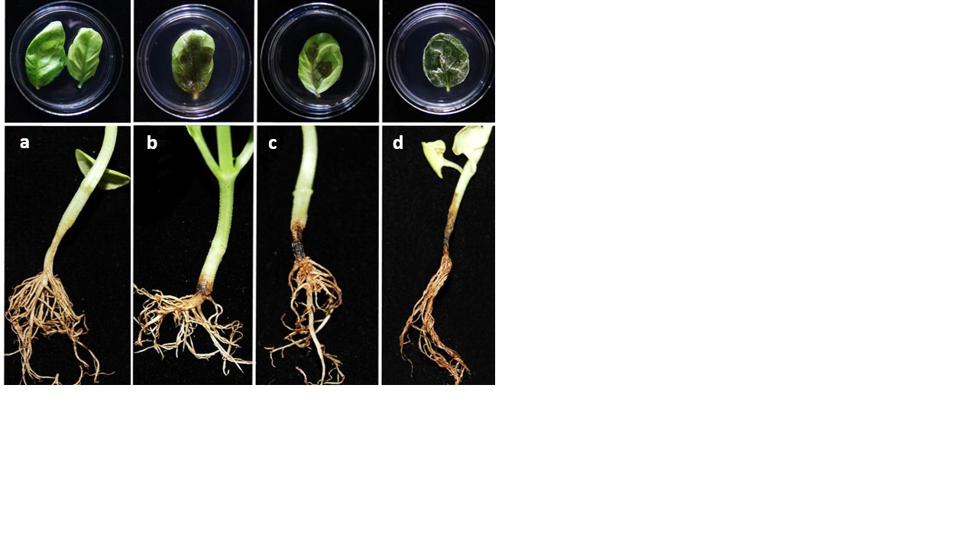
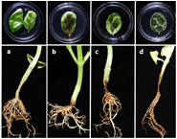

Representative samples in pathogenicity essays for disease carried out on basil leaves and seedlings under artificial conditions. Steril distilled water (a); Pa. pauciseptata (b); Pa. plurivora (c); Pa. ramiseptata (d).

Recent Publications
- Carlucci A, Raimondo ML, Santos J, Phillips AJL (2012). Plectosphaerella species associated with root and collar rots of horticultural crops in southern Italy. Persoonia 28: 34–48.
- Egel, D., Ruhl, G., Hoke, S., Dicklow, M. B., and Wick, R. 2010. First report of black leg of hydroponic basil in the United States caused by Plectosporium tabacinum. Plant Disease 94: 484.
- Raimondo, M. L., and Carlucci, A. 2017. Characterisation and pathogenicity assessment of Plectosphaerella species associated with stunting disease on tomato and pepper crops in Italy. Plant Pathology, doi: 10.1111/ppa.12766.
- Usami, T., Morii, S., Matsubara, C., and Amemiya, Y., 2012. Plectosphaerella rot of lettuce, coriander, and chervil caused by Plectosphaerella pauciseptata. Journal of General Plant Pathology 78: 368–371.
- Xu, J., Xu, X. D., Cao, Y.Y., and Zhang, W.M., 2014. First report of greenhouse tomato wilt caused by Plectosphaerella cucumerina in China. Plant Disease 98: 158.

 Biography
Dr. Maria Luisa Raimondo is a Plant Pathology PhD and actually have a research fellowship in the Department of Sciences of Agriculture, Food and Environment in Foggia, Italy. Her main expertises are in taxonomic studies of fungi by morphological and molecular tools, as well as by use of Bionformatic softwares. She collaborates in several research projects related to Plant Pathology and described seven novel fungal species by molecular approaches. Dr. Maria Luisa Raimondo has been also interesting to research and study new control means by biostimulants, resistance inducers, fungal antagonists and biocides substances.

Email: marialuisa.raimondo@unifg.it Contact No: 0881/589322

Notes/Comments: Track 3-3 Plant pathology and plant-micro-biology

