Assessing the effect of glyphosate application on soil enzymatic activities and microbial communities from soil in Viljoenskroon, South Africa.
Thokozile N.M Yende, PhD Tara A Walmsley, MSc Andrew Beckerling, Mohau Mofojane and PhD Jasim Basheer
Department of Biotechnology, Vaal University of Technology, South Africa

Abstract
Glyphosate (N-(phosphonomethyl) glycine), a non- selective herbicide used to eliminate weeds, is applied extensively throughout the world. However, the excessive use of glyphosate in agriculture has raised concerns due to its accumulation in the soil and its non-targeted toxicity. Glyphosate targets and binds the enzyme EPSPS (5-enolpyruvylshikimate 3-phosphate synthase) to form a very stable complex that permanently deactivates the enzyme to affect the metabolic activity of the plant, which results in its death. However, this pathway is also found in soil microorganisms. The purpose of this study is to assess the effect of glyphosate treatment on soil enzymatic activities and to isolate glyphosate resistant bacteria and characterize these bacteria using molecular techniques. Soil was collected and treated with glyphosate (6 L/ha) three times and once with 120 kg/ha of urea and ammonium nitrate fertilizers. Soil was sampled in 24-hour intervals. Dehydrogenase activity was measured spectrophotometrically using TTC as a substrate and urease activity was quantified using an assay kit. Glyphosate resistant bacteria were cultured and purified from agricultural soil in nutrient agar containing different concentrations of glyphosate of 1 g/L, 2 g/L, 5 g/L, 10 g/L and 20 g/L. DNA was then isolated, amplified with 16S rDNA primers and sequenced. Bioinformatics tools were then used to identify these bacteria. Dehydrogenase and urease activity were found to be high on native soil samples that received glyphosate and nitrogen fertilizers, compared to agricultural soil that received the same treatment. Bacillus sp., Paenibacillus sp., Rhodococcus sp., Pseudomonas sp., Stenotrophomonas sp., Enterobacter sp., Xanthomonas arboricola, Pantoaea agglomerans, Klebsiella pneumoniae and Bordetella avium bacteria were found to be resistant to glyphosate. This study shows that the measurement of changes in enzyme activities provide useful guide of changes in soil quality and increase knowledge of glyphosate resistant bacteria.
Recent publications
1. Kryuchkova, Yelena V et al. 2014. “Isolation and Characterization of a Glyphosate-Degrading Rhizosphere Strain, Enterobacter Cloacae K7 ଝ.” Microbiological Research 169(1):99–105.
2. Kumar, S., S. Chaudhuri, and S. K. Maiti. 2013. “Soil Dehydrogenase Enzyme Activity in Natural and Mine Soil - A Review Department of Environmental Science & Engineering / Centre for Mining Environment , Department of Mining Engineering , Indian School of Mines ; Dhanbad -826004 India.” 13(7):898–906.
3. Benslama O, Boulahrouf A. 2013. Impact of glyphosate application on the microbial activity of two Algerian soils. Int. J. Curr. Microbiol. App. Sci, vol. 2, issue 12, pp. 628-635

4. Lane, Matthew, Nicola Lorenz, Jyotisna Saxena, Cliff Ramsier, and Richard P. Dick. 2012. “The Effect of Glyphosate on Soil Microbial Activity, Microbial Community Structure, and Soil Potassium.” Pedobiologia 55(6):335–42.
5. Araújo A, Monteiro R, Abarkeli R. 2003"Effect of glyphosate on the microbial activity of two Brazilian soils"Chemosphere, vol. 52, issue 5, pp. 799-804

(a)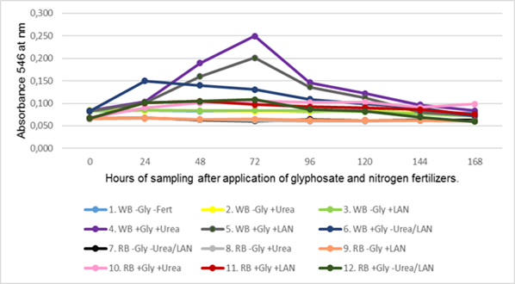 | (b)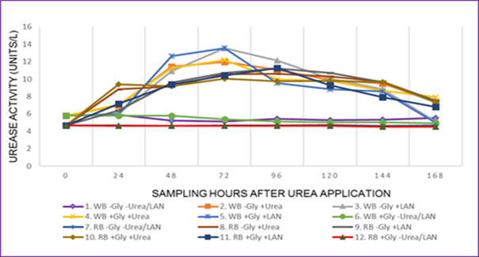
(c)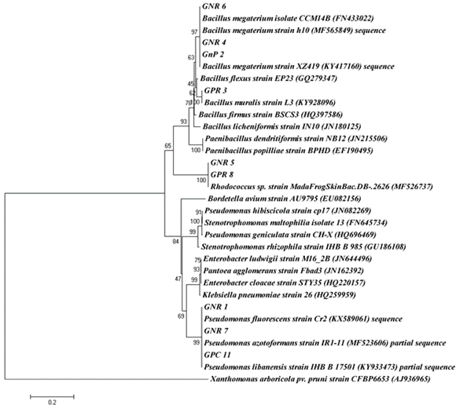
Figure 1: (a) Mean values of dehydrogenase activity measured after hours of sampling soil over a period of seven days after glyphosate application. (b) Mean values of urease activity measured after hours of sampling soil over a period of seven days after urea application. (c) Phylogenetic relationships built on sequences of 16S rDNA amplicons derived glyphosate-resistant bacterial isolate.
 | Thokozile Yende is a Masters’ student in the Department of Biotechnology, Vaal University of Technology, and zealous about the field of environmental and agricultural studies. Her project is about evaluating the effect of glyphosate on soil microbial communities and the consequent effect it has on the topically applied nitrogen fertilizers.  Email: yendetnm@gmail.com Contact number: +27 734624756

