MALOLACTIC FERMENTATION AND AGEING IN OAK WOOD BARRELS: IMPACT ON ELLAGITANNIN AND ANTHOCYANIN CONTENT, VOLATILE COMPOSITION AND SENSORY PROFILE OF RED WINES
Kleopatra CHIRA, Research Scientist in Institut des Sciences de la Vigne et du Vin, Unité de recherche Œnologie, Bordeaux

Abstract (300 word limit)

Chemical composition, aromatic profile and sensory attributes of wines lie in the grape variety, winemaking procedure, maturation and ageing. Traditional red wine production usually consists of performing both alcoholic and malolactic fermentations in the same tank, and then, ageing in oak barrels for a variable period of time, ranging from a few months to over a year. In an attempt to obtain particular quality wines with their own personality and a higher organoleptic complexity, alternative production technologies, such as carrying out the malolactic fermentation (MLF) in the same oak barrels where ageing will take place, are being introduced in the wineries in an increasingly widespread way. The present research compares ellagitannin and anthocyanin profiles, woody volatile composition and sensory properties of wines in which malolactic fermentation (MLF) takes place in tanks prior to 12-months ageing or in oak barrels themselves. Three different barrel toastings (medium toast, MT; medium toast with watering, MTAA; noisette) were considered for ageing of each wine modality. Sensory analyses (triangle and rating tests) were also performed. Two-way ANOVA of the raw experimental data revealed that the toasting method and the container where MLF took place, as well as the interaction between both factors, have a significant influence on ellagitannin, anthocyanin and woody volatile profiles of Cabernet Sauvignon wines. Barrel-fermented wines generally presented 1.2-fold higher total phenolics, whereas tank-fermented wines exhibited 1.1 and 1.2-fold greater total proanthocyanidin and anthocyanin contents, respectively. Concerning the ellagitannin composition, barrel toasting effect seemed to be more important that differences due to MLF-container. Certain woody and fruity volatiles varied significantly depending on whether MLF occurred in barrels or tanks. Barrel-fermented wines were preferred in mouth, while olfactory preference depended on barrel toasting.

Image

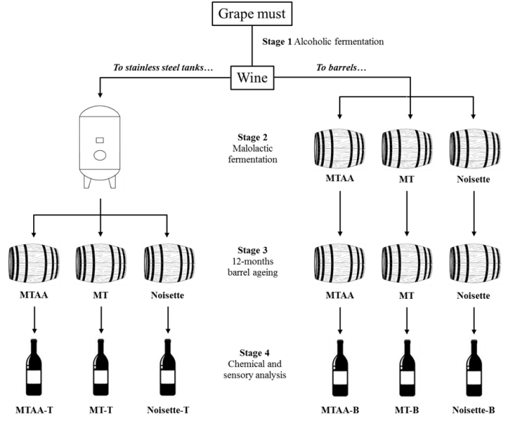

Recent Publications (minimum 5)
- González-Centeno, M.R., Chira, K., Teissedre, P.-L (2017) Comparison between Malolactic Fermentation Container and Barrel Toasting Effects on Phenolic,Volatile, and Sensory Profiles of Red Wines. Journal of Agricultural and Food Chemistry 65: 3320-3329.
- González-Centeno, M.R., Chira, K., Teissedre, P.-L. (2016) Ellagitannin content, volatile composition and sensory profile of wines from different countries matured in oak barrels subjected to different toasting methods Food Chemistry 210:500-511.
- Chira, K., Zeng, L., Le Floch, A., Péchamat, L., Jourdes, M., Teissedre, P.-L. (2015) Compositional and sensory characterization of grape proanthocyanidins and oak wood ellagitannin). Tetrahedron 71: 2999-3006.
- Chira, K., Teissedre, P.-L. (2014) Chemical and sensory evaluation of wine matured in oak barrel: effect of oak species involved and
toasting process. European Food Research and Technology 240:533-547.
5. Chira, K., Teissedre, P.-L. (2013) Extraction of oak volatiles and ellagitannins compounds and sensory profile of wine aged with French winewoods subjected to different toasting methods: Behaviour during storage. Food Chemistry, 140 : 168-177.

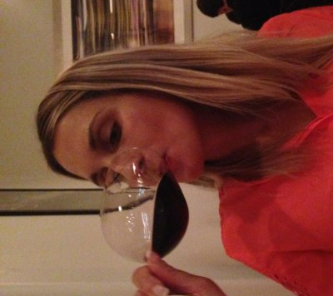 Biography (150 word limit)
Kleopatra Chira realized her first studies as an Agricultural Engineer in Greece; in 2004 she went to Bordeaux in France in order to obtain the National Diploma of Oenology. She continued with a Master degree as well and a PhD in Viticulture-Oenology. She works as a Research Scientist in the Institut of wine and vine in Bordeaux for Nadalie cooperage.
Email: kleopatra.chira@u-bordeaux.com Contact No: +33(0)5 57 57 5888

