Evaluation of phosphate Solubilizing bacteria by their effects on lead (Pb) toxicity
RHAN Hettiarachchi, Department of Soil Science, Faculty of Agriculture, University of Ruhuna, Sri Lank
BC Walpola, PhD, Department of Soil Science, Faculty of Agriculture, University of Ruhuna, Sri Lanka

Abstract
Lead (Pb) is regarded as a potent occupational toxin and its toxicological manifestations are well known. When soil is contaminated with lead plants would absorb it as it’s a persistent contaminant. This lead poisoning can be detoxified by using physical, chemical and Biological methods. Biological detoxification is defined as enzymatic degradation or transformation of toxins that leads to less toxic products. But a complete understanding of how these detoxification mechanisms influence their P solubilization is lacking. Microorganisms play an important role in the environmental fate of toxic metal including Pb with physiochemical mechanisms transformations between soluble and insoluble phases. Such mechanisms are important components of natural toxicity tolerance of heavy metal including Pb. Phosphate Solubilizing Microorganisms (PSMs) have specialized attributes for conversion of insoluble form of phosphate to soluble via methods like solubilization and mineralization. Therefor this study was conducted to identify the capability of growth of PSMs in the presence of Pb. Agricultural soil was used to isolate the Phosphate solubilizing bacteria and isolation was done by using National Botanical Research Institutes Phosphate (NBRIP) medium. 15 phosphate solubilizing bacterial isolates were found and their resistance to Pb was tested in a medium consist with different concentrations of Pb respectively 100ppm, 200ppm and 400ppm. The survived bacterial strains were used to determine the phosphate solubilization under Pb toxicity. Survived bacterial strains were inoculated into NBRIP broth medium. Phosphorus solubilization, growth and pH was monitored respectively after 1, 3 and 5 days. Among 14 isolates 11 were growth in 100ppm, 10 were growth in 200ppm, and 7 were growth in 400ppm Pb concentration. 7 isolates from 400ppm Pb toxicity were used for further analysis of Phosphorus solubilization. Among them PSB-8 strain has shown a vigorous growth within a maximum Pb toxicity and has

solubilized 72.02ppm phosphate under 400ppm Pb toxicity.

Image
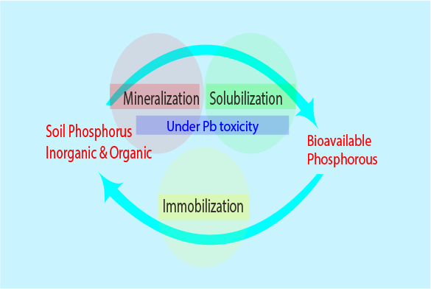Figure 1: effect on mineralization and solubilization on Pb toxicity of P solubilizing bacteria

References
- Chen, Y.P., Rekha, P.D., Arun, A.B., Shen, F.T., Lai, W.A. and Young, C.C., 2006. Phosphate solubilizing bacteria from subtropical soil and their tricalcium phosphate solubilizing abilities. Applied soil ecology, 34(1), pp.33-41.
- Collavino, M.M., Sansberro, P.A., Mroginski, L.A. and Aguilar, O.M., 2010. Comparison of in vitro solubilization activity of diverse phosphate-solubilizing bacteria native to acid soil and their ability to promote Phaseolus vulgaris growth. Biology and Fertility of Soils, 46(7), pp.727-738.
- Dong, J., Mao, W.H., Zhang, G.P., Wu, F.B. and Cai, Y., 2007. Root excretion and plant tolerance to cadmium toxicity-a review. Plant Soil and Environment, 53(5), p.193.
- Han, H.S. and Lee, K.D., 2006. Effect of co-inoculation with phosphate and potassium solubilizing bacteria on mineral uptake and growth of pepper and cucumber. Plant soil and Environment, 52(3), p.130.
- Park, J., Nanthi B., Mallavarapu, M., and Ravi N., 2010, Isolation of Phosphate-Solubilizing Bacteria and Characterization of Their Effects on Lead Immobilization

Biography (150 word limit)
Nuwan Hettiarachchil has her expertise in evaluation and passion in improving available P in soil by using P Solubilizing microorganisms. His findings help to new pathways for environment friendly biological P Solubilization. He has studied in 2 years of his Mphil research, in department of Soil Science University of Ruhuna. Acknowledgments should be done to the University of Ruhuna research grant for funding of this research and supported it for almost two years
Email: nuwanrha@mail.com Contact No: +94715955596

