Soil fertility status of major nutrients, micronutrients and mapping in Nicchapura-2 micro watershed of Davanagere district, Karnataka
KRISHNA, N. R., PARASHURAM CHANDRAVAMSHI,., GURUMURTHY, K. T., SRIDHARA, C. J. AND ASHOK, L. B.
Department of Soil Science and Agricultural Chemistry, College of Agriculture, University of Agricultural and Horticultural Sciences, Shivamogga- 577204, India
Abstract:
The investigation was conducted at UAHS, Shivamogga to know the Soil fertility status of available macro and micronutrient in Nicchapura-2 micro watershed of Davanagere district. 103 soil samples were collected grid-wise by using cadastral map of study area and were analyzed for their fertility status of available macro and micronutrient status of study area. The value of pH, electrical conductivity, and organic carbon was ranged from 6.2 to 8.7, 0.11 to 0.84 dS m⁻¹ and 3.1 to 5.6 g kg⁻¹ respectively. The available N, P₂O₅, K₂O, was ranged from 135 to 236 kg ha⁻¹, 10 to 34 kg ha⁻¹,130 to 415 kg ha⁻¹, 8.1 to 38.1 cmol (p⁺)kg⁻¹,6.3 to 26.2 cmol(p+)kg⁻¹ and 6.3 to 12.1 ppm respectively. Available micronutrients iron, manganese, zincs and copper was ranged from 0.58 to 5.92 mg kg⁻¹, 0.60 to 10.83 mg kg⁻¹, 0.01 to 0.41 mg kg⁻¹, 0.06 to 4.81 mg kg⁻¹ respectively. Available micronutrients such as zinc and iron are deficient but copper and manganese were sufficient in these soils of micro-watershed.
Key words: KSRSAC- Karnataka State Remote Sensing and Application Centre, topo sheet, cadastral maps and grids. GIS
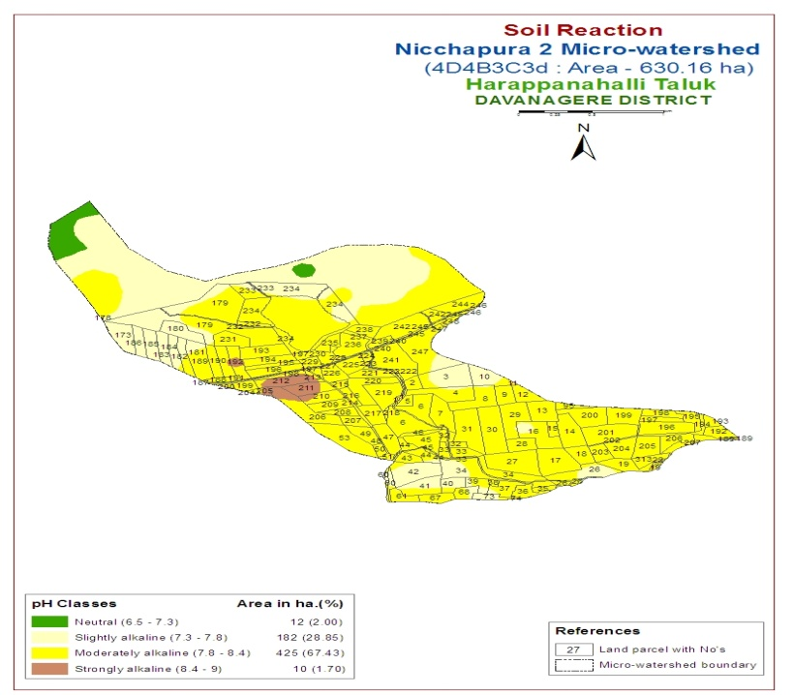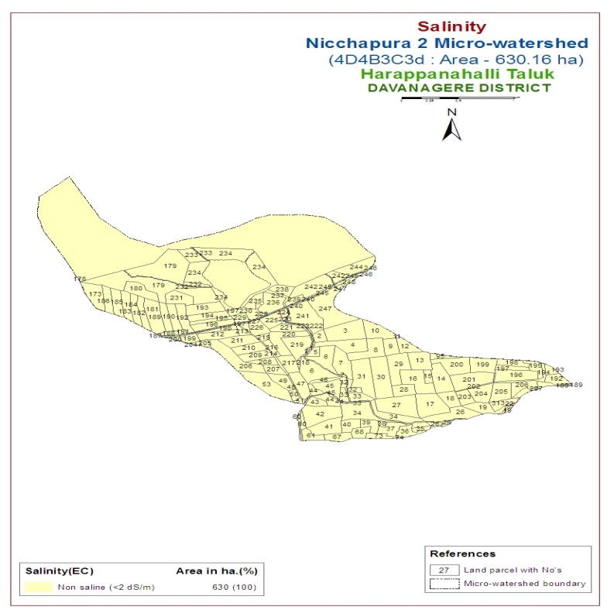
Fig.1: pH, EC, available N and OC status of Nicchapura-2 micro-watershed
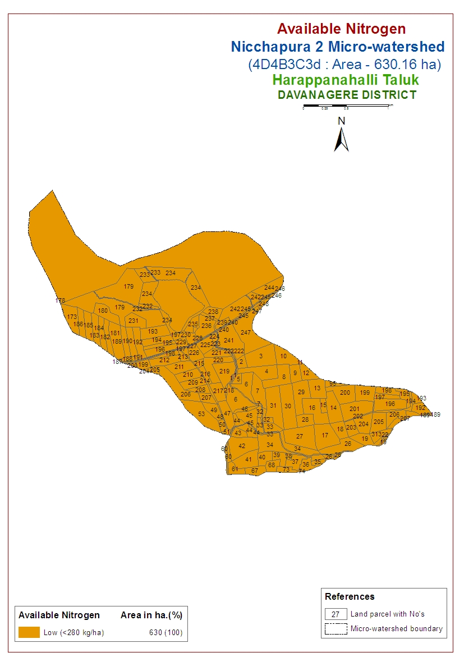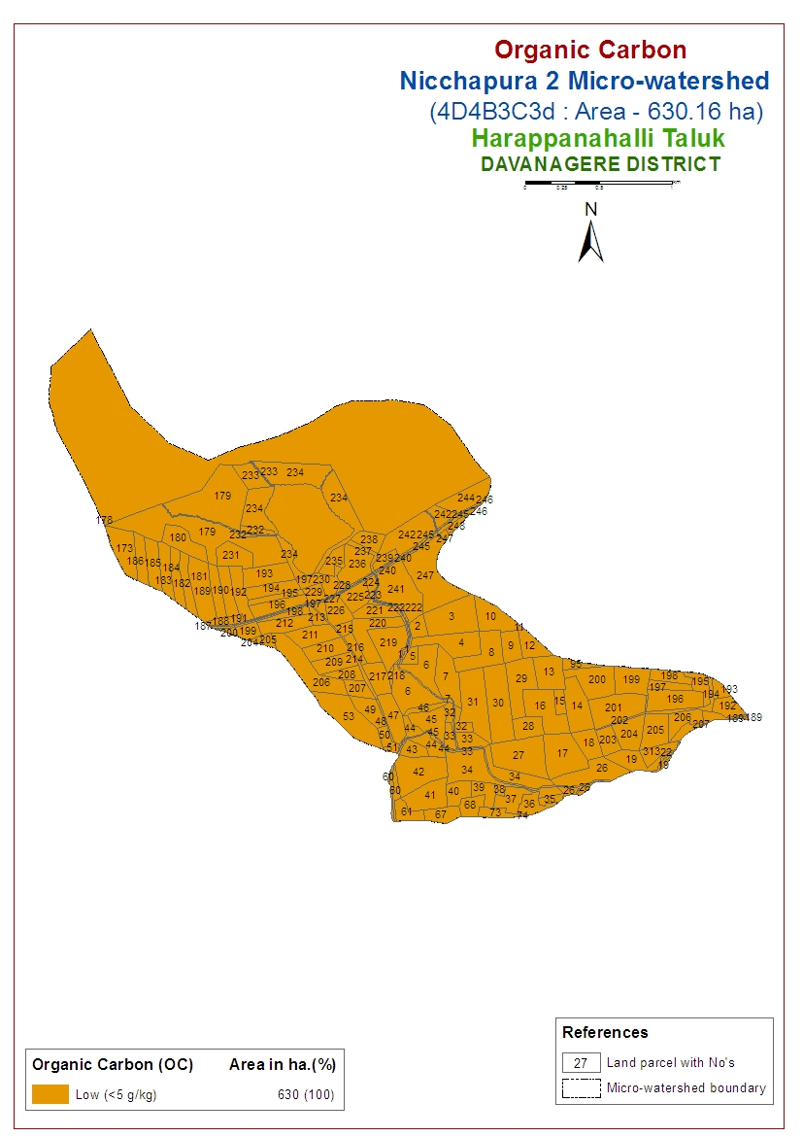
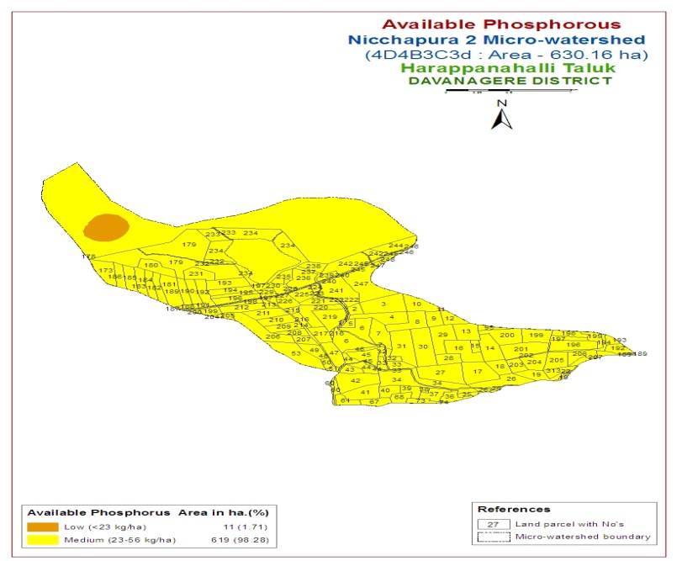
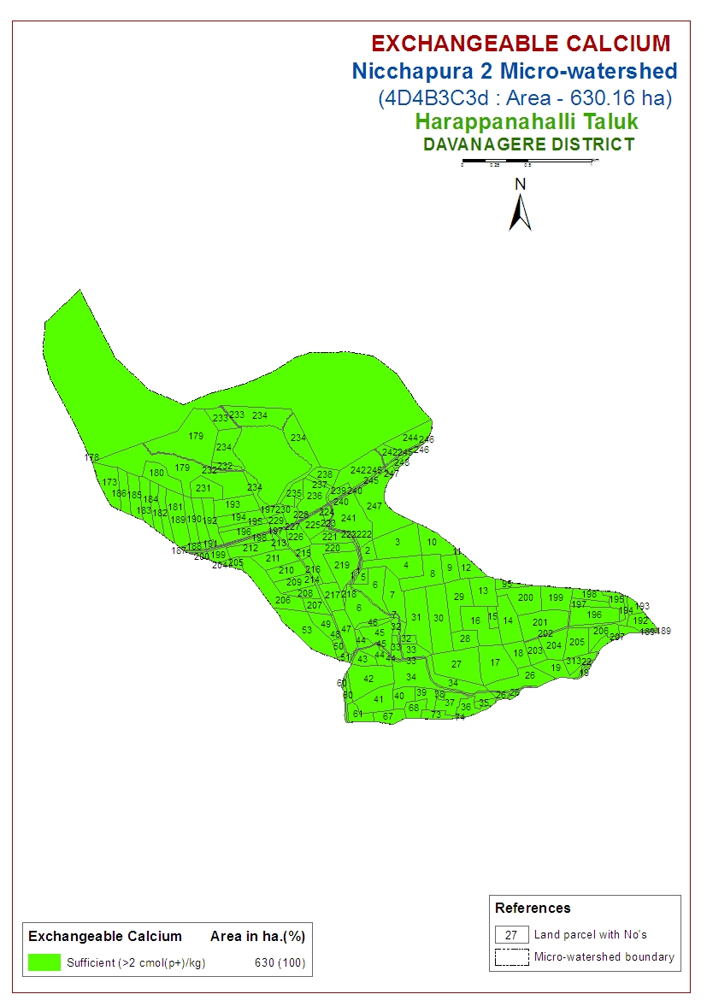
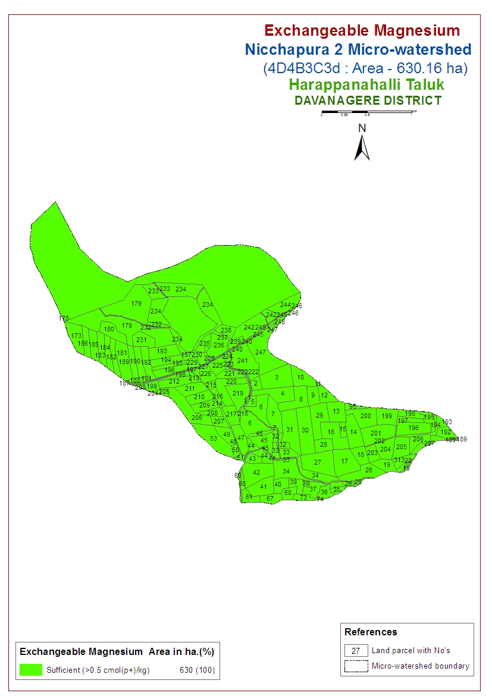
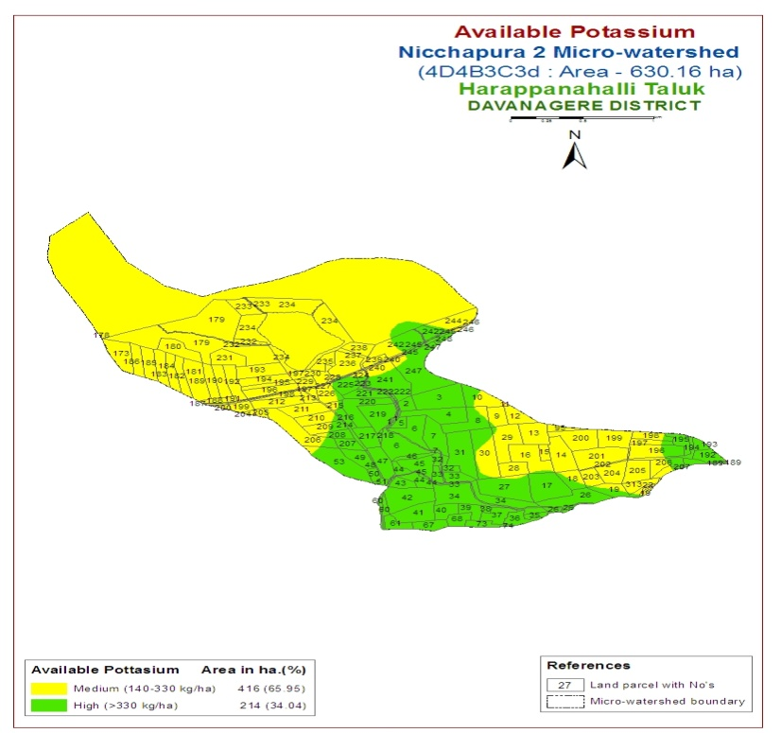
Fig.2: Available P₂O₅, K₂O and exchangeable Ca and Mg status of Nicchapura-2 micro watershed

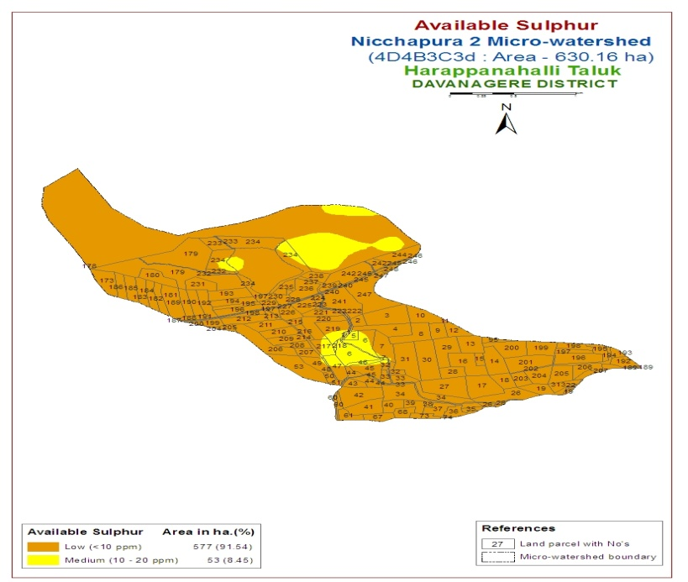
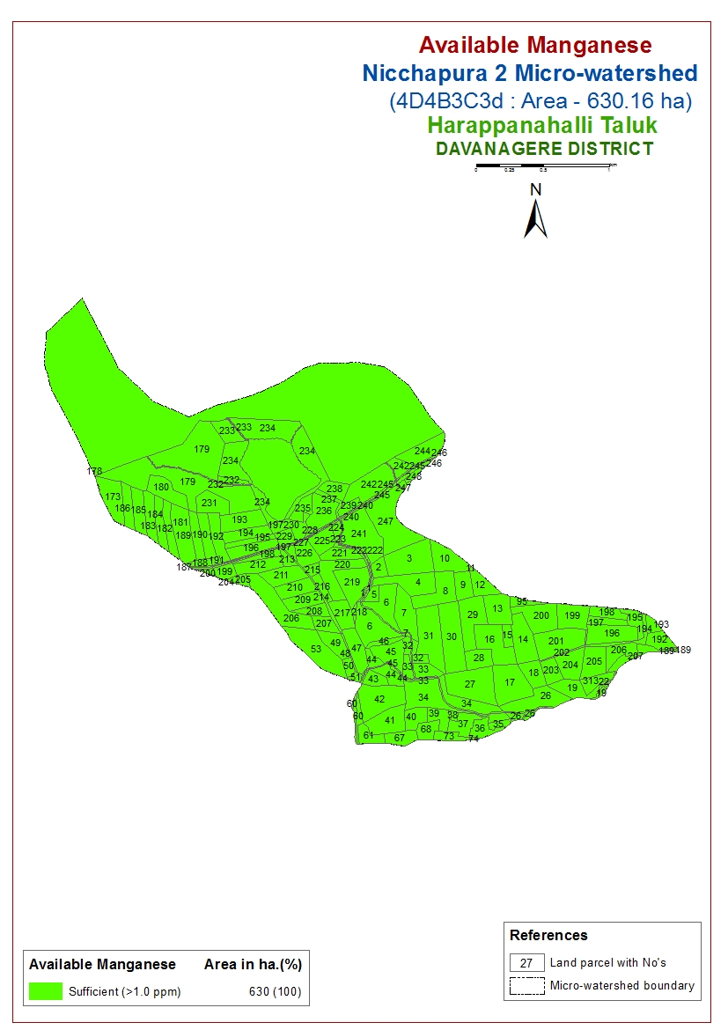
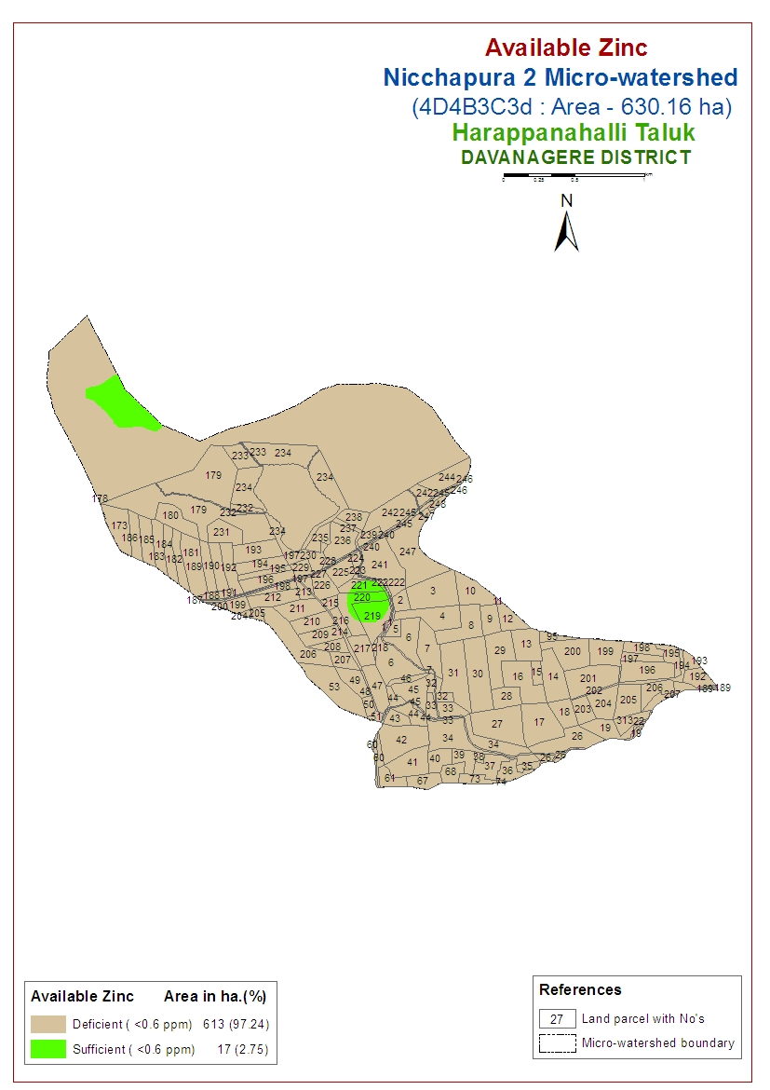
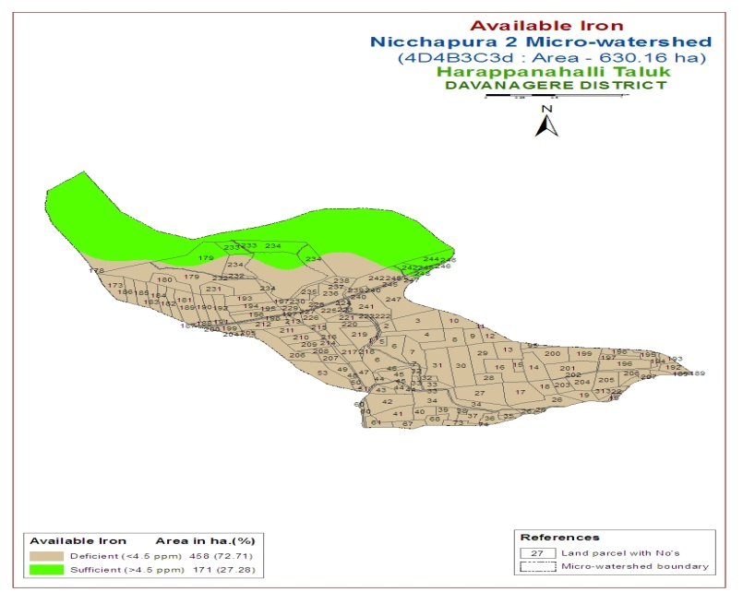
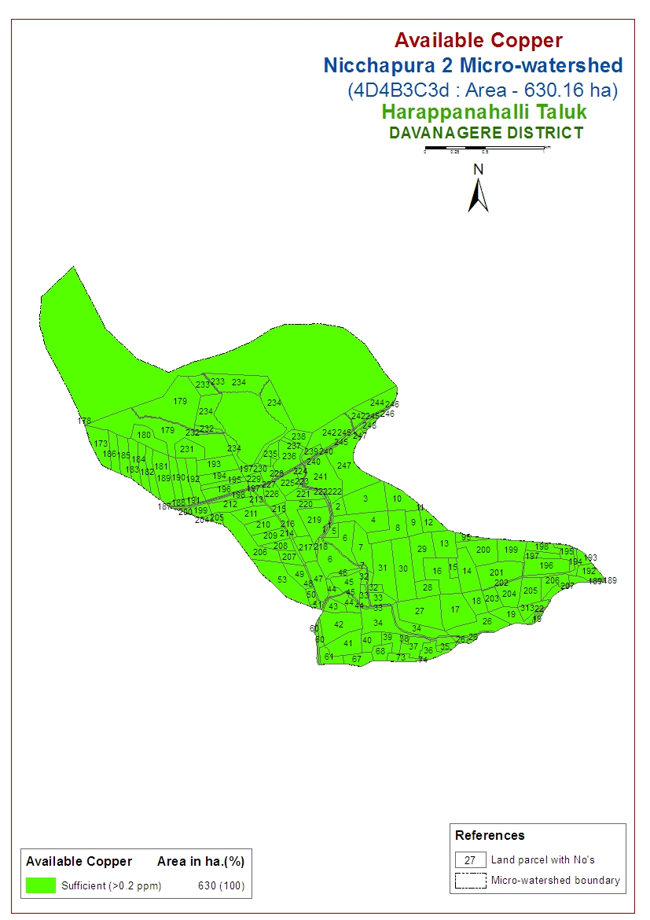

Fig.3: Available S, Fe, Mn, Cu and Zn status of Nicchapura-2 micro-watershed

Conclusion
These variations of nutrients in soils are may be due to variation soil properties like clay content, CEC and P fixation capacity.The exchangeable Ca and Mg content were sufficient surface samples. Low in available nutrients content may be because of acidic reaction, low EC and OC values in both black and red soils. Available micronutrients such as zinc and iron are deficient but copper and manganese were sufficient in these soils of micro-watershed.
References:
ALUR, A. S., 1994, Properties of red soils of agro-climatic zone-3 (region-II) of North Karnataka. M. Sc. (Agri.) Thesis, Uni. Agril. Sci., Dharwad, Karnataka (India).
ASHOK KUMAR, S., 2000, Studies on soil aggregation in Vertisols of North Karnataka. M. Sc.(Agri.) Thesis, Univ. Agril. Sci., Dharwad, Karnataka (India).
ASHOK, K.B., 2001, Sulphur status of selected soil series of Karnataka and studies on direct and residual effect of graded level of sulphur on crop M. Sc. (Agri.) Thesis. Univ. Agric. Sci., Dharwad, Karnatakka (India).
BINITHA, N. K., DASOG, G. S. AND PATIL, P. L., 2009, Soil fertility mapping in Gatabrabha left bank canal command area of North Karnataka by geographic information system technique. Karnataka J. Agric. Sci., 22: 73-76.
DASOG G. S., AND PATIL, P. L., 2011, Genesis and classification of black, red and lateritic soils of Karnataka. In: Soil Science Research in North Karnataka, Dharwad chapter of ISSS (Ed.), 76th annual convention of ISSS, p. 1-10.

