Management of Insect Pests and a pollinator, Elaiedobius kamerunicus, of oil Palm in Malaysia
Idris Abd Ghani, PhD, UKM, Malaysia
Norman Kamrudin, PhD, MPOB, Malaysia
Ramlee Muslem, MPOB, Malaysia

Abstract (300 word limit)
Oil palm is the main industrial crop contributing up to 30% of Malaysia national revenue. To date, about 5.5 million ha (60% ) of agricultural land area is being planted with oil palm. Despite the rapid growth of the industry, the sustainable oil palm yield production remains prone to insect pests damage and its pollinators. In Peninsular Malaysia and Sabah, bagworms remain the major insect pest, followed by the rhinoceros beetle, in replanting areas. In Sarawak, bunch moth and termite are the major threats which more related to those oil palm trees planted on peat soil. The potential of a new invasive insect pest, red palm weevils (Rhynchophorus ferrugineus)(RPW) of causing severe damage to Malaysian oil industry need serious attention. Sustainable management of the insect pests with short and long term effects are being practiced by most plantations. For bagworms, the integrated pest management (IPM) approach of census and detection followed by application of Bacillus thuringiensis or selective insecticides, planting of beneficial plants and mass trapping seemed to reduce bagworms population without endangering the environment. Good agricultural practices like planting of cover crops, proper management of biomass residues and the use of microbes such as Metarhizium have successfully used to control rhinoceros beetle during replanting period. Bunch moth and termites remain critical insect pests in peat areas. Similar approaches employed to reduce their infestation. No specific control measure yet recommended for controlling RPW in Malaysia except using pheromone trap. The inefficiency of oil palm pollinators, Elaeidobius kamerunicus that linked to low fresh fruit bunch (FFB) production is serious problem to the oil palm industries and Malaysian economy. This paper presents an updated information on the control and management of major insect pest of oil palm as well as latest research finding on the relationship between EK inefficiency and FFB produced
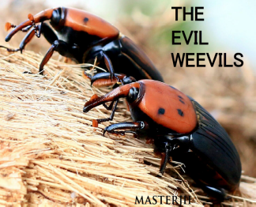
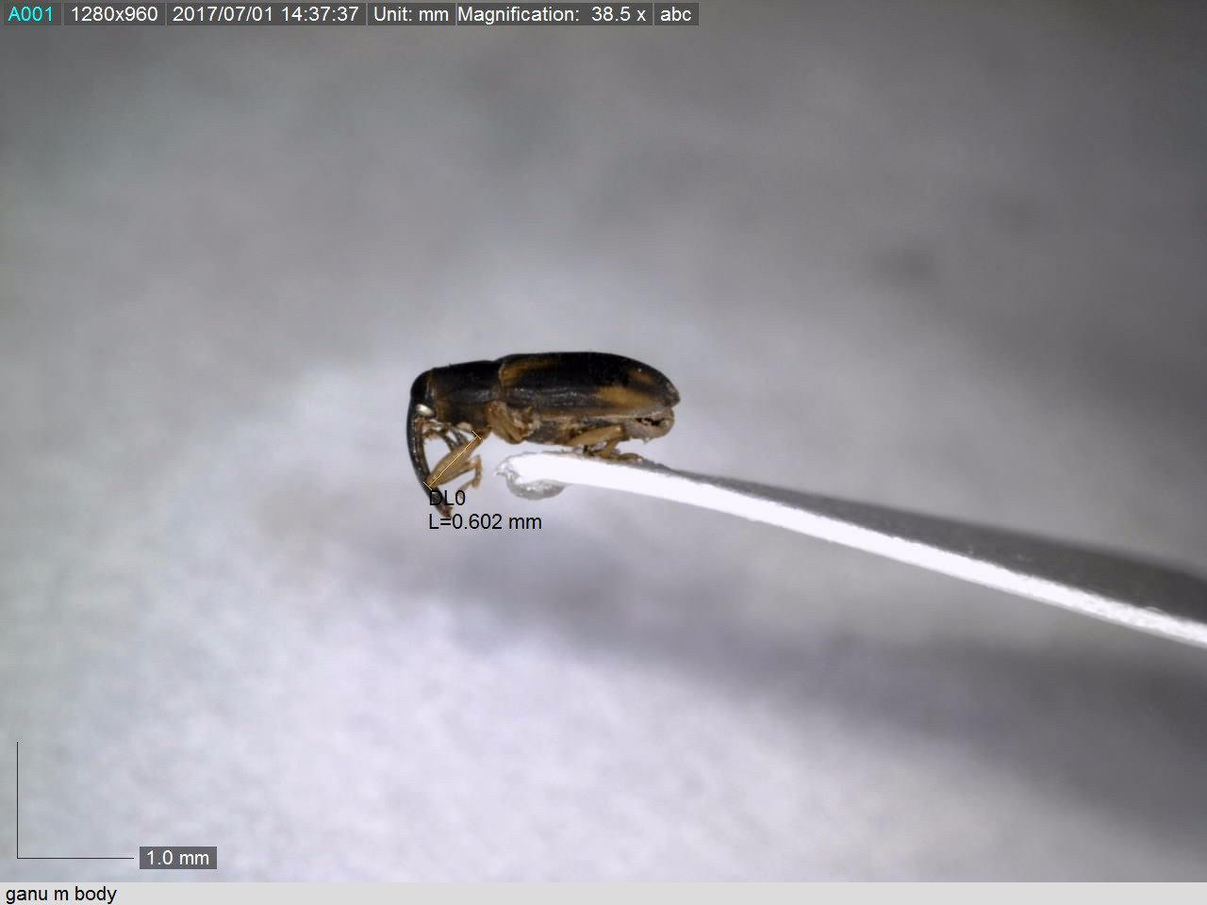

THE PEARL
WEEVILS

Oil pam pollinator
Red palm weevils

Recent Publications (minimum 5)

Idris A. B, Mokhtaruddin, Zazali, Nurul Wahida O., Yaakop S., & Hazmi. I. R. (2014). The potential of red palm weevil infesting and destroying oil palm industry in Malaysia. The Planter, Kuala Lumpur, 90 (1058): 329-335
Muhamad Fahmi, M.H. A. K. Ahmad Bukhary, H. Norma, and A. B. Idris M. H. (2016). Analysis of volatile organic compound from Elaeis guineensis inflorescences planted on different soil types in Malaysia. AIP Conference Proceedings 1784, 060020 (2016); doi: 10.1063/1.496685

Muhammad Idrus, (2017). Fruit bunch moth, Tirathaba spp (Lepdoptera>Pyralidae): Population dynamic, control and management on peat soil. MSc thesis. USM. 132 pp.
Salim, H., Md. Rawi, C. S., Ahmad, A. H., & Al-Shami, S. A. 2015. Efficacy of insecticide and bioinsecticide ground sprays to control Metisa plana Walker (Lepidoptera: Psychidae) in oil palm plantation, Malaysia. Tropical Life Science Research 26, 73-83.

Syari, J. 2017. Role of beneficial plants in improving performance of predators of oil palm bagworm. PhD thesis. UPM. 84 pp

Salmah Yaakop and Shafariza Mohd Abdul Manaf.. 2016.The Bunch Moth of the Tirathaba Species As A Hidden Pest on The Peat Soil of Oil Palm Plantations: Implications of Biological Life Cycles, The DNA Barcoding Approach, and Infestation Pattern Detection. 3rd International Conference on Chemical, Agricultural and Medical Sciences (CAMS-2015) Dec. 10-11, 2015 Singapore

Zulkefli M. , Alindra, G. S., Saharul A. M. , Norman K., , Siti Ramlah, A.I,, Chuan, S.T , Ramle, M. and Siti Nurulhidayah. A. 2015. Evaluation of chemical insecticides and biological agents to control bunch moth, Tirathaba rufivena in young oil palm area in Sarawak, Malaysia : https://www.researchgate.net/publication/301227734. July 6, 2017.

 Biography (150 word limit)
Idris Abd Ghani has expertise in integrated pest management focusing on maximizing use of reared and field natural enemy populations. He is always referred to for pest management program. He is currently working on developing integrated approach for controlling red palm weevil and research on the main oil palm pollinator Email: idrisyatie@yahoo.com Contact No: 0197305657

