Development and Evaluation of Iron-fortified Ready to eat Rice Grains

Elizabeth Devi Wahengbam¹,

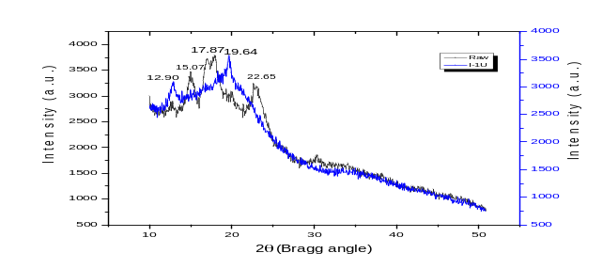

Danielle Calderwood², Manuj Kumar Hazarika³ and Brian D Green⁴

^{1,3}Food Engineering and Technology Dept.
Tezpur University, Assam, 784028, India
^{2,4} Institute for Global Food Security
Queen's University Belfast, Belfast, BT9 5AG
Northern Ireland, UK

Abstract (300 word limit)
A ready to eat hydrothermally treated iron fortified brown rice was prepared in the laboratory from a low amylose rice variety called ‘chokua’ unlike traditional paddy parboiling methods, which is locally known as ‘komal chawal’ meaning ‘soft rice’. Five ranges of iron concentrations were added in the warm water solution. Fortification during soaking for 90min below the gelatinization temperature was found to be a favorable condition for steaming process and further dried rice grains were polished at two different times for each concentration. This rice grains renders into an edible form after cold or warm water soaking. The iron content of cooked rice was measured by XRF. As increasing fortification concentrations the iron content in the grains increases. However, decreases by increasing the time of polishing with respect to each concentration. The XRF results were in the range of 1.72 to 12mg of iron per 100g of rice. These ranges were found to be acceptable for the daily requirement per person. The total iron content measured by acid digestion process by using AAS were found to be higher as compared to XRF results. RVA study reveals that the kernel and flour properties are tremendously altered under pressure steaming conditions. Texture profile analysis reveals that the warm water soaked fortified rice for 15-20min gives the hardness value of nearly similar to that of cooked rice. Wide angle X-ray diffractography (XRD) of raw rice flour shows typical A-type starch diffraction pattern with peaks at 2 values near 15.07°, 17.76°, and 23.01°, whereas iron fortified rice shows peak values at the ranges of 12.90 and 19.64. This processing condition for the development of fortified ready to eat rice grains will be considered for supplying as a ready to eat rice grains for the vulnerable people as well as the meal for disaster victim.
Recent Publications (minimum 5)
1. W. Elizabeth Devi, R. N. Shukla, K. L. Bala, A. Kumar, A. A. Mishra, and K. C. Yadav.“Extraction of Pectin from Citrus Fruit Peel and Its Utilization in Preparation of Jelly." Int. J. of Eng. Res. and Techn., vol. 3, no. 5(2014).
2. W. Elizabeth Devi, R. N. Shukla, Anitha Abraham, Surender Jarpula, and U. Kaushik "Optimized Extraction Condition and Characterization of Pectin from Orange Peel". Int. J. of Res. in Eng. and Advanced Techn., vol. 2, no.2 (2014).
3. Kaushik, U., Shukla, R. N., Kumar, A., Mishra, A. A., & W. Elizabeth Devi. “Effect of Blanching (time and temperature) and Frying Temperatures on The Oil Uptake and Texture of Chips Prepared From Elephant Foot Yam (Amorphophallus Paeoniifolius)”. International J. of Research in Eng. and Advanced Techn., vol. 2, no.3 (2014).
4. Anitha Abraham , S.K. Giri , M.K. Tripathi , Rongen Singh , W. Elizabeth Devi, Vikash Shukla. “Optimization of Fermentation Conditions for the Development of Probiotic Soymilk Using Lactobacillus Paracasei Ssp. Paracasei 013 Strain”. In International J. of Research in Eng. and Advanced Techn., vol. 2, no.3 (2014).
5. Shah Faisal, Sourav Chakraborty, Wahengbam Elizabeth Devi, Manuj Kumar Hazarika, Vinita Puranik. 2015. Sensory evaluation of probiotic whey beverages formulated from orange powder and flavor using fuzzy logic. “Int. Food Res. Journal”. 24(2):703-710.

Biography (150 word limit)
I have completed my Bachelor of Technology (2012) and Master of Technology degree (2014) in Food Process Engineering. In 2014 July, just after the Master Degree, I have enrolled PhD as a UGC National Fellow in the Department of Food Engineering and Technology, Tezpur University, Assam, India. My research interest includes waste utilization, product development, extraction of compounds, food fortification, product development and food processing, drying kinetics, rehydration kinetics of food products. Presently I am a Newton Bhabha Fellow at the School of Biological Sciences, Institute for Global Food Security, Queen’s University Belfast, Northern Ireland. And I am working a part of my PhD work which is based on in-vitro Bioavailability study of fortified rice under Newton Bhabha Placement Programmed 2016-17,

Full name of presenter- Wahengbam Elizabeth Devi
Email: wahengbam.elizabeth@gmail.com Contact No: +447780907610
Category- Oral/Poster

Notes/Comments:
I would like to participate in oral presentation but if in case slot are full then I can present poster presentation.

