Profile of carbohydrates and their effect on their body
Author: Mahdi.Tajalifar.Iran.Qazvin
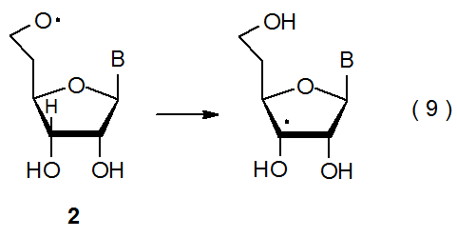
Abstract: What's most important is the type of carbohydrate you choose to eat because some sources are healthier than others. The amount of carbohydrate in the diet high or low is less important than the type of carbohydrate in the diet. For example, healthy, whole grams such as whole wheat bread, barley and quiroa are better choices than highly refined white bread or French fries. Eating too many carbohydrates in the form of processed, starchy, or sugary foods can cause and increase in total calories. This can lead to weight gain.
Severaly restricting carbohydrates can causes ketosis, this is when body uses fat energy because there are not enough carbohydrates from food for the body to use for energy.
Keyword: carbohydrate, sources, healthy, starchy, energy.

Introduction
Many people are confused about carbohydrates, but keep in the mind that it's more important to eat carbohydrates from healthy foods than to follow a strict diet limiting or couting the number of grams of carbohydrates consumed.
Carbohydrates are found in a wide array of both healthy and unhealthy foods-bread, beans, milk, popcorn, potatoes, cookies, spaghetti, soft drinks, corn, and cherry pie. They also comina variety of form. The most common and abundant forms are sugars, fibers and starches.
Foods high in carbohydrates are an important part of a healthy diet. Carbohydrates provide the body with glucose, which is converted to energy used to support bodily functions and physical activity. But carbohydrate quality is important.
The general consensus among nutrition professionals that active people need to eat carbohydrates before exercise is based on many studies that have been performed in the last 100 years, primarily linking muscle carbohydrate stores to a better ability to perform high intensity exercise. In addition, many doctors report that their patients who follow low carbohydrate diets frequently experience light headedeness, weakness, fatigue and poor motivation especially when they're trying to exercise.

Material and method
Carbohydrates are one of the main nutrients in our diet. They help provide energy for our body. There are three main types of carbohydrates found in foods: sugars, starches, and fiber. People with diabetes often need to count the amount of carbohydrates they eat.

Function
Your body needs all three forms of carbohydrates to function properly. Sugars and starches are broken down by the body into glucose (blood sugar) to be used as energy.
Fiber is the part of food that is not broken down by the body. Fiber helps you to feel full and can help you stay at healthy weight.
There are two types of fiber. Insoluble fiber adds bulk to your stools so you stay regular. Soluble fiber helps lower cholesterol lovels and can help improve blood glucose control.

Food sources
- Sugars Fraits
- Milk and milk products
- Candy
- Cookies, cakes, and pastries
- Regular (non diet) carbonated beverges, such as soda
- Heave syrups, such as these added to caned fruit
- Starches
- Canned and dried beans, such as kidney beans, black beans, pintobeans, black eyed peas, split peas, and garbansobeans.
- Starchy vegetable, such as potatoes, corn, green peas, and parsnips.
- Whole grains, such as brounricooats, barly, and quinoa.
- Fiber
- Whole grains, such as whole wheat and brown rice as well as whole-grains, cereals, and crackers.
- Beans and legumes, such as black beans, kidney beans, and garbanzo beans
- Vegetables, such as broccli, Brussels sprouts, corn, potato with skin
- Fruits, such as raspberries, pears, apples and figs
- Nuts and seed.
Notice: My name is Mahdi Tajalifaar. Engineer agriculture. For sport body building and other sport need to starches and fiber. Because. This two parameter have most energy.
- During long cardio workouts, your body is actally very eficiental using fat a safuel especially when your intosiky is not high.
- During hard cardio workouls, your body's sugar needs are elevated and the muscles rely more on fast-burning carbohydrates as a fuel.
- Meal of rice crackers, yogurt and honey to get me ready for it.
- Due to the tryptophan serotonin connection, and also due to the fact that blood sugars can potentially decrease focus and intensity.
From the moment a bite of food enters the mouth, each more of nutrition with starts to lee broken down for use by the body the carbohydrates in food are digested into smalls pieces either glucose or sugar is easily converted to glucose that can be absorbed through the small intestine walls.
Arizona state university found that a very low carbohydrate diet signicicantly enhanceffalgue and reduced the desire to exercise in ovenueight adults.

Result/Discussion
Carbohydrates are of the main nutrients in our diet.
Food sources: Fruit – Milk – Condy – Cookies (sugar)
Starches: potato – barly – oat
Fiber: beans – legumes – vegetable – broccoli
Morsal of nutrition with starts to be broken down for use by the body.
Abbreviation and nomenclature
First: Mahdi Last: Tajalifar Degree: engineer agriculture
Country: Iran City: Qazvin Address: 4 wey Padegan, Nabsh Alley Shahid Babaee, Services agriculture Pardis (green)
Tell: 00982833367725 Skype: Mahdi.tajalifar
Google⁺: Mahditajalifar Email: $\frac{Mahditajalifar@yahoo.com}{Mahditajalifar1@gmail.com}$

Acknowledgement
I am thank of my mother and father that support me.
And news agency (Mehr, Fars, Irna, Moj, Irsna) and (Aftab-Yazd, Khorasan, Rayehemehr) that published my subject science. And journal healthy house plant (Mrs. Julie Bowden-Davis) that send your news. of profottermann heege am thanks that my subject used on university kie (germany. Of kewgarden (UK) am thanks that every month send your news letter. On finish of Acs that every day send Abstract journal and I was support.

Funding sources
I have not needed to funding sources.

References
- www.hsph.harvard.edu/.../car/...
- www.nlm.nih.gov/oo/
- www.diabetsforecast.org/.../how-the-body-uses-carbohydrate-proteins.
- www.quickarddirtytipes.com/...fitness/.../should-you-carbohydrates-b.

figure caption
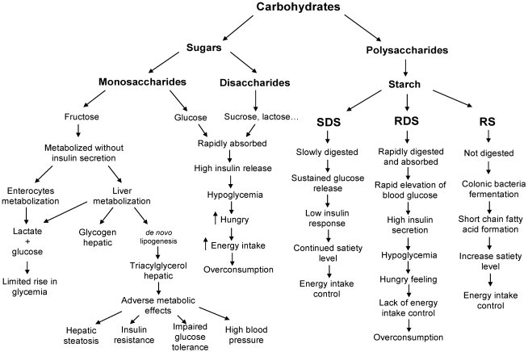
Table
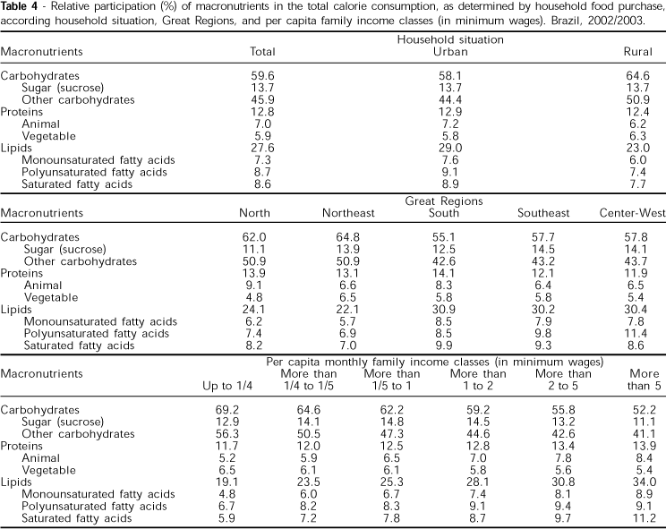
Figure graphics

Biology 12 - Chemistry of Carbohydrates - Section 2-5 and 2-6
- 1. UNIT A: Cell Biology Chapter 2: The Molecules of Cells: Sections 2.5, 2.6 Chapter 3: Cell Structure and Function Chapter 4: DNA Structure and Gene Expression Chapter 5: Metabolism: Energy and Enzymes Chapter 6: Cellular Respiration Chapter 7: Photosynthesis
- 2. In this chapter, you will learn how basic chemistry is used in biology. What life processes might be affected by a problem with protein structure? How are biological molecules involved in energy use in the body? UNIT A Chapter 2: The Molecules of Cells TO PREVIOUS SLIDE Chapter 2: The Molecules of Cells
- 3. 2.5 Carbohydrates Carbohydrates function as a supply of energy and have a structural role in some plants and animals. •Characterized by the presence of the group of atoms H C OH in a ratio of H atoms to O atoms that is− − approximately 2:1 •There are many types of carbohydrates in the cell, and they are often categorized as simple carbohydrates and complex carbohydrates. UNIT A Chapter 2: The Molecules of Cells Section 2.5 TO PREVIOUS SLIDE
- 4. Simple Carbohydrates A carbohydrate with three to seven carbon atoms is called a simple sugar or monosaccharide. •Pentose means a 5-carbon sugar •Hexose means a 6-carbon sugar •Glucose is a hexose sugar that our bodies commonly use as an energy source. Other common hexoses are fructose and galactose, which have the same molecular formula but the ring structures and atom arrangements differ. Figure 2.12 Three ways to represent the structure of glucose. UNIT A Chapter 2: The Molecules of Cells Section 2.5 TO PREVIOUS SLIDE
- 5. Simple Carbohydrates Disaccharides contain two monosaccharides joined by a dehydration reaction. •Maltose forms from two glucoses. We have digestive enzymes that break the bond between them. •Sucrose (table sugar) forms from glucose and fructose. •Lactose (in milk) forms from glucose and galactose. Figure 2.13 Synthesis and degradation of maltose (a disaccharide). UNIT A Chapter 2: The Molecules of Cells Section 2.5 TO PREVIOUS SLIDE
- 6. Complex Carbohydrates Polysaccharides contain many monomers linked together. •Polysaccharides can have the same monomers but are linked together differently. Starch is a storage form of glucose in plants. It has very long chains of glucose and fewer side chains than glycogen. It is found in foods (e.g., potatoes and bread). Figure 2.14 Starch structure and function. UNIT A Chapter 2: The Molecules of Cells Section 2.5 TO PREVIOUS SLIDE
- 7. UNIT A Chapter 2: The Molecules of Cells Section 2.5 TO PREVIOUS SLIDE Glycogen is a storage form of glucose in animals. It has very long chains of glucose and more side chains than starch. •The liver stores glucose as glycogen. Between meals, the liver releases glucose to help keep glucose levels constant. Glycogen Figure 2.15 Glycogen structure and function.
- 8. UNIT A Chapter 2: The Molecules of Cells Section 2.5 TO PREVIOUS SLIDE Figure 2.16 Cellulose structure and function. Cellulose is a polymer of glucose that is found in plant cell walls and acts as a structural component. •The glucose molecules are linked together in a different manner than in starch and glycogen. This difference means we cannot digest cellulose. Instead, it passes through the digestive tract as fibre. Cellulose
- 9. UNIT A Chapter 2: The Molecules of Cells Section 2.5 TO PREVIOUS SLIDE Check Your Progress 1. Identify the structural element that all carbohydrates have in common. 2. Explain why starch in plants is a source of glucose for our bodies, but cellulose in plants is not.
- 10. UNIT A Chapter 2: The Molecules of Cells Section 2.5 TO PREVIOUS SLIDE
- 11. 2.6 Lipids Lipids are a diverse group of molecules that contain more energy per gram than any other biological molecule. •Lipids include fats (e.g., butter) and oils (e.g., corn oil), which are energy storage molecules in organisms •Lipids include phospholipids, which are the main components of cell membranes •Lipids include steroids such as the sex hormones •Although lipids are structurally and functionally diverse, they have one common feature: they are all hydrophobic UNIT A Chapter 2: The Molecules of Cells Section 2.6 TO PREVIOUS SLIDE
- 12. Fats and Oils Fats tend to be from animals and are solids at room temperature (e.g., butter). Oils are usually from plants and are liquid at room temperature (e.g., corn oil). Fats and oils form when a glycerol molecule reacts with three fatty acids. A fat molecule is often called a triglyceride. Figure 2.17 Synthesis and degradation of a triglyceride. UNIT A Chapter 2: The Molecules of Cells Section 2.6 TO PREVIOUS SLIDE
- 13. Fats and Oils Fats and oils are hydrophobic but can disperse in water when an emulsifier is added. •Emulsifiers have a nonpolar end and a polar end. They position themselves around an oil or fat droplet so that the nonpolar ends project inward and the polar heads project outward. •Dispersion of fats and oils in water is called emulsification. An example is the use of soap (an emulsifier) when cleaning dishes or clothes. •Bile, produced in the liver, emulsifies fats in the intestine. UNIT A Chapter 2: The Molecules of Cells Section 2.6 TO PREVIOUS SLIDE
- 14. Saturated, Unsaturated, and Trans-Fatty Acids Fatty acids contain hydrocarbon chains that end in the functional group COOH.− •Saturated fatty acids do not contain double bonds; these fats are solid at room temperature •Unsaturated fatty acids contain one or more double bonds; these oils are liquid at room temperature •Trans-fats have trans double bonds; they are often produced chemically and occur in processed foods UNIT A Chapter 2: The Molecules of Cells Section 2.6 TO PREVIOUS SLIDE Figure 2.18 Comparison of saturated fats, unsaturated fats, and trans-fats.
- 15. Phospholipids Phospholipids are similar to fats except they have a polar phosphate head group instead of a third fatty acid. •One part of the molecule is polar (hydrophilic) and the rest is nonpolar (hydrophobic) •In an aqueous environment they spontaneously form a bilayer •They form the bilayer of cell membranes UNIT A Chapter 2: The Molecules of Cells Section 2.6 TO PREVIOUS SLIDE Figure 2.19 Phospholipids form membranes.
- 16. Steroids Steroids are a type of lipid that has a structure that consists of a backbone of four fused carbon rings. •Different steroids have different arrangements of atoms in the rings and different functional groups. •Cholesterol is a steroid formed by the body and also consumed in food. It is a component of the plasma membrane and a precursor for other steroids, such as testosterone and estrogen. Figure 2.20 Steroids. UNIT A Chapter 2: The Molecules of Cells Section 2.6 TO PREVIOUS SLIDE
- 17. UNIT A Chapter 2: The Molecules of Cells Section 2.6 TO PREVIOUS SLIDE Check Your Progress 1. List the two types of lipid molecules found in the plasma membranes of animal cells. 2. Compare unsaturated fats to saturated fats.

Toc graphics
