Personalised Rejuvenation in Aesthetic Medicine using PRGF-Endoret (Plasma Rich in Growth Factors-Endogenous Regenerative Technology) and Endoret Gel. By Dr Lisa Godfrey BDS, FFD RCS, MClinDent(Pros), MSc Aesthetic Medicine.

PRGF-Endoret is a unique platelet rich plasma (PRP), which has been formulated by BTI-Biotechnology. PRGF is completely autologous. It is a concentration of platelets in plasma obtained from a patient’s blood, then used as a treatment for the same patient. PRPs are a rich source of growth factors and other important biological proteins promoting angiogenesis, chemotaxis, cell proliferation and differentiation. PRPs have been researched and used in various fields of medicine and has emerged as a novel treatment modality. PRGF has been shown to have an anti-ageing effect by improving skin quality, reversing sun damage, protecting against sun damage, reducing wrinkles, improving skin hydration, laxity and regenerating skin tissue by enhancing activity of skin fibroblasts and promoting autologous production of hyaluronic acid, collagen and elastin. There is also evidence to suggest that it is effective in the treatment of hair loss conditions by promoting hair regrowth.

Endoret Gel is a new autologous, bioactive skin volume enhancer easily made from PRGF with a great lifting and volumising capacity and the ability to reduce wrinkles as well as encouraging regeneration of the soft tissues. It stimulates the production of hyaluronic acid and collagen and has adaptable biomenchanical properties according to different indications and integrates naturally into the tissues.

The aim of the presentation will be to learn how PRGF and Endoret Gel are obtained and the applications of both products as an effective anti-ageing, regenerative treatment, where and when to use both products and case studies demonstrating the beneficial effects along with scientific studies and the positive effects at a cellular level.

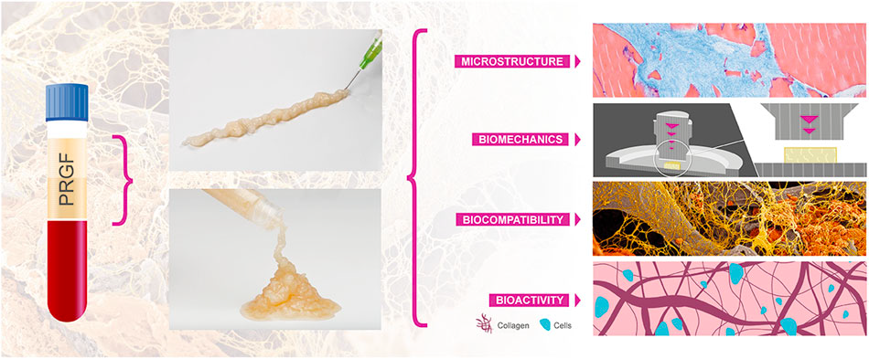
Fig 1 Demonstrating PRGF and properties of Endoret Gel

Recent Publications

Anitua E, Sanchez M, Zalduendo MM, de la Fuente M, Prado R, Orive G and Andia I. Fibroblastic response to treatment with different preparations rich in growth factors. Cell Prolif 2009;42:pp162-170

Anitua E, Pino A, Jaen P and Orive G. Plasma Rich in Growth Factors Enhances Wound Healing and Protects from Photo-oxidative stress in Dermal Fibroblasts and 3D skin Models. Current Pharmaceut Biotech 2016;17:pp1-14

Anitua E, Pino A, Martinez N, Orive G and Berridi D. The Effect of Plasma Rich in Growth Factors on Pattern Hair Loss: A Pilot Study. Dermatol Surg 2017;0:pp 1-13

Anitua E, Pino A, Troya M, Jaen P and Orive G. A Novel Personalised 3G Injectable Protein Scaffold for Regenerative Medicine. J Mater Sci: Mater Med 2018; pp 29

Diaz-Ley B, Cuevas J, Alonso-Castro L, Calvo MI, Rios-Buceta L, Orives G, Anitua E and Jaen P. Benefits of plasma rich in growth factors (PRGF) in skin photodamage: Clinical response and histological assessment. Dermatol Therapy 2015;pp1-6

