Thermal aging can be induced by decrease of lipogenesis in heat-stimulated adipocytes

Hyuk Chul Kwon *, Chun Mong Lee, Kwang Sik Lee, Kun Kook Lee
Songpa R&D Center, Coreana Cosmetics CO.,Ltd, 6, Samgok 2-gil, Seonggeo-eup, Seobuk-gu, Cheonan-si, Chungcheognam-do, 31041, Republic of Korea
* corresponding author. E-mail address: gurcjf@coreana.co.kr (H.-C. Kwon)

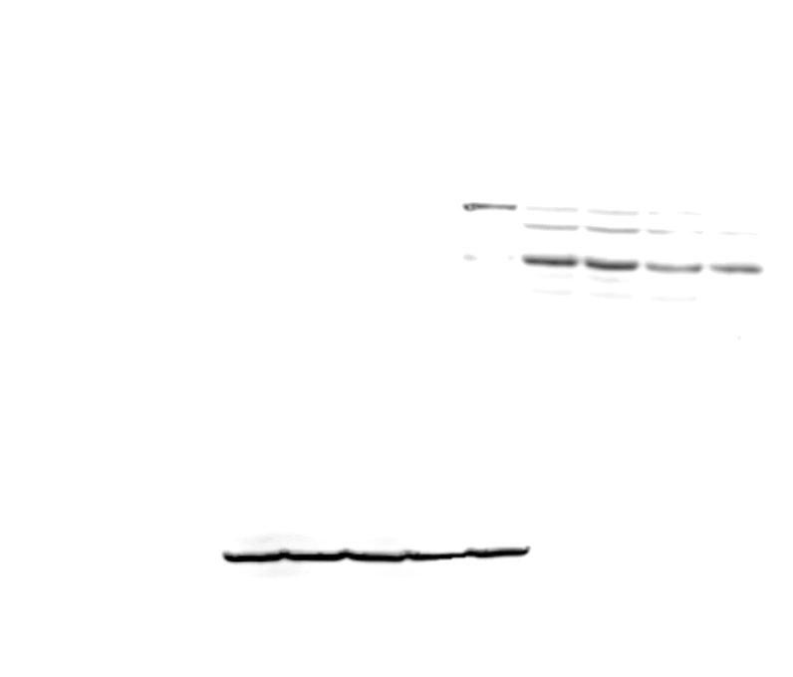


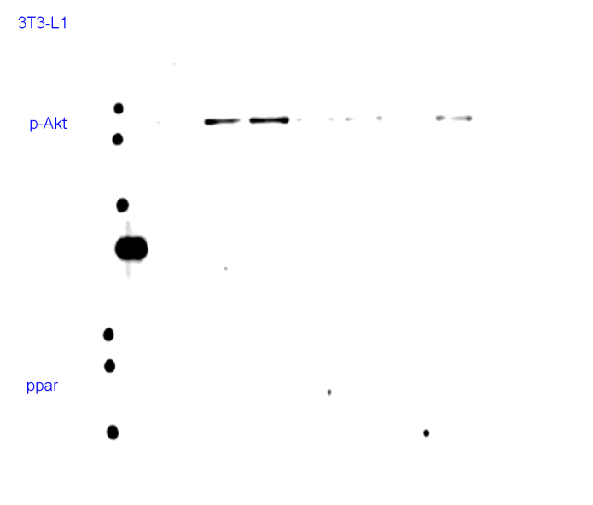
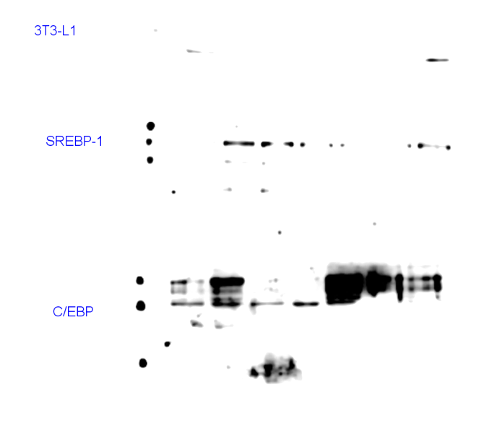
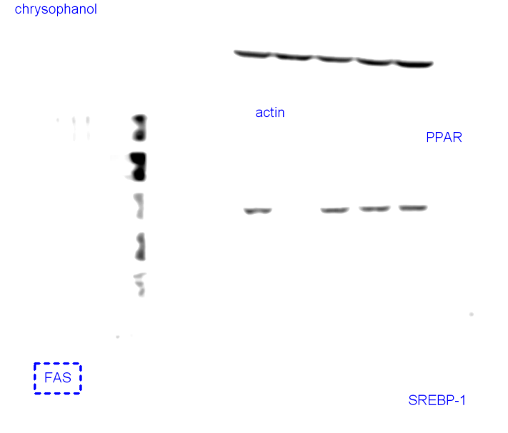
ABSTRACT
C/EBPα
actin
Con
40℃
42℃
44℃
D
PPARγ
C/EBPα
actin
Con
D
44℃
(B)
F
K
PPARγ
C/EBPα
actin
Con
D
44℃
* Adipocytes were co-culture in serum free DMEM with heat treated keratinocyte or fibroblast
D : Differentiation 5day
K : heat treated human keratinocyte
F : heat treated human fibroblast
(C)
(A)
Skin aging can be divided into intrinsic or chronologic aging and extrinsic aging. Extrinsic factors are caused by outside influences such as UV, heat, pollution, and smoke. Heat from infrared (IR) radiation during sun exposure increases skin temperature. IR radiation is classified as IR-A (760–1400 nm), IR-B (1400–3000 nm), and IR-C (300 nm–1 mm). IR-A penetrates deep into subcutaneous tissues, whereas IR-B and -C are mostly absorbed by the epidermis. excessive sun exposure increases skin temperature and can lead to thermal and photo-aging. a previous study reported that UV exposure to human skin and photo-aging process reduce the lipid synthesis in the SC fat tissue. However little is known about the relationship between heat induced by IR radiation and lipid biosynthesis in adipocytes. this study investigated the expression of factors involved in lipid biosynthesis in adipocytes exposed to heat. we found that C/EBPα, differentiation marker of adipocyte, was decreased by heat treatment in a temperature-dependent manner. also, peroxisome proliferator-activated receptor γ (PPARγ), which is an important transcription factor in the development and function of the adipose tissue, was decreased by heat. furthermore, the treatment of the differentiated adipocytes with the conditioned media of heat-irradiated keratinocytes or fibroblast reduced C/EBPα and PPARγ levels. These results suggest that The lipid synthesis in the fat layer is reduced by heat, and the fat layer is thinned, causing heat aging.
IMAGE

Figure 1) lipogenesis was decreased by heat in adipocytes. (A) after treatment in a temperature-dependent manner, C/EBPα protein level was analyzed by western blotting. (B) cell lysates were analyzed by western blotting for PPARγ and C/EBPα. (C) Differentiated adipocytes were co-cultured in serum-free DMEM with heat-irradiated keratinocytes or fibroblast.
REFERENCE
- Eun Ju Kim, et al (2010) UV decreases the synthesis of free fatty acids and triglycerides in the epidermis of human skin in vivo, contributing to development of skin photoaging. 57(1):19-26
- Eun Ju Kim, et al (2011) UV modulation of subcutaneous fat metabolism.131(8):1720-6
- Park CH, Lee MJ, Ahn J, et al. Heat shock-induced matrix metalloproteinase (MMP)-1 and MMP-3 are mediated through ERK and JNK activation and via an autocrine interleukin-6 loop. 123:1012–1019
- Gretchen J. Darlington, Sarah E. Ross, Ormond A. MacDougald (1998) The Role of C/EBP Genes in Adipocyte Differentiation 13;273(46):30057-60
- Songbai Lin, et al (2006) Leptin Increases Tissue Inhibitor of Metalloproteinase I (TIMP-1) Gene Expression by a Specificity Protein 1/Signal Transducer and Activator of Transcription 3 Mechanism 20(12): 3376–3388


Biography
Mr.kwon works in Coreana Cosmetics , which cosmetic company in korea. He is mainly responsible in-vitro effect test about material of cosmetic such as aging, whitening, and acne. Coreana Cosmetics is one of the representative companies of Korean cosmetics. Based on the creation of beauty through nature, It is exported to 20 countries, and LAVIDA, 자인(ZAIN) and CELLENIQUE are the representative brand
Email: gurcjf@nate.com

Notes/Comments:

