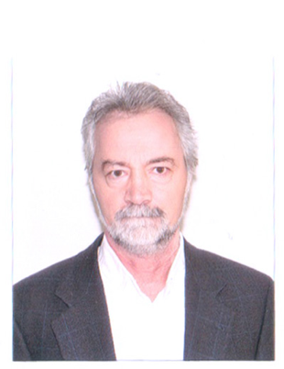

Title: CELLULAR AUTOPHAGY – TREATMENT TARGET FOR THE AGING PROCESS
Aurel Popa-Wagner
Department of Neurology, Chair of Vascular Neurology and Dementia, University of Medicine Essen, Germany
E-mail: aurel.popa-wagner@geriatrics-healthyageing.com

As life expectancy increases, there is an ever growing interest in preventing these diseases and multiple studies are looking for the answer to a healthy aging. Recently, several studies have focused on various aspects of ageing and autophagy. Cellular autophagy plays an important role in cytoprotection and in maintaining cellular homeostasis by preventing accumulation of toxic proteins and by eliminating pathogens. We hypothesized that pharmacological stimulation of autophagy may lead to partial regeneration of aged tissues and may stimulate healthy aging from a cognitive, as well as a functional point of view. Our objective was to assess the efficacy of the drug SPT100 to extend life and improve cognitive function and spatial memory (Water-Maze) and motor function (Rotor-Rod), by stimulating autophagy processes at tissue and cellular level in the brain and the liver through transcriptomic, genomic, proteomic and imunohistochemical methods. We found that treatment with SPT100 did not extend the life span of aged rats. However, SPT100 improved the cognitive and motor functions of the aged rats, as assessed with Elevated Plus maze, Latency Curiosity Test and Forced Swim. This compound has also promising anti-inflammatory and anti-apoptotic effects on the central nervous system. We hypothesized that long-term treatment with SPT100 could reduce gene expression of various inflammation markers, including: C11, CR3, Tgfb, Cxcl10, CXCR4, Fcgr3a and Stat. Thus, by RT–PCR, we found significant decreases in the expression of mRNA coding for inflammation and astroglial markers. These results may offer a basis for further studies regarding the protective mechanisms of autophagy stimulation on the aging process.

Biography

Dr. Popa-Wagner has completed his PhD at the age of 31 years from University of Karlsruhe postdoctoral studies from University of Southern California. In 2012, he joined the the Department of Psychiatry, University of Medicine, Rostock, Germany and from 2017 he joined the Chair of Vascular Neurology and Dementia at the Clinic of Neurology, Medical University, Essen, Germany. He has published more than 120 papers in reputed journals and has been serving as an Associate Editor for several journals and editorial board member of repute for many journals.
Presenting author details
Full name: Aurel Popa-Wagner
Contact number: +4915202946197
Twitter account:
Linked In account:
Session name/ number: Longevity and medicine
Category: Oral presentation

