Title: The Impact of Arsha Vidya Programs on the Health and Functioning of Older Adults
Swami Brahmaparananda Saraswati, Arsha Vidya, Jaipur
Neha Sharma, Warwick Research Services, UK

Abstract (300 word limit)
A number of studies have investigated the therapeutic effects of religion and spirituality, but these have typically been uncontrolled, often focused on patients, and usually concerned with one or a limited number of areas of impact. Arsha Vidya programs are accessible to communities around the country, in urban and rural areas alike, making feasible to follow.
Present study assessed the impact of Arsha Vidya community-based spiritual program on the physical, mental and social wellbeing of elderly.
Methods: The data used in these analyses were from a site-specific subsample of ongoing longitudinal study involving three study sites. Eighty-six older adults aged 60 and over from Rajasthan, India were recruited. Participants were randomly assigned to either an intervention (Arshavidya activity) or comparison (usual activity) group. Self-reported assessments of general physical health, Philadelphia Geriatric Center Morale Scale, the Loneliness Scale-III and self-recorded engagement in social activities were taken at baseline and repeated at 6 months.
Results: Assessment questionnaires and self-reported measures were used. There wasn’t any significant difference in demographic or baseline measures between two groups. Post assessment showed significant difference between groups in overall physical health (p<0.001), mental health (p<0.0001) and social activities (p<0.001). The intervention group had better morale and less loneliness, whereas comparison group had a significant decline in social activities (p<0.05).
Implications: The positive impact of spiritual activities for older adults in this study had better overall health, morale, and activities.

Image
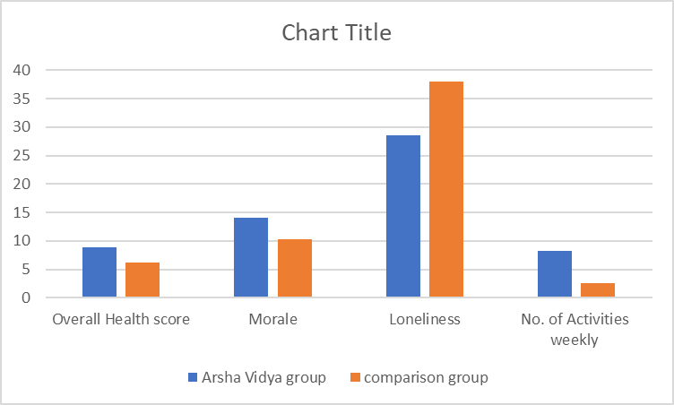
Recent Publications:
- Blazer, D. (1991). Spirituality and aging well. Generations, xv(1) pp. 61-66.
- Clingan, Donald F. 1995. "Aging: Gathering a spiritual perspective." Center for Aging Religion & Spirituality CHRONICLE. [http://www.luthersem.edu/cars/newsletters/FRSTNEWS.
- Lee, Ramonia L. 1992. "Healing connections: Ethnic perspectives on spirituality and mental health." Aging & Spirituality. [http://www.asaging.org/networks/forsa/a&s92.html]
- Waxman, B.F. (1999). Nature, spirituality and later life in literature: An essay on the Romanticism of older writers. Gerontologist, 39 (5) pp. 516-524.

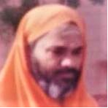
Biography (150 word limit)
Swami Brahmaparananda Saraswati has been mentor and leader in Arshavidya Tirtha, Jaipur, India. He has been working for two decades to combine Indian spirituality with modern world. Social reform and spreading the true sense of Indian spirituality, religion and ethics given a prominent place in his aims and he specific activiities for elderly, children and families. He has been co-authored in international collaborative research studies and published several books.

Presenting author details
Full name: Swami Brahmaparananda Saraswati
Personal email id: nmpmedicalresearch@gmail.com
Mobile Number: :+91 9414042292
Category: (Poster presentation)

