Title: The Aging Surgeon
Edward A Luce, MD, Memphis, TN USA

Abstract
Considerable emphasis has been placed contemporaneously on quality control in medical care and, more specifically, on physician maintenance of professional competence. Inevitably, this emphasis will focus on the aging physician in general and the surgeon in particular. The important question must be posed: When should surgeons retire? The obvious answer is when loss of competency occurs, but how is that loss determined?
The presentation will summarize the relatively little data available, give the results of a focused survey of 21 senior surgeons (average age 71), draw parallels between the aviation industry, and offer some recommendations for further study.

Recent Publications:
- Dellinger EP, Pellegrini CA, and Gallagher TH, “The Aging Physician and the Medical Profession A review”, JAMA Surg. (2017); 152: 967.
- Sataloff RT, Hawkshaw M, Kutinsky J, and Maitz EA, “The aging physician and surgeon.” Ear Nose Throat J. (2016 Apr-May); 95(4-5):E35-48.

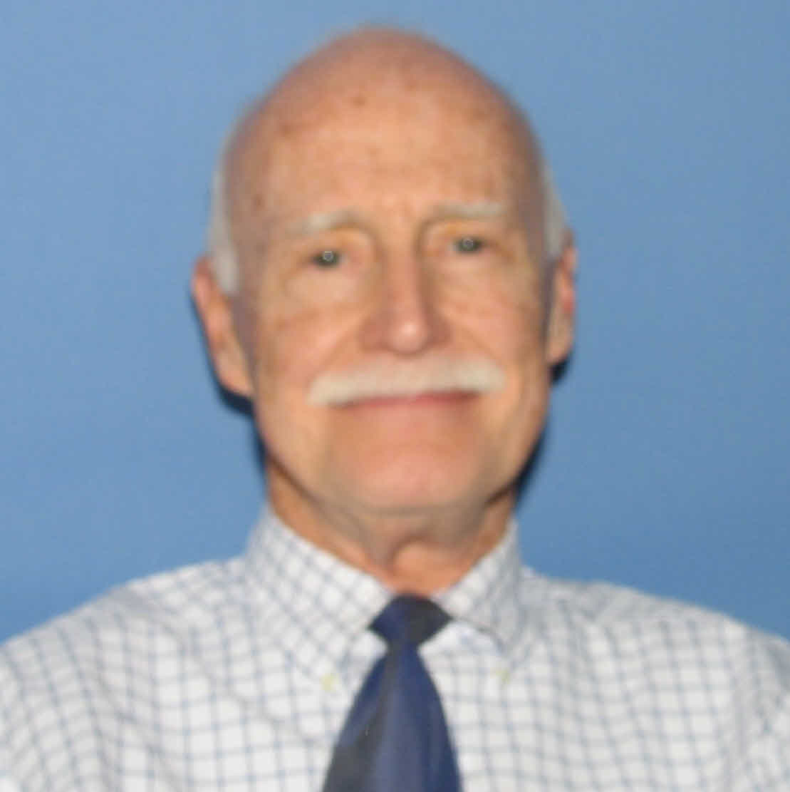

Biography
Dr. Edward Luce is a professor of plastic surgery at the University of Tennessee. His past positions include chairman of plastic surgery at the University of Kentucky and Case – Western Reserve. Offices held include the chairman of the American Board of Plastic Surgery (ABPS), the organization that grants board certification, President of the American Society of Plastic Surgeons (ASPS), American Association of Plastic Surgeons (AAPS), American Society of Maxillo-Facial Surgeons (ASMS) as well as the American Council of Academic Plastic Surgeons (ACAPS). Dr. Luce is in active practice in Memphis, TN.

Presenting author details
Full name: Edward A. Luce, MD
Personal email id: edluce@yahoo.com
Mobile Number: 901-517-7122
Telephone Number: n/a
Twitter account: n/a
Linked In account: n/a
Session name/ number:
Category: Oral presentation

Notes/Comments:

