Title: Women, Care giving and Social Support for the Aged: The Nigerian Perspective and Its Counselling Implication
Beatrice Ifeoma Ajufo, PhD, National Open University of Nigeria, Nigeria
Beatrice Ifeoma Ajufo, PhD, National Open University of Nigeria, Nigeria

Abstract
Nigerian population has always been described as ‘’ youthful population’’ but with gradual increase in the elderly population from 6.4 million in 2005 to 11.5 million in 2025 and 22.5 million in 2050 really calls for concern especially with no social security policies for them on ground by the Government. While most of the western world has accepted that the ageing of the population constitutes a vital public issue, in Nigeria the issue of the aged and their care has been regarded as personal problems falling under the expectation that the extended family will take care of its elderly members. However extended family system is diminishing and fast fading out. This study therefore sought to find out how much satisfaction the elderly are receiving from different categories of family members and friends. A cross- sectional descriptive study was carried out among retirees . Two research questions were generated for the study. Instrument for data collection was self – developed validated questionnaire. Frequencies, percentages, means and standard deviation were used in data analysis. The findings revealed that the elderly people who feel satisfied with the support and care they receive from members of the family and friends (especially from their daughters) see ‘Old Age’ as a happy period. The findings therefore revealed that there is paradigm shift from the care of the aged by the extended family to the nuclear family especially adult daughters. Based on these findings, it was recommended among other things that structures should be put in place to promote and improve family relationship and appropriate legislation should be introduced to provide some measure of social services .The counselling implication was also discussed.
Keywords: Caregiving, Social Support, Aged, Perspective, Counselling implication

Image

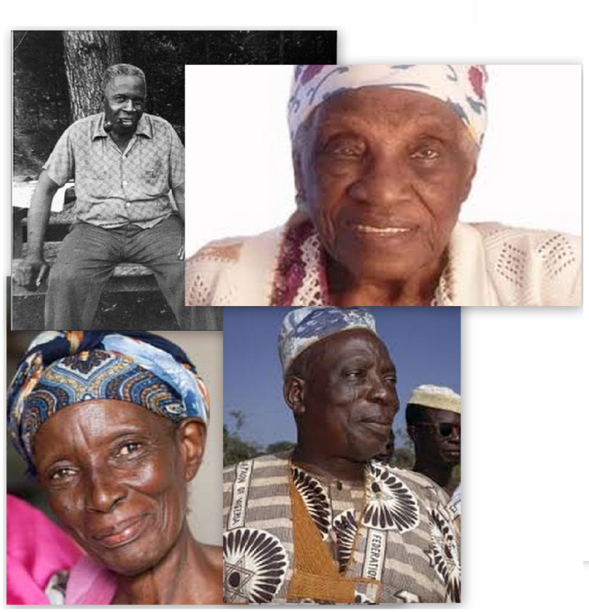

A picture showing some aged Nigerians
References/Bibliography:
- Idris S.H., Ibrahim M. J., Sufyan M.B. A and Oladpo .I.A (2012) Health problems and pattern and pattern of care for elderly people in rural Nigeria. Asian .J . Gerontol Geriatr7 (2) 115
- Mudiare . P. E.U. (2013) Abuse of the Aged in Nigeria: Elders Also Cry. American International Journal of Contemporary Research Vol 3 No.9
- Shofoyeke A.D and Amosun P.A. A survey of care and support for the Elderly People in Nigeria, Mediterrean Journal of social sciences , MCSER , Publishing , Rome – Italy Vol 5 No33
- Youg Tong (2008) Social Support of elderly caregivers. International Journal of Business and Management Vol 3, No . 8
- The World Bank , author, Nigeria ( internet) Washington DC: The world bank ; 2015 ( cited 2016 Aug 31) Available from http: data. Worldbank.org/country/Nigeria

 Biography
Dr Beatrice Ifeoma Ajufo was born May 9, 1964 . She holds a PhD in Counselling Psychology from University of Ibadan, Ibadan, Oyo – State, Nigeria. She is an Associate Professor of Counselling Psychology in the Faculty of Education, National Open University of Nigeria. Her teaching career spans over three decades. She has many scholarly publications in local and international journals to her credit. She is a recipient of many awards as a result of her contributions to national development in the sphere of education. Dr Beatrice Ajufo is a member of APA ( American Psychological Association) and several other professional bodies. Dr Ajufo has attended many conferences, seminars and workshops within and outside the country.
.

Presenting author details
Full name: Beatrice Ifeoma Ajufo
Personal email id: ifyajufo@yahoo.co.uk
Mobile Number: +2348034103357s
Telephone Number:
Twitter account:
Linked In account::
Session name/ number:
Category: (Oral presentation/ Poster presentation): Oral presentation

Notes/Comments:

