Title: Active Aging by age, sexo, and years of education in a sample of Mexican older adults

Bertha C. Salazar¹, PhD. Martha E. Salazar², Doctoral student, Esther C. Gallegos¹, PhD, Perla L. Hernández¹, DNS

1 Universidad Autónoma de Nuevo León

2. Universidad Autónoma de Tamaulipas

Abstract (300 word limit)
Statement of the Problem: Population aging is considered a successful of humanity by international organizations. But at the same time it is likely that older adults suffer from one o more chronic diseases imposing challenges to older adults, families, and society. Efforts are needed to maintain older adults health and active as much as possible. The purpose of this paper is to describe active aging according to sex, age, and years of school in a sample of Mexican older adults from Matamoros, Mexico. The data are part of a bigger study. Methodology & Theoretical Orientation: A descriptive design was used with 200 older adults. A non probabilistic sampling was used. Participants were recruited through referrals of principal investigator's university colleagues. It was assured that that participants with more than 14 years of education were also recruited to seek for differences by years of school. Active aging was measured by basic and instrumental activities of daily living, Yesavage depression short scale, Pffeifer mental state questionnaire and one question perceived health. Cutoff point were establish for each measurement and sum to dichotomized
into active aging or not. Additional questions were time spent in physical activities, and as volunteer work. Findings: Most of participants (190; 95%) presented a chronic disease. One hundred two participants qualified in active aging (physical independent, free of depressive symptoms, good mental state and perceived their health as good or excellent. Only 21% (42) said they walked 120 minutes or more weekly, 14% (80) used a treadmill or stationary bike and 53% (106) were involved in volunteer work. Conclusion & Significance: Those with less age, women and more years of education showed higher proportions of active aging. Recommendations are made to different health professional to develop programs involving older adults in different activities to promote active aging.

Active Aging: Cuttoff points
Measurements | Items | Values | Active Aging
Katz Index of Independence in Activities of Daily Living | 6 | 0-6 | 6 points
Lawton-Brody Instrumental Activities of Daily Living (IADL) Scale | 8 | 0-8 | Female  8 points | Male  5 points
Short Portable Mental Status Questionnaire Pfeiffer | 10 | 0-10 | ≥ 9 points (1error)
Perception of Health | 1 | 1-4 | ≥ 3 points

Recent Publications:
- Fernandez-Ballesteros R., Robine J., Walker A, Kalache A. (2013). Active Aging: A Global Goal. Current Gerontology and Geriatrics Research, 4, 1-4. http://dx.doi.org/10.1155/2013/298012
- Fernández-Ballesteros R., Caprara, J. M., Iñigueza G. & Garcia, L.F. (2005). Promoción del envejecimiento activo: efectos del programa «Vivir con vitalidad”. Revista Española Geriatría Gerontológica; 40(2), 92-102.
- Pillemer. K., Moen. P., Wethington. E., & Glasgow, N. (2000). Social integration in the second half of life. Baltimore MD: Johns Hopkins University Press
- Troutman, M., Nies, M., Small, S & Bates, A. (2011). The development and testing of an instrument to measure successful aging. Research in Gerontological Nursing, 4(3): 221-232. DOI: 10.3928/19404921-20110106-02
5. World Health Organization. Active Ageing: A policy framework. (2002) http://www.who.int/ageing/publications/active_ageing/en/
6. World Health Organization. (2015). World report on aging and health. http://apps.who.int/iris/bitstream/10665/186466/1/9789240694873_spa.pdf

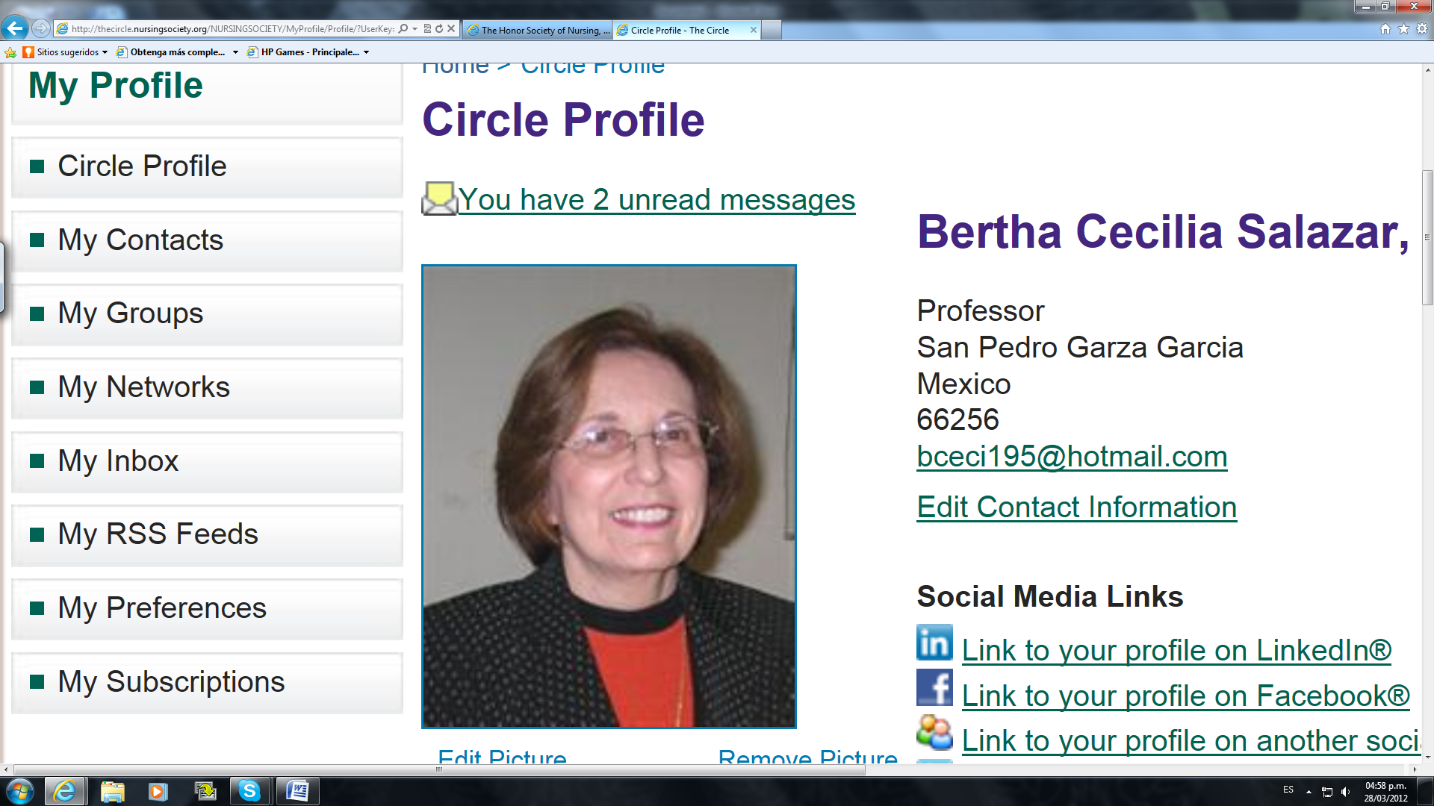

Headshot photograph
Biography (150 word limit)
Bertha C. Salazar is full time professor in the graduate program of the Nursing School of Universidad Autonoma de Nuevo Leon, Monterrey Mexico. Teaches Philosophy and Knowledge Construction of Nursing and serves as Chair for master and doctoral students in Nursing Science. Research interest is older adult´s functionality, particularly physical exercise and cognitive interventions to improve gait parameters and cognitive function. Currently developing an intervention aimed to improve everyday memory of older adults. She belongs to the National System of Researchers (Sistema Nacional de Investigadores), Consejo Nacional de Ciencia y Tecnología of México.
Email: bceci195@hotmail.com

Notes/Comments:

