Title: Factors associated with ketamine use in pancreatic cancer patient in a single hospice center
Kyung min Kwon, MD, St.Mary’s hospital, South Korea

Abstract (300 word limit)
Purpose : Up to 90% of pancreatic cancer patient suffer from neuropathic pain. In palliative care setting, pain control in pancreatic cancer patient is one of the major goals. Ketamine is a NMDA receptor antagonist effective in neuropathic pain. Also there have been studies about opioid sparing effect of ketamine. This study was held in palliative care unit among pancreatic cancer patients to find out the factors related to ketamine use and the opioid sparing effect.
Methods : Medical records of pancreatic cancer patients admitted to St.Mary’s hospital palliative care unit from 2013.1 to 2014.12 were reviewed. Patients were divided in to 2 categories according to ketamine use. Also opioid use before and after ketamine use was compared in ketamine group.
Results : Compared to non ketamine use group, patients in ketamine group required higher dose of opioid. Total opioid dose, daily opioid dose, number of daily rescue medication, daily average rescue dose were statistically significantly higher in ketamine group. Opioid requirement was increased after ketamine administration.
Conclusion : In this study, ketamine group required more opioid. Ketamine is frequently considered in patients with severe pain, requiring high amount of opioid. Also ketamine did not have a opioid sparing effect. Future studies about palliative use of ketamine in larger number of patients are required.

Recent Publications:
- 1. Inverse association between total bilirubin and metabolic syndrome in rural korean women. Kwon KM, Kam JH, Kang HT., J Womens Health (Larchmt). 2011 Jun

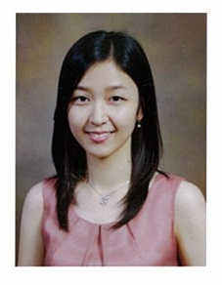

Headshot photograph
Biography (150 word limit)
Dr. Kyung min Kwon has Graduated from Yonsei wonju college of medicine of Korea as Medical Doctor, currently a house staff in in St.Mary’s hospital family medicine department as a clinical fellow. She also is involved in palliative care, taking care of advanced cancer patients. Studing in St.Mary’s hospital graduate school.

Email: kmkwins@naver.com

Notes/Comments:

