Mizell Senior Center: A Matter of Balance (MOB)
Casey Leier, PhD. HARC (Health Assessment & Research for Communities). USA, CA, Palm Desert.
Suzanne Spencer, Mizell Senior Center, USA, CA, Palm Springs.
Jack Newby, Mizell Senior Center, USA, CA, Palm Springs.

Abstract (300 word limit)

Background: Mizell Senior Center has run the successful, evidence-based, falls prevention program A Matter of Balance (AMOB) for many years. Recently, Mizell expanded to offer the AMOB class at additional locations throughout the Coachella Valley.

Methods: A participant survey was completed by AMOB participants to evaluate the impact of program. Participants tended to be older, as the median age was 80. Surveys were completed by participants at the beginning (n=266), end (n=277), and three-months after (n=25) the AMOB course. A Site Survey was also conducted in which each of the host sites were given the opportunity to provide feedback about their overall experience with the AMOB program. A total of eight sites completed the organizational survey.

Results from participant survey suggest that the AMOB program was beneficial to participants in a number of ways. First, participants increased their fall efficacy (or confidence) that they can both avoid falls and recover from falls. Qualitative interviews suggest many participants decreased their feelings of isolation. The three-month follow-up survey revealed that the majority of participants (83.3%) were continuing to take exercise classes. Finally, the majority of participants indicated they made some changes to their home, including: installing grab bars in the bathroom and removing objects from the floor. A Site Survey was also conducted and completed by all eight sites. Findings suggest that the majority of sites were satisfied with the AMOB program: most rated the experience as positive, would recommend the program to others, and plan to continue to host AMOB.
Image
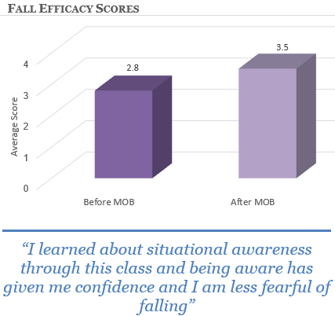
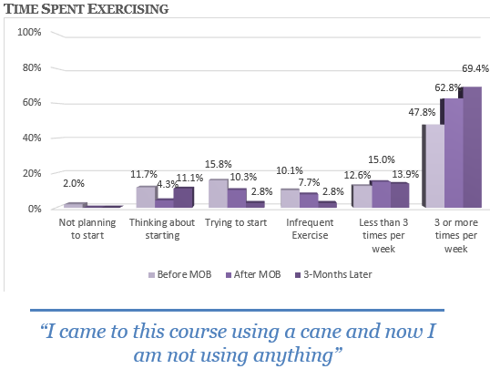

Recent Publications (minimum 5)
- HARC (Health Assessment and Research for Communities). (2016). Diabetes in the Coachella Valley. http://harcdata.org/wp-content/uploads/2016/09/HARC-Diabetes-Report_2013data.pdf
- HARC (Health Assessment and Research for Communities). (2016). Health of Uninsured Adults in the Coachella Valley. http://harcdata.org/wp-content/uploads/2016/09/HARC-Uninsured-Report_2013data.pdf
- HARC (Health Assessment and Research for Communities). (2016). Health of Children 0 to 10 in the Coachella Valley. http://harcdata.org/wp-content/uploads/2016/09/HARC_0-10-Child-Report.pdf
- HARC (Health Assessment and Research for Communities). (2015). Veteran Health in the Coachella Valley. http://harcdata.org/wp-content/uploads/2016/09/HARC-Veteran-Report_2013data.pdf

5. HARC (Health Assessment and Research for Communities). (2015). Mental Health in the Coachella Valley. http://harcdata.org/wp-content/uploads/2016/09/HARC-Mental-Health-Report_2013data.pdf

Biography (150 word limit)
Dr. Cassaundra Leier is the Director of Research and Evaluation for HARC (Health Assessment and Research for Communities). She is a researcher with over nine years of experience in research design and analysis. She holds a master’s degree in industrial/organizational psychology from California State University of San Bernardino and a doctorate in organizational communication from Arizona State University. Dr. Leier has conducted research related to individual well-being and workplace practices that foster positivity and creativity. Prior to working for HARC, Dr. Leier worked at Arizona State University teaching courses on a variety of different topics including leadership, conflict and negotiation, and advanced research methods.
Email: cleier@harcdata.org

