Title: Effective Aged Care Assessment: Wellness, Reablement, and Sector Sustainability.
Jason Diederich, B Sc (Occupational Therapy), APM, Melbourne Australia

Abstract (300 word limit)
In the last 2-3 years, Australia has embarked on a remarkable reform process for Aged Care services. The key goals are to achieve a consumer driven and market based national aged care system that is funded in a sustainable way based on need. This reform is essential to put choice and control in to the hands of the aged care consumer, as well as ensuring that the limited government funds available are allocated to those who need it most. A key component of this reform process, known as My Aged Care, is the introduction of new levels of assessment. The previous high level clinical based assessments (known as ACAT) have been supplemented by entry level non-clinical assessments (known as RAS). Services are also delivered in a two-tiered system for lower level and higher level care needs. Over time the plan is to integrate the non-clinical (RAS) and clinical (ACAT) assessments, but it is unclear how this will look. Whilst the clinicians currently delivering the clinical ACAT assessments also have the skills to deliver non-clinical assessments, this is not a good use of this expensive and increasingly rare resource. The non-clinical RAS assessments meet the needs of many older people who are after basic support services such as cleaning or transport, but what happens when they encounter someone with more complex needs?
This workshop will explore the Australian experience, and go in to more detail about the wellness and reablement approach used as part of the assessment itself. But will also seek input and share information from participants about different models of aged care assessment from the USA and around the world.

Aged Care Reform in Australia

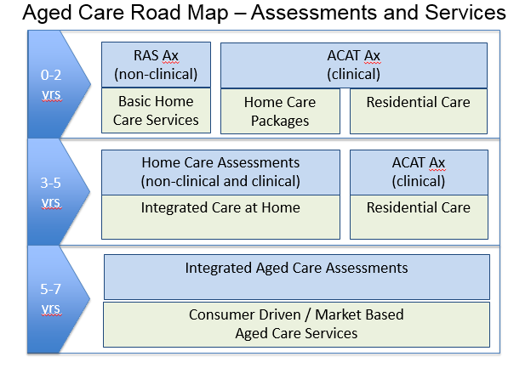

Recent Publications:
Aged Care Roadmap.
Australian Government, Department of Health, 2015.
https://agedcare.health.gov.au/aged-care-reform/aged-care-roadmap

Report on the Operation of the Aged Care Act 1997
Australian Government, Department of Health, 2016
https://agedcare.health.gov.au/publications-and-articles/reports/report-on-the-operation-of-the-aged-care-act-1997



Biography (150 word limit)
Jason Diederich is the General Manager of Aged Care Regional Assessment Services at APM, Australia’s largest private provider of aged care assessments. Part of the Australian Government’s MyAgedCare program, APM uses a wellness and reablement focus to identify the care needs of older Australians to allow them to remain at home for longer. Jason’s background in Occupational Therapy drives his holistic approach to the assessment process, underpinned by an understanding of the economic drivers of a sustainable aged care model. Based in Melbourne, Australia, Jason has managed a number of national assessment contracts on behalf of the Australian Government, as well as managing the operations of residential aged care and community care providers.
Email: Jason.diederich@apm.net.au

Notes/Comments:
I would welcome the opportunity to run a workshop where I can share information on the Australian experience of aged care needs assessments, and also canvas the input from participants as to other models used around the world.

