DNACPR: Can the GO-FAR score improve decision-making?
Dr Georgina Hicks MBBS BSc
Dr Thomas Pepper MBBS BDS
Chelsea and Westminster NHS Foundation Trust, London, UK

Abstract (300 word limit)
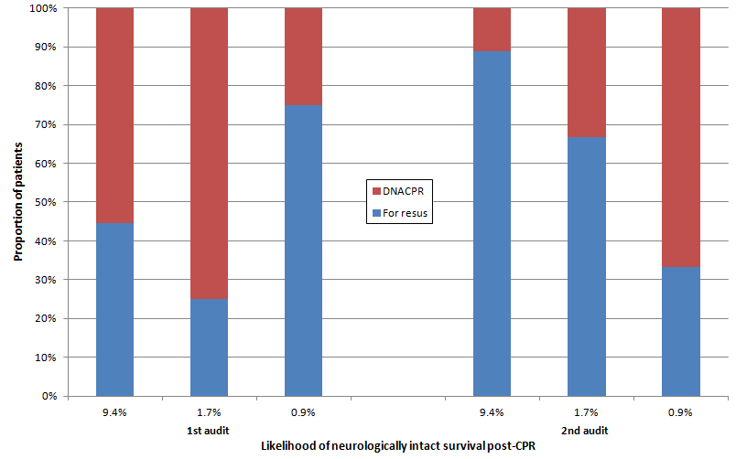
Statement of the Problem: Do Not Attempt CPR (DNACPR) decisions are commonly made in UK hospitals. Recent legislation¹ dictates that the decision be discussed with the patient or their relatives. Many patients and relatives have unrealistic expectations of CPR outcome², and it is essential that this is addressed in such conversations. We undertook two investigations of the appropriateness of resuscitation decisions based on a validated tool for predicting neurologically intact survival after in-patient CPR (Good Outcome Following Attempted Resuscitation, GO-FAR score)³.
Methodology: All patient records from a geriatric ward were reviewed on a single day. Information was collected regarding patient age, comorbidities and DNACPR decisions, and a GO-FAR score calculated. The process was repeated on a second day two months after reporting our initial findings to clinical staff.
Findings: 48 patients with a mean age of 73 years (SD±13) were included. Of the 25 patients in the initial study, 5/9 patients with a 9.4% likelihood of neurologically intact survival were DNACPR, 9/12 with a 1.7% likelihood were DNACPR, and 1/4 with a 0.9% likelihood was DNACPR. Of the 23 patients in the subsequent study, 1/9 patients with a 9.4% likelihood of neurologically intact survival was DNACPR, 3/11 with a 1.7% likelihood were DNACPR, and 2/3 with a 0.9% likelihood were DNACPR.
Conclusion & Significance: Following introduction of the GO-FAR score, a smaller proportion of patients with 9.4% and 1.7% likelihood of neurologically intact survival were made DNACPR (p=0.13 and 0.04 respectively), and a greater proportion of patients with 0.9% likelihood were made DNACPR (p=0.49). Introduction of the GO-FAR score influenced the practice of clinicians with varying significance. The score’s greatest utility may be in prompting consideration of resuscitation status for patients with <1% likelihood of neurologically intact survival, and facilitating an evidence-based discussion with the patient and their relatives.

Image

Recent Publications (minimum 5)
- Court of Appeal (2014) R (David Tracey) v (1) Cambridge University Hospitals NHS Foundation Trust (2) Secretary of State for Health.
- Van den Bulck JJ (2002) The impact of television fiction on public expectations of survival following inhospital cardiopulmonary resuscitation by medical professionals. Eur J Emerg Med 9:325-9.
- Ebell MH, Jang W, Shen Y, Geocadin RG (2013) Development and validation of the Good Outcome Following Attempted Resuscitation (GO-FAR) score to predict neurologically intact survival after in-hospital cardiopulmonary resuscitation. JAMA Intern Med. 173:1872-8.
- Oliver D. (2016) Resuscitation orders and reality. BMJ 352:i1494.
- Ohlsson MA, Kennedy LM, Ebell MH, Juhlin T, Melander O (2016) Validation of the good outcome following attempted resuscitation score on in-hospital cardiac arrest in southern Sweden. Int J Cardiol 221:294-7.

Biography (150 word limit)
Dr Georgina Hicks and Dr Thomas Pepper undertook their postgraduate medical degrees at King’s College London. Following graduation they worked as Foundation Doctors in London, gaining broad experience in geriatric wards specializing in heart failure and stroke, as well as other specialties.

Email: tom.pepper@outlook.com

Notes/Comments:

