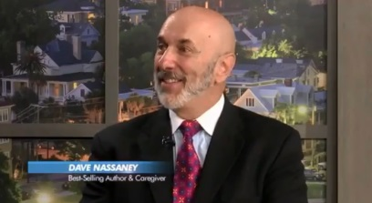 Speaker Abstract 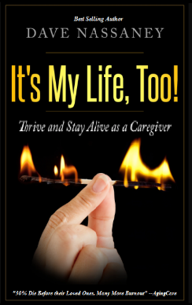

TITLE: AVOIDING CAREGIVER BURNOUT – A DEADLY OCCUPATION
INTEREST AREA / TRACK: Importance of Unpaid Family Caregivers/Elderly Care
SUB CATEGORY: Caregiver Burnout causing 30% to die before loved ones
KEYWORDS: Caregiver Burnout, Unpaid Family Caregiver, Caregiving,
LEVEL OF DIFFICULTY: Easy
TYPE OF PRESENTATION: Lecture, Workshop, Power Point, Panel Discussion.
LEARNING OBJECTIVES: Discuss the plight of the unpaid family caregiver, and how 30% of them are dying before their loved ones do. Many more become hospitalized – eventually needing a caregiver of their own. Discuss what can be done for caregivers to help them thrive, and not just survive. Discuss the necessity of healthcare professionals treating caregivers as a potential patient, and therefore asking them probing questions of their health and what medical, emotional and mental issues may be present.
ABSTRACT TEXT:
There are three huge mistakes that caregivers make that put them at a higher risk of dying or becoming hospitalized. Dave discusses tips on how they can thrive as a caregiver, and explains the importance of becoming involved in practical and actionable solutions to their situations including a caregiver support group.
Nobody in the healthcare industry is talking about the plight of the unpaid family caregiver, and how the entire healthcare industry would collapse if these “volunteers” suddenly had to be replaced with paid counterparts. It would cost the industry Billions of dollars, that’s why Dave calls it the “Caregiver Tsunami.” It is as dire an eventual catastrophe as is the Medicare crisis that is already here – too many patients requiring care – not enough workers paying into it. It is estimated that the Medicare Trust Fund has 8 more years of solvency before it goes broke. (Two more years if our law makers pass “Medicare for All.).”
Dave also discusses potential government models of states, like Hawaii, who has a Caregiver Respite payment of about $1500 a month that is paid to caregivers working a minimum of 30 hours a week to help with their respite, and other financial and personal obligations. People are living longer than ever before, and the Healthcare system, including Long-Term Care Insurance, is not equipped to handle it. There has to be a program to promote a National awareness in Congress and the White House about the “Caregiver Tsunami” that is coming very soon.

BIOGRAPHY:
Dave Nassaney is an entrepreneur and USC Business School graduate. He became a caregiver 23 years ago when his wife suffered a stroke that left her speech impaired and paralyzed on one side. He has had no formal training or certification in this field, however, his experience of a 2 to 3-year grief process with his wife almost caused them to break up. As a result, his caregiving experience gives him a unique perspective that cannot be duplicated with a degree or a certification in higher education. His first-hand “boot camp” experience has made him an expert on this topic.
www.CaregiverDave.com
Twitter: https://twitter.com/davecaregiver
Linked In: https://www.linkedin.com/in/david-nassaney-2793263a/

