Dr. Dalia Ata
- Masters Course in Face Thread Lifting, 2017
American Academy .
- Diploma in Aesthetic Medicine, 2016
American Academy.
- Deploma in Cutaneous Lasers 2011
Kaser El Aini faculty of Medicine – Cairo University
- Deploma inCosmetic Dermatologic Surgery 2011
Kaser El Aini faculty of Medicine – Cairo University
- Master in Dermatology, 2010
Tanta University.
- BSC of Medicine, 2002
Tanta University.
Introduction
- The tear trough is a concave deformity of the orbital fat that is noticeable as a result of inherited anatomical differences and aging.
- It is characterized by a sunken appearance of the lower eyelid that results in the casting of a dark shadow over the lower eyelid giving the patient a fatigue appearence
Methods
- Mono threads which are simple PDO strands used to achieve the goal of dermal revitalization.
Depth of insertion
- The correct tissue plane for the insertion of PDO threads is the subcutaneous tissue (superficial musculoaponeurotic system or SMAS layer).
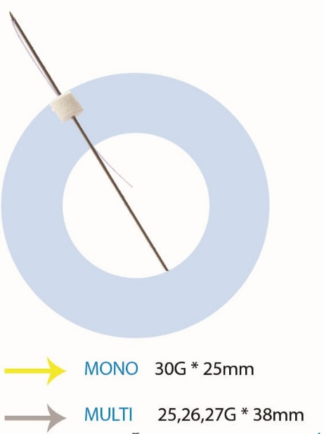

AFTER TREATMENT:
- Rapid lifting of treated area is visible immediately after the end of treatment.
- After 2 month marked improvement in skin tone wrinkle.
- The greatest effect is reached at around 2 to 3 months.
- Implanting new threads until the desired effect is achieved. Retouching treatments can be carried out at any time WITH MAXIMUM SAFETY.
