
BILATERAL POSTERIOR SUBCAPSULAR CATARACT IN A PATIENT WITH STERNAL KELOID TREATED WITH INTRALESIONAL CORTICOSTEROIDS
Tajinder Pal Singh¹ MD, Gaurav Kumar¹ MS
1.Affiliation-ESIC, Model Hospital, Baddi, District Solan, Himachal Pradesh, India
Abstract
Cataract formation following extra ocular intralesional corticosteroids has not been reported previously although there are case reports of cataract following topical dermatological corticosteroids.¹ We report bilateral posterior subcapsular cataract in a 35 year old non- diabetic male patient with a larger sternal keloid disorder treated with multiple doses of intralesional triamcinolone acetonide (Figure.1). There was no history of systemic corticosteroids treatment intake in any other form except intralesional route. Ocular examination showed best corrected visual acuity (BCVA) of 6/18 in both the eyes with presence of bilateral posterior subcapsular cataract (Figure 2A and 2B) and normal posterior segment. Development of Cushing’s syndrome has been reported after intralesional steroids injections for keloid and majority them received doses larger than 40mg in a month.² Our patient received 8 injections of triamcinolone acetonide over a period of six months, the cumulative dose might have increased the systemic levels of triamcinolone leading to formation of typical bilateral posterior subcapsular cataract. Kristinia et al in their retrospective study have shown that intralesional triamcinolone acetonide are ineffective in curing large keloid and have advised to limit total number of injections to a maximum of four.⁴ To conclude, intralesional corticosteroids injections for keloid can lead to cataract formation like corticosteroids through other routes. Therefore, overenthusiastic treatment in the form of too many injections of steroids should be avoided especially in large keloids.
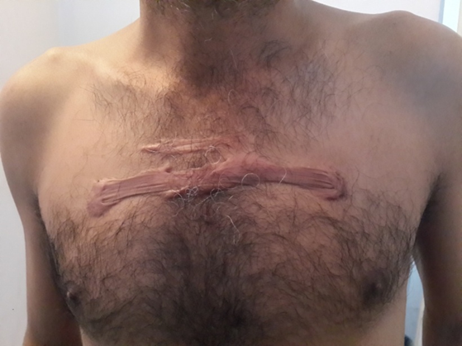
Figure1. Photograph showing a large sternal keloids
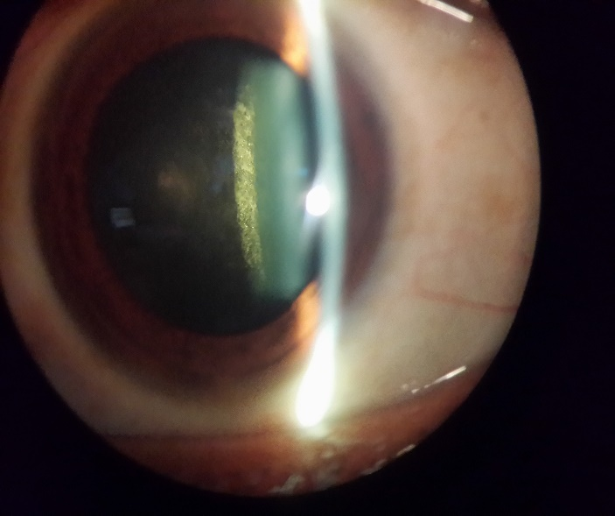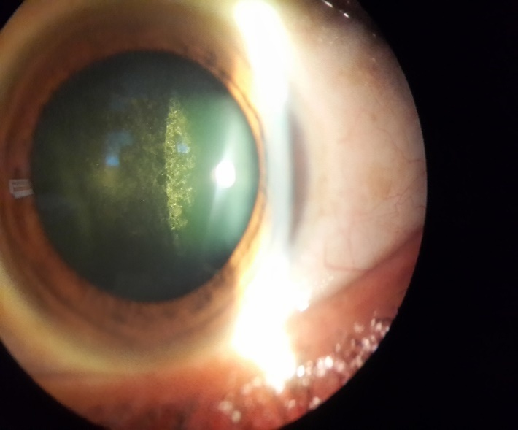
Figure 2A & 2B. Posterior subcapsular cataract in right eye (A) and left eye (B)
References
1. Andrew Tatham. (2008) Atopic dermatitis, cutaneous steroids and cataracts in children. two case reports Journal of Medical case reports 2:124.
2. Fredman R, Tenenhaus M (2013). Cushing ‘s syndrome after intralesional triamcinolone acetonide: a systemic review of literature and multinational survey. Burns;39:549-557.
3. Kristinia Hietanen, Petri Valisuo, Hannu Kuokkanen, Ikka Kaartinen (2016). Long term results of intralesional triamcinolone acetonide injections in keloid treatment. J Clin Trials,6:4. DOI:10.4172/2167-0870.100278

Presenting Author Details
Tajinder Pal Singh, MD
Present Post/Affiliation: Consultant Ophthalmologist/ESIC, Model Hospital, Baddi, District -Solan, Himachal Pradesh, India. Pin code-173205
E-mail Address: tajinderpal2004@gmail.com
Mobile number: +91-9872975038
Session: Keloid and Pityriasis rosea
Category: Poster Presentation
Date of Birth: 25-07-1978

