

Jaw and Neck Contouring
Combining Procedures for
Ultimate Beauty Effect with
Threads and Calcium Hydroxylapatite (CaHA)

Dr. Christeen Youssef
Dermatologist & Aesthetic Physician
Associate Professor of Dermatology
Founder of Everlast Wellness Medical Center Abu Dhabi UAE

Introduction:
The most obvious signs of aging result from chronological remodeling of underlying soft tissue structures. While conventional nonsurgical procedures are not sufficient for improving deep wrinkles or decreased laxity, direct surgical lifting requires extensive and meticulous dissection of the superficial muscular aponeurotic system and involves a significant recovery period. Various modifications of the technique have been introduced to simplify the procedure for both patient and the practitioner.
Nowadays, thread lifting is favored as minimally invasive alternative to surgical lifting.
Early signs of aging in facial skin results from elastic tissue and collagen degradation, causing fine – to – deep wrinkles. In addition to decreased laxity, generalized thinning of subcutaneous fat tissue leads to volume depletion and a sagging appearance, especially on the jowls and neck. With the advent of various cosmetic procedures for facial rejuvenation, minimally invasive modalities have gained in popularity.
Materials and Method:
Always correct lax skin in the neck one to two weeks using Calcium Hydroxylapatite (CaHA) to increase the body's natural ability to produce collagen and elastin before a lifting procedure using threads with Poly L-Lactide-Ɛ-Caprolactone P(LA/CL) to provide a complex solution for neck, and offers good results.
Using non –invasive light lift threads, which created on the basis of the bio-absorbable materials, and its structure with microscopic barbs, it is reliably fixed in

soft tissues and forms a strong supporting skeleton. It is possible to reach a visible lifting effect on various areas of the face as well as on the neck.

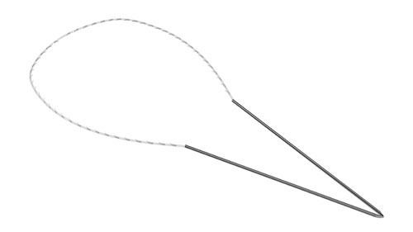
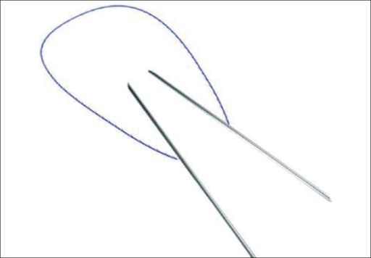
Aptos Thread 2G
Light Lift Thread 2G
Thread with barbs connected to the coupled needle

Aptos Needle 2G
Light Lift Needle 2G
Double-edged needle with the thread having barbs

Results:
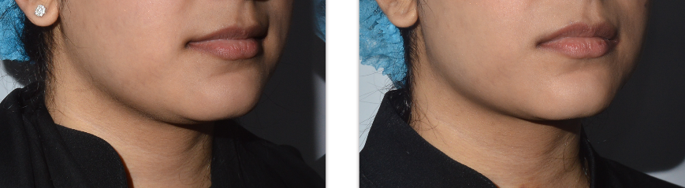

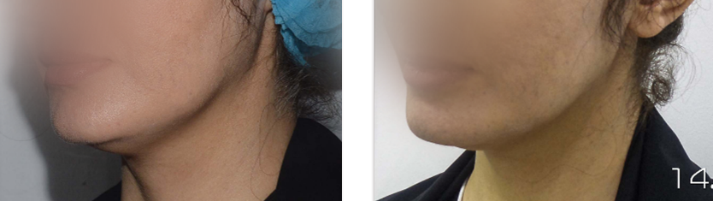
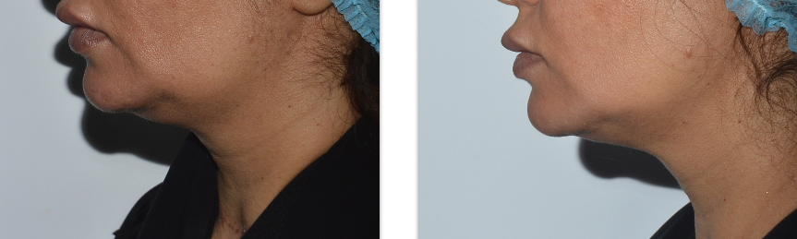

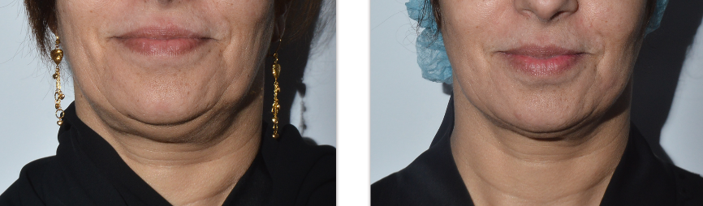

Results:
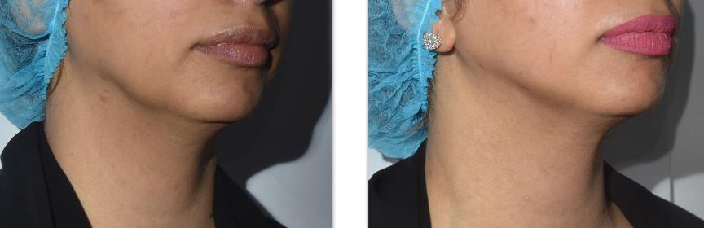
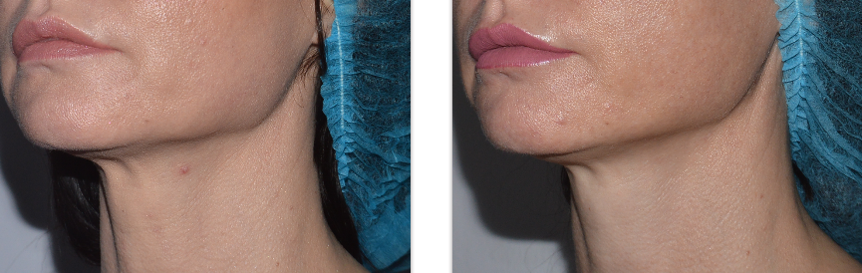
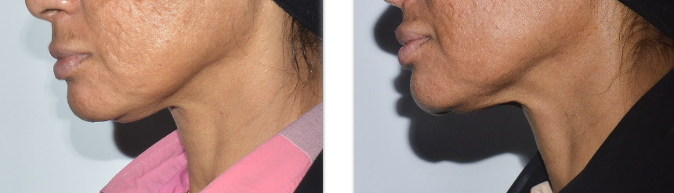
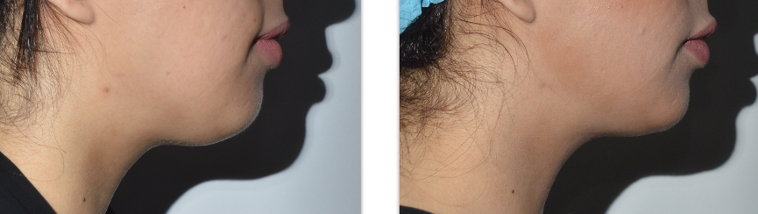

Analysis
Introducing threads through last few years has certainly provided aesthetic field with a broader range of options to treat more challenging areas of the face and neck.

Threads could be combined with Calcium Hydroxylapatite (CaHA) to stimulate of collagen and elastin to improve quality of skin two weeks prior to threads insertion. This technique is effective to create contour and reposition of the volume of different areas of the face and neck.

Addition advantage is the effect of biorevitalization due to the presence of Lactic Acid and complete resorption of threads with the formation of a new collagen. The results continue to improve over three to four months.

Discussion:
Choosing the ideal patient for the procedure is important.
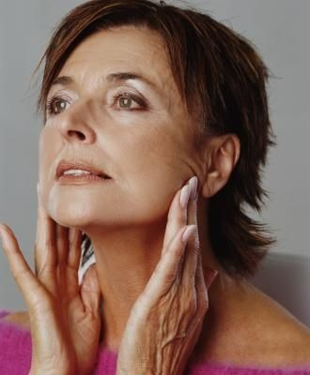
- This is not a face lift, although it does provide repositioning of displaced fat and volume restoration.
- Suitable patients would include those with mid-face ptosis, jaw line ptosis, neck relaxation and brow ptosis.
- One way of evaluating the potential effect of the procedure is by lifting the tissue by approximately 1cm with your fingers placed proximally. If this produces a positive effect, the patient should do well with the procedure.

Biography:

Dr. Christeen Yousef
Dermatology & Aesthetic Specialist
Founder of Everlast Wellness Medical Center

Dr. Christeen Youssef is the Founder of Everlast Wellness Medical Center, leading dermatology practice in the United Arab Emirates and internationally acclaimed speaker on Dermatology and Dermatological Surgery. Known for her Combination in thread contouring techniques.

A certified Merz and Aptos Trainer. She has lectured nationally and internationally on the topics of dermatologic, laser, aesthetic and cosmetic procedures, threading, skin care, and anti-aging. Dr. Youssef has published Ph.D. Research published in Int J Dermatol and author contributing to international journals and conferences.

Dr. Christeen Youssef received her M.Sc in Dermatology and Venereology Degree from, Zagazig University, Egypt. A member of several international societies such as The American Academy of Dermatology, the European Academy of Dermatology, and the International Academy of Dermatology. She completed her American Board Certification in Aesthetic Medicine in 2013 and is a member of the American Fellowship in Anti-aging Medicine.

Presenting Author Details
Full name: Dr. Christeen Youssef
Contact number: Tel.: +971 2 4918368 / Mobile: +971 50 816487
Twitter account: N/A
Linked In account: https://bit.ly/2NWtxIU
Session name/ number: -
Category: Oral presentation

