Functional role of vitamin D in patients with acne
Junwoo Ko, Department of Dermatology, School of Medicine, Chungnam National University, Daejeon, Korea

Abstract (300 word limit)
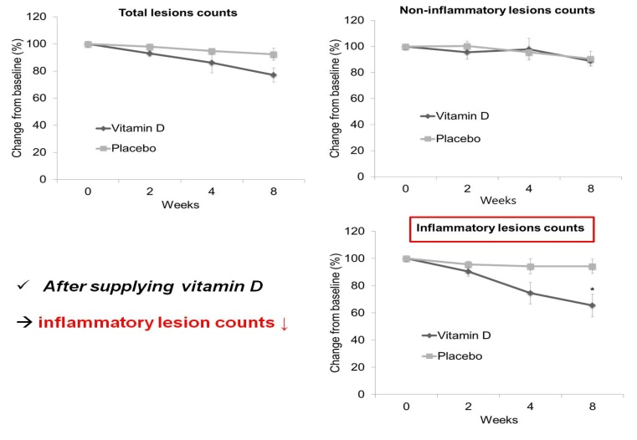
Backgroud : Vitamin D plays an important role in the immune system and its deficiency has been implicated in various skin diseases, including atopic dermatitis and psoriasis. Acne is a common inflammatory skin disease; however, the association with vitamin D remains unclear.
Objectives : We evaluated vitamin D levels in patients with acne to determine the effect of vitamin D supplementation.
Methods : This study included 80 patients with acne and 80 healthy controls. Serum 25-hydroxyvitamin D (25(OH)D) levels were measured, and demographic data were collected. Vitamin D-deficient patients were treated with oral cholecalciferol at 1000 IU/day for 2 months.
Results : Deficiency in 25(OH)D was detected in 48.8% of patients with acne, but in only 22.5% of the healthy controls. The level of 25(OH)D was inversely associated with the severity of acne, and there was a significant negative correlation with inflammatory lesions. In a subsequent trial, improvement in inflammatory lesions was noted after supplementation with vitamin D in acne patients with 25(OH)D deficiency.
Conclusions : Deficiency in vitamin D plays an important role in acne development. Therefore, supplementation with vitamin D could be used as an adjuvant treatment for inflammatory acne.

Image
Recent Publications (minimum 5)
- Arnson Y, Amital H , Shoenfeld Y. Vitamin D and autoimmunity: new aetiological and therapeutic considerations. Ann Rheum Dis. 2007;66:1137-42.
- Kostoglou-Athanassiou I, Athanassiou P, Lyraki A, Raftakis I , Antoniadis C. Vitamin D and rheumatoid arthritis. Ther Adv Endocrinol Metab. 2012;3:181-7.
- Cheng HM, Kim S, Park GH, Chang SE, Bang S, Won CH et al. Low vitamin D levels are associated with atopic dermatitis, but not allergic rhinitis, asthma, or IgE sensitization, in the adult Korean population. J Allergy Clin Immunol. 2014;133:1048-55.
- Kramer C, Seltmann H, Seifert M, Tilgen W, Zouboulis CC , Reichrath J. Characterization of the vitamin D endocrine system in human sebocytes in vitro. J Steroid Biochem Mol Biol. 2009;113:9-16.
- Nieves NJ, Ahrens JM, Plum LA, DeLuca HF, Clagett-Dame M. Identification of a unique subset of 2-methylene-19-nor analogs of vitamin D with comedolytic activity in the rhino mouse. J Invest Dermatol. 2010;130(10):2359-67.
- Lee WJ, Choi YH, Sohn MY, Lee SJ , Kim do W. Expression of Inflammatory Biomarkers from Cultured Sebocytes was Influenced by Treatment with Vitamin D. Indian J Dermatol. 2013;58:327.

 Biography (150 word limit)
Jungwoo Ko graduated from Chungnam National University College of Medicine in 2012 (gained M.D. degree) and worked as a public health doctor in Yeosu and Jincheon counties' public health center from 2012 to 2015. He worked as an intern at Chungnam National University Hospital in 2015 and has been working as a dermatology resident at Chungnam National University Hospital since 2016..
Email: ggoogoong@hanmail.net
Phone: +82-10-8924-5361

Notes/Comments:

