Title: Pain Management in Aesthetic Medicine
Assoc Prof Dr Ramamurthy, DAOS Corporation | dr@daos.us

Pain in an aesthetic medical procedure is multifactorial; it depends on the type of procedure (Botulinium Toxin, Fillers, Threads, Lasers, Radiofrequency, Infrared, Chemical Peel), site of treatment (face, body, bony area, hairy area), type of pain – nociceptive, neuropathic or inflammatory and patient’s threshold to pain. To some, the psychological pain of what may go wrong can be more than the physical pain caused by the procedure. There is also the proportion of pain to skin color in Laser related procedures. It is well known that anxiety and fear also play an important role in aesthetic procedures.
Managing pain is just as much about managing expectations and starts during consultation. Giving an insight to the pain and describing the sensation helps to prepare the patient. A holistic approach will be to provide a soothing ambience, clinical hypnotherapy and engaging all the senses – sight, hearing, smell, taste and touch, which are proven adjuvants in minimizing pain. Thereafter, simple and easily available approach will be to use ice cubes, cold sprays, ice gels, topical anesthetic cream, etc. Pharmacological pain relief can be classified into non-sedative and sedative options, with proper monitoring and emergency facilities required for the later. With so many options available, the physician’s suggestion for pain management must be discussed with the patients and must not be carried out without their consent. Additionally, the choice of pain management must not interfere with the treatment outcome, such as using sedation when the patient’s input is important during augmentation procedure.
The objective for today’s aesthetic professionals must be to minimize the fear of pain, as well as effectively reducing the physical pain that ensues. With so many techniques and pain relief formulations available in aesthetics, the old saying, ‘No pain, No gain’ should not have a place in aesthetic clinics. The best practitioners need to keep their pain management protocol under review, operate a feedback system with patients, learn from individual experiences and adapt to tailor future pain management strategies.
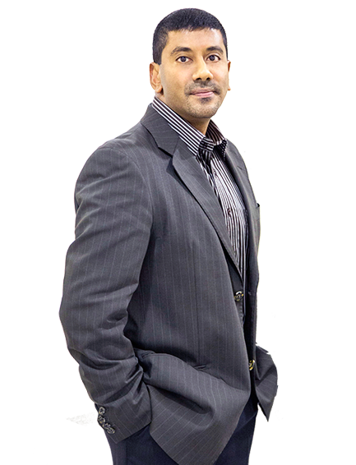
Biography
Assoc Professor Dr Ramamurthy completed his medical studies in India in year 1996 and pursued his Diploma in Dermatology (Cardiff - 2000), Fellowship in Laser Surgery (Bangkok - 2002) and Certification in Pain Management (Paris – 2003). After being appointed as the Vice President of Association of International Certified Aestheticians in 2012, he was honorarily awarded the Letter of Credentialing & Privileging (Aesthetic Medicine) from the Ministry of Health in 2013 and currently heads the Academy of Aesthetic Medicine in Malaysia. He has been lecturing in several universities in Malaysia since 2002.

Presenting author details
Full name: Assoc Prof Dr Ramamurthy
Contact number: +6012 2006670
Twitter account:
Linked In account: https://my.linkedin.com/in/assoc-prof-dr-morthy-89377186
Session name/ number:
Category: (Oral presentation/ Poster presentation)

