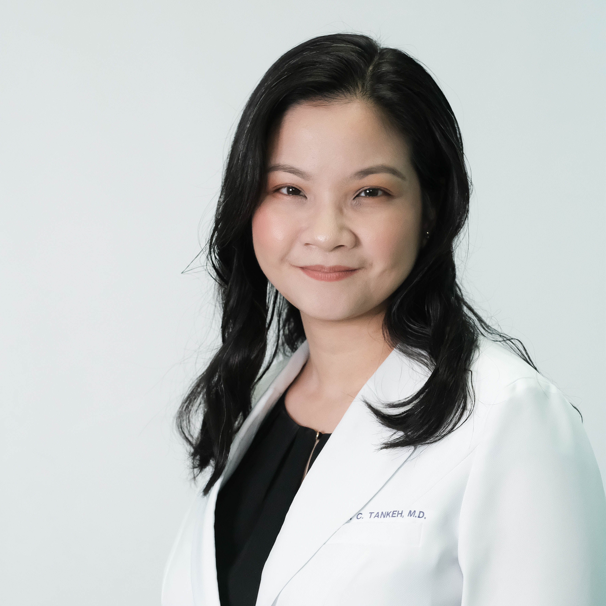

Title: A Case of Lupus Erythematosus with Concomitant Hansen’s Disease

Anna C. Tankeh, MD; Vilma C. Ramilo, MD, FPDS; Andrea Marie Bernales-Mendoza, MD, DPDS
Dr. Jose N. Rodriguez Memorial Hospital, Caloocan City, 1427, Philippines

We describe a case of a 27-year old female who presented with a two month history of painful nodules on both lower extremities. Impression at another institution was Erythema Nodosum. Patient was given Prednisone (0.5mg/kg of body weight) with potent topical steroids. Two weeks later the patient developed high grade fever and appearance of multiple erythematous papules, plaques and painful nodules over the face and both upper and lower extremities that let to her admission. Skin punch biopsy was done. The histopathologic diagnosis was Tumid Lupus Erythematosus. ANA was positive with a titer of 1:40 (speckled pattern). Anti-SSA (Ro) was 0.4U/ml. Patient was referred to a rheumatologist and started on Prednisone (1mg/kg of body weight) with gradual tapering. After several months, patient developed cough, fever, dysuria, hematuria and increase in the number of lesions on her face which led to her re-admission and referral to our institution. Hypoesthetic lesions were noted on examination. AFS and skin punch biopsy were done which revealed results consistent with Hansen’s Disease. She was started on multidrug therapy under multibacillary regimen.

The presentation of pain instead of numbness coupled by histopathologic and serologic findings of connective tissue disease could mask Hansen’s Disease which could impose a challenge to health care providers leading to a delay in recognition.

Biography:
Dr. Anna C. Tankeh obtained her medical degree from the University of Santo Tomas in the Philippines. Currently, she is a first year dermatology resident at Dr. Jose N. Rodriguez Memorial Hospital in the Philippines. She had a poster presentation entitled “The Clinico-Epidemiologic Profile of Hansen’s Disease in Dr. Jose Natalio Rodriguez Memorial Medical Center Dermatology Out Patient Department: A 5-Year Review” at the 20th International Leprosy Congress held in Manila, Philippines.

Presenting author details
Full name: Anna C. Tankeh
Contact number: +63 917 531 0609
Twitter account: N/A
Linked In account: N/A
Session name/ number:
Category: (Oral presentation/Poster presentation) Poster Presentation

