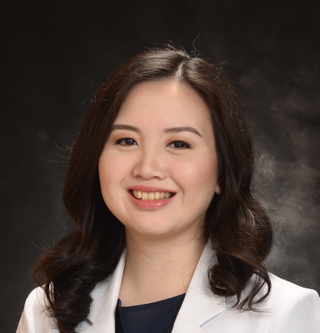

Title: A Rare Presentation of CD30 Negative Mycosis Fungoides Mimicking Erythema Nodosum Leprosum in a 68-Year Old Filipino Male

Names: Ma. Cristina Georgina T. Paloma, MD; Andrea Marie Bernales-Mendoza, MD, DPDS
Dr. Jose N. Rodriguez Memorial Hospital, Caloocan 1427, Philippines

Mycosis Fungoides is a type of primary cutaneous lymphoma of T-cell origin. It generally begins as erythematous patches and plaques before progressing to the tumor stage. It can be similar in presentation to a multitude of other cutaneous conditions making it difficult to diagnose early in the course. Multiple biopsies are often needed before a definite diagnosis can be reached. A 68-year old male presented with a 13-year history of multiple erythematous patches and plaques on the arms and trunk. Lesions were pruritic and chronically relapsing over the years, temporarily relieved by topical corticosteroids. Thereafter, there was onset of multiple nodules on the trunk, extremities and face. Biopsy was done which revealed Hansen’s Disease, Borderline spectrum. Despite being treated for Hansen’s Disease for seven months, lesions continued to worsen, eventually developing spontaneous ulcerations over the trunk and extremities. Impression during this time was Erythema Nodosum Leprosum. Another biopsy was done which revealed Cutaneous T-Cell Lymphoma. Immunohistochemistry was done for confirmation of diagnosis: CD3 positive on diffuse stain, CD20 positive on focal stain, and CD30 negative. Fite faraco was also negative. Histopathology of Hansen’s disease and Cutaneous T-Cell Lymphoma may appear similar on routine H&E staining. Immunohistochemistry remains the gold standard for diagnosing this condition. The histopathologic and immunohistochemistry findings combined with the clinical presentation led to the diagnosis of Mycosis Fungoides. Workup was done for proper staging and referral to oncology was made for definitive management.

Biography

Dr. Paloma completed her medical degree from the Ateneo School of Medicine and Public Health. She is a first year dermatology resident at Dr. Jose N. Rodriguez Memorial Hospital. She recently presented her epidemiologic study on Hansen’s Disease at the 20th International Leprosy Congress held in Manila.

Presenting author details
Full name: Ma. Cristina Georgina T. Paloma
Contact number: 639175651948
Twitter account: N/A
Linked In account: N/A
Session name/ number:
Category: Poster presentation

