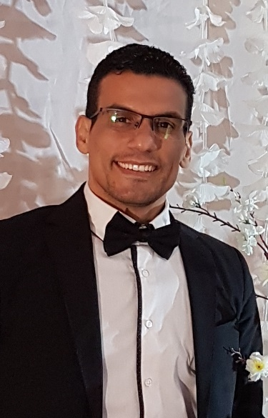
MAHRAN ASHOUR
Healthcare Management Consultant

MAHRAN ASHOUR is a healthcare management consultant in Dubai, United Arab Emirates. Mahran has a rich and varied background in the operational and business aspects of healthcare operations and management. He has demonstrated success in the health care field as both a manager and consultant for over 11 years. In that time, he has worked in single and multi-specialty practices, aesthetic & cosmetics, primary care, surgical groups and academic medical centers. he has lead with a very hands-on approach to the daily operations of these organizations and has developed proven strategies in the management of start-up, business planning, insurance, billing, personnel, budgeting, marketing, contracting, accounts receivable, accounts payable and strategic planning.
His initial introduction to health care began as an Patient Relation Ass. Manager at Emaar Health Care in 2008, where he ultimately managed a private outpatient clinic with more than 45 doctors and 127 employees in Dubai Mall Medical Center. he later moved on to work with practices ranging from solo practitioners to groups of 50+ physicians, and has used that experience to develop strategies that are key to the billing operations of S&S Healthcare Services.
Ashour who is graduated from Cairo University in 2006, and in 2007, has obtained Healthcare Management Course at the University of Cairo and in 2008, Mr. Ashour has obtained his diploma in HealthCare Management Services and decided to relocate to Dubai to further his career. Before becoming a Director of Med Art Clinics (UAE - KSA), and before that Operations Manager of DUBAI POLYCLINICs, he worked for the largest providers of health care services in Dubai, such as EMAAR Healthcare, Methodist International USA and Neuro Spinal Hospital in DUBAI, besides being an independent consultant for cosmetic and primary healthcare providers in GCC & Meddle East. In 2014 in Berlin, Germany he received a quality award for the best director of medical institution (The Diamond Eye Award).
During his work in healthcare management & consultancy, Ashour has developed new strategies to incorporate 5* hotel standards into healthcare provision ranging from reception and booking process, through the development of new methods of communication with customers, to the provision of quality medical services. Not forgetting, however, about the importance of right infrastructure with its exterior and interior design.
Mahran has acquired great knowledge and deep understanding with regard to the healthcare management and related specialities, which includes among others insurance administration for corporate and individual clients, medical healthcare, provision of quality services to meet customer satisfaction, and development and maintenance of patient relations in line with the new standards.
“By relying on his management & consultancy knowledge, experience and appetite to stay current with emerging technologies, Mahran is able to give hospitals and clinics what they need to compete during a time of explosive development and start-up level or after long term operations”

HOW TO DEAL AND MANAGE UNHAPPY PATIENTS?
TURNING A CHALLENGE INTO AN OPPORTUNITY!

By: Mahran Ashour (Diploma of Healthcare Management, Methodist International), Operations Manager of M.A Healthcare Business Consultancy! Dubai and GCC!
Intro:
Dealing with unhappy and unsatisfied patients is a real challenge and many of us have to deal with them as part of our roles, and we know, it's never been easy. But if we know what to say and, more importantly, how to say it, we may be able to save the situation. Here we won’t only save the situation, but in fact we can change this to a powerful marketing tool and better relationship with those patients.
Methods:
By following some simple steps, you can make the change, those steps are easy to get, but it’s not easy to implement! So we need to have the way, talent, training to achieve the remarkable outcome! One of the most important steps is to Adjust Your Mindset, once you're aware that your client is unhappy then your first priority is to put yourself into a customer service mindset and It's important to handle difficult customers professionally. Learning how to stay calm and how to stay cool under pressure can help you get through challenging situations with grace and professionalism!
Occasionally a client or patients may become verbally abusive towards you or your team. Know in advance what you'll tolerate, and what you won't. If things escalate, you may need to be assertive and stand up for yourself, or even walk away from the situation to give the client time to cool down
Results:
- If you can prevent 5% of your customers from leaving you can increase your bottom line profit by 25 – 95% - “Harvard Business Review” If you can change the anger into happiness, frustration and disappointment into hope, discomfort into trust, and sure you can gain back the trust of the patient, you have definitely created a new and powerful word of mouth source, and make sure that this patient will get you 10 patients! Do your best to prevent your customer leaving your practise for whatever reasons.
Conclusion:
Not all patients will be vocal with their dissatisfaction or ideas for improvement. Indeed, most patients will leave silently. However, being able to determine which patients are unhappy and find out why is powerful information, so you need to be grateful to those who speak and share their anger, for you to be able to solve their issues and develop your practice.

