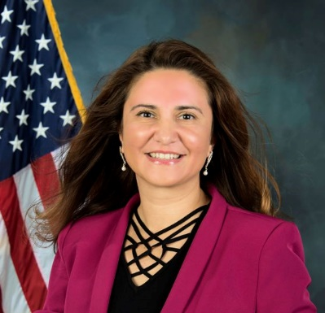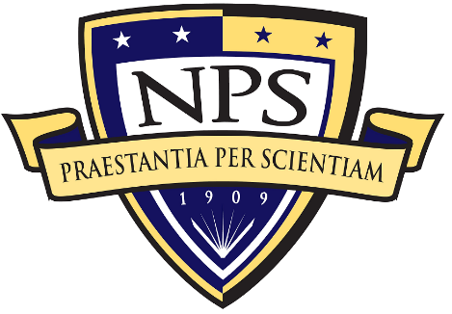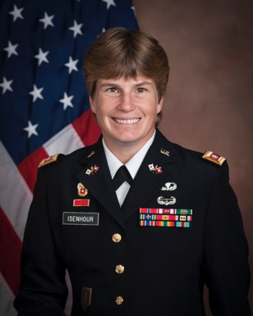

Title: CHUNK Learning

Name: Ralucca Gera and Michelle Isenhour

Naval Postgraduate School, CA 93940 USA

Education has progressed from traditional “front of the classroom” lectures to an augmented instructional environment with interactive materials such as PowerPoint presentations, online surveys and polls, video presentations, and various other collaborative methods. While these instructional techniques provide faculty with a multitude of ways to impart instruction, they do not provide options for the students on how to learn. The students are still forced to learn based on the particular method or methods selected by the instructor. Research has shown that different instructional techniques work for different students and learning is most efficient when students are afforded an opportunity choose how to learn. CHUNK Learning is a learner-based method of learning, allowing the student to engage with educational material in a way that works best for the individual learner. Moreover, CHUNK Learning breaks away from the predictable pattern of traditional education and provides content delivery that respects the different capabilities, learning styles, and approaches to problem solving of every student. In this talk, we will demonstrate how CHUNK Learning empowers students by ensuring that learning is efficient, flexible, and respectful of time.

Biography

Dr. Ralucca Gera is the Associate Provost for Graduate Education and Professor of Mathematics at the Naval Postgraduate School. Ralucca is also a researcher in the Center for Cyber Warfare at the Naval Postgraduate School, as well as an associate researcher in the Network Science Center at United States Military Academy. Her research interests are in graph theory and network science, with applications to the study of the Internet, Cyber networks and Natural Language Processing, sponsored by multiple DoD organization. Dr. Gera is the founder and director of the Academic Certificate in Network Science. Her latest passion is education taking leading roles in graduate education and NPS, as well as network science education. She engages with learners of different generations through CHUNK Learning or teaching short courses for professors and researchers, organizes teachers' workshops such as the Networks in Classroom Education (NiCE) for elementary school teachers, short courses as well as innovation and support for faculty through the Teaching & Learning Commons. She has published over 50 journal and conference papers, and 2 edited books.

Dr. Michelle Isenhour, is an Assistant Professor in the Operations Research Department at the Naval Postgraduate School where she teaches statistics, serves as the Project Manager for CHUNK Learning, and conducts research on innovative methods in education, mathematical modeling, pedestrian movement, multi-scale crowd control and management, and evacuation dynamics. She has presented the results of her research at 15 conferences, including four international conferences, and published 10 papers in peer-reviewed journals and proceedings. Dr. Isenhour has more than 25 years of service as a commissioned military officer, including two overseas deployments to Iraq and Afghanistan.

