Development of multi-rotor flight robotics and applications

Ikuo Yamamoto
Nagasaki University, Japan

The author developed a disk type flight robot equipped with multiple rotors used as an aerial observation platform (Fig.1) in 2007. Models for the system are introduced. A quadratic optimal linear regulator based solution has been proposed. A simulation model is used to test the controller which successfully tracks a reference trajectory while providing rigidity against external disturbance. For the fault tolerant control of an eight-rotor VTOL Unmanned Air Vehicle (UAV), a control allocation scheme is proposed.
Also, the authors have also used hybrid flying robotic mechanisms to provide solutions tailored to specific needs. Such examples include a hybrid lighter-than-air (LTA) balloon (to remotely check tunnels) and tethered kite controlled by multi-rotors, and a wheeled vehicle also controlled by multi-rotors for efficiently checking bridge cables despite windy conditions shown in Fig. 2.

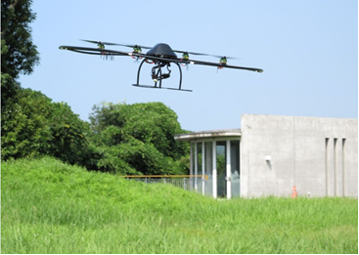 | 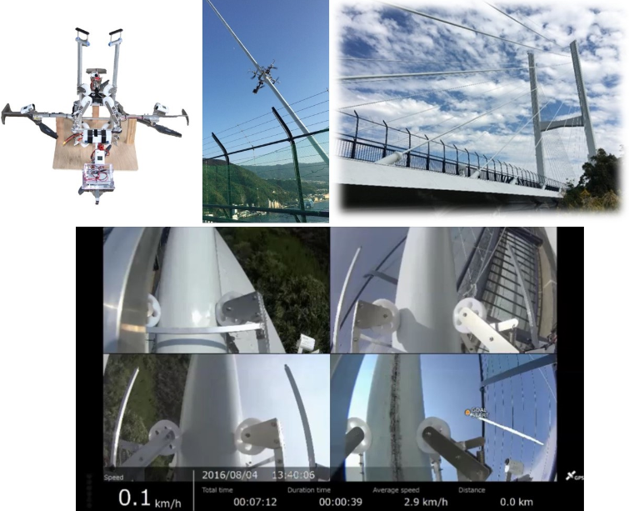
Fig.1 Disk-type flying robot | Fig.2 The flight robot for checking bridge cables

References
- Ikuo Yamamoto, Practical Robotics and Mechatronics: Marine, Space and Medical Applications, IET(The Institution of Enginnering and Technology, UK, ISBN 978-1-84919-968-1, pp.1-192
- I. Yamamoto, N. Inagawa, T. Tsuji, and T. Otawa, “Research and development of the multifunctional observation and data transfer system for disaster prevention,” Proceedings of the 4th International Congress on Image and Signal Processing (CISP 2011), Shanghai, China, Oct. 2011.
- T. Matsuzaki, I. Yamamoto, N. Inagawa, T. Nakamura, W. Batty, and J. F. Whidborne, “Development of unmanned flying observation robot with real time video transmission system,” Proc. World Automation Congress (WAC 2010), Kobe, Japan, Sep. 2010, p. 5 pages, article number 5665710. [Online]. Available: http://wacong.org/Finalprogram.html
- N. Inagawa, I. Yamamoto, and T. Nakamura, “Application of unmanned flying observation robot using real time video transmit system,” Journal of Electrical Engineering Theory and Application, vol. 12010, no. Iss. 2, pp. 86-91, 2010.
- A. Marks, J. F. Whidborne, and I. Yamamoto, “Control allocation for fault tolerant control of a VTOL octorotor,” in UKACC International Conference on Control 2012, Cardiff, U.K., Sep. 2012, pp. 357-362.

