 Official Photo  University/Organization Logo

Comparisons of anti-/de-icing performance of DBD plasma actuators with different power supplies
Borui Zheng, Associate prof, XAUT, China

Abstract (300 word limit)
Ice accretion on aircraft surfaces has been widely recognized as a significant safety hazard in cold weathers, especially when aircraft travel through clouds with supercooled water droplets suspended. Dielectric-Barrier-Discharge (DBD) plasma actuator, as a burgeoning type of active flow control technology, also has a thermal effect on the surrounding air during the high-voltage discharge. Two NACA0012 airfoil models embedded with an DBD plasma actuator and a conventional electrical film heater over the airfoil surface were tested in the icing research tunnel under typical glaze/rime icing conditions pertinent to aircraft inflight icing phenomena. The anti-/de-icing performance of DBD plasma actuators stimulated by alternate current (AC), nanosecond(NS) and radio frequency (RF) power supply were compared. While a high-speed imaging system was used to record the dynamic ice accretion and transient surface water transport processes over the airfoil surface, an infrared (IR) thermal imaging system was also utilized to map the corresponding surface temperature distributions over the airfoil surface simultaneously to quantify the unsteady heat transfer and phase changing process over the ice accreting airfoil surface. The findings derived from the present study demonstrated the potential of a new class of anti-/de-icing strategy by leveraging the integral effect of aerodynamic impact and thermal effect for aircraft in-flight icing mitigation.

Key words: ice accretion on aircraft, anti-icing, de-icing, Dielectric-Barrier-Discharge plasma actuator.
Image
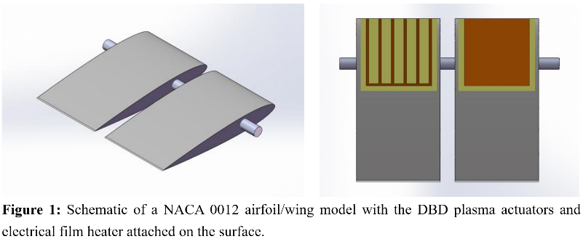
Recent Publications (minimum 5)
- Yang L, Cem K(2018) A Comparison Study on AC-DBD Plasma and Electrical Heating for Aircraft Icing Mitigation. AIAA 2018-0167.
- Zaid A J, Barbara T,(2018) Mixed ice accretion on aircraft wings. Physics of Fluids 30:027101.
- Huimin S, Min J (2016) Electric and plasma characteristics of RF discharge plasma actuation under varying pressures. Chin Phys B 25(3):035204.
- F. Rodriguesa, J. Pascoaa(2018) Heat generation mechanisms of DBD plasma actuators. Experimental Thermal and Fluid Science 90 :55–65.

Biography
Borui Zheng has his expertise in plasma flow control and passion in active flow control of UAV, aircraft icing mitigation and asymmetric vortices over slender bodies at high angles of attack. His theory of icing mitigation utilizing the integral effect of aerodynamic impact and thermal effect of high frequency plasma actuation creates new pathways for aircraft icing mitigation.

Presenting author details
Full name (As per the passport): Borui Zheng
University/Industry/Organization name: Xi’an University of Technology
Designation(Director/Prof/Assistant or Associate prof/Researcher/Student): Associate prof
Country: China
Mobile number (country code – number) : +86-13772133860
Email: narcker@163.com
Track number: http://optics.physicsmeeting.com/call-for-abstracts.php (For track number follow this link)
Category (Oral presentation/ Poster presentation/Young researcher forum/E-poster): Oral presentation
Research interest: plasma flow control, aircraft icing mitigation and active flow control of UAV.
Your profile page URL in your department:
Year of birth:
Linked In/Facebook/twitter account:

Note: Please fill up the Red mark fields so that it would be easier for us to cite your details in the conference particulars. (Please do not forget to fix your photo and Logo above the title)

