

Spherical magnetic drive for attitude control on nano satellites
Grazvydas Kazokaitis, PhD student, KTU, Lithuania
Vytautas Jurenas, Prof. Dr., KTU, Lithuania

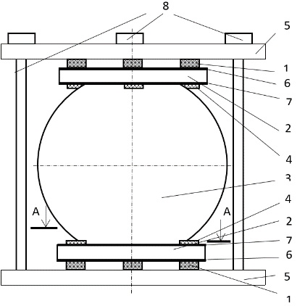

Abstract (300 word limit)
Small satellites are great tools for various research and analysis tasks. They can work like standalone units or to be modular and combined together to the clusters. Depending on their missions and provided exercises, various orientation and positioning systems are needed. Attitude control systems can be with active or passive elements. Typically, these systems are driven by: gravitational forces, permanent or electromagnets, reactions wheels or thrusters. Small satellites have limited capabilities and many restrictions for size, composition, energy consumptions. Nowadays most popular systems consume significant amounts of energy, takes a lot of volume. As a possible option for alternative attitude control mechanism spherical magnetic drive was submitted. Spherical permanent magnet has stable dipole and when it orientates with the Earth’s magnetic field, attitude control can be achieved. This developed drive combines advantages of active and passive systems. The drive is fairly simple: permanent magnetic sphere is inserted between two ring-shaped piezoelectric actuators. Electrodes of the piezoelectric rings are divided into three equal sectors and is excited by separate harmonic signal. The out-of-plane bending and radial vibration modes of the piezoelectric rings are excited to obtain elliptical motion of the contacting points and rotate magnetic sphere about three axes. Amplitude and duration of the applied signal depends on rotation or motion trajectory of the sphere. In addition, it must be mentioned that actuator can be driven by burst type signal in order to achieve very high resolution. Using this technique, controlled movement of magnetic sphere is achieved. Numerical and experimental studies were performed to verify operating principle and output characteristics of the actuator. The aims of studies were to investigate vibration modes of the piezoelectric actuators and identify resonance frequencies at which these piezoelectric actuators generate 3-DOF rotational motion of a spherical rotor with high resolution, determinate further development steps.

Key words: CubeSat, attitude control, spherical drive, magnetic sphere, piezoelectric rings

Image
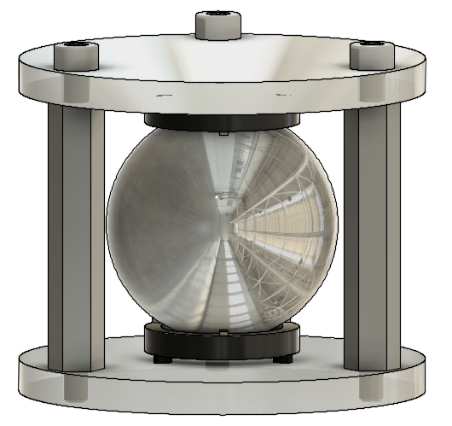

1-elastic supports; 2 – piezoelectric transducers; 3-magnetic sphere; 4- contact points; 5 – flanges; 6 – sides of continuous electrodes of piezoelectric rings; 7 - sides of divided electrodes of piezoelectric rings; 8 – bolts.

Recent Publications (minimum 5)
- Kazokaitis, Gražvydas; Jurėnas, Vytautas; Eidukynas, Darius. Research and analysis of spherical magnetic drive for attitude control on nano satellites // Vibroengineering Procedia. ISSN 2345-0533. 2017, vol. 15, p. 50-56.
- Bansevičius, Ramutis Petras; Mažeika, Dalius; Jūrėnas, Vytautas; Kulvietis, Genadijus; Bakanauskas, Vytautas. Development of traveling wave actuators using waveguides of different geometrical forms // Shock and Vibration. New York: Hindawi publishing corporation. ISSN 1070-9622. 2016, vol. 2016, article 4101062, p. 1-9.
- Grybas, Ignas; Bansevičius, Ramutis Petras; Jūrėnas, Vytautas; Bubulis, Algimantas; Janutėnaitė, Jūratė; Kulvietis, Genadijus. Ultrasonic standing waves-driven high resolution rotary table // Precision engineering. New York, NY: Elsevier. ISSN 0141-6359. 2016, vol. 45, p. 396-402.
- Ostaševičius, Vytautas; Markevičius, Vytautas; Jūrėnas, Vytautas; Žilys, Mindaugas; Čepėnas, Mindaugas; Kižauskienė, Laura (aut.; aut.); Gylienė, Virginija. Cutting tool vibration energy harvesting for wireless sensors applications // Sensors and actuators A: Physical. Lausanne: Elsevier. ISSN 0924-4247. 2015, vol. 233, p. 310-318.
- Šakalys, Rokas; Janušas, Giedrius; Palevičius, Arvydas; Čekas, Elingas; Jūrėnas, Vytautas; Sodah, Amer. Microstructures replication using high frequency excitation // Microsystem technologies. Berlin: Springer. ISSN 0946-7076. 2016, vol. 22, iss. 7, p. 1831-1843.

Biography
Grazvydas Kazokaitis has experience in design and R&D fields developing small and precise mechanisms for ultra-fast laser beam control and machining apparatus. This experience allows provide solid foundation and knowledge creating possible solutions for laser beam orientation mechanisms between small units in space, attitude control and other control tasks.
Vytautas Jurenas is senior researcher in Kaunas University of Technology. The main areas of R&D are dynamics and diagnostics of mechanical systems. His research interests include piezomechanics and its application in hi-tech mechatronics.

Presenting author details
Full name (As per the passport): Grazvydas Kazokaitis
University/Industry/Organization name: Kaunas university of technology
Designation(Director/Prof/Assistant or Associate prof/Researcher/Student): PhD Student
Country: Lithuania
Mobile number (country code – number) :+37067220243
Email: grazvydas.kazokaitis@ktu.edu
Track number: http://optics.physicsmeeting.com/call-for-abstracts.php (For track number follow this link)
Category (Oral presentation/ Poster presentation/Young researcher forum/E-poster): Poster presentation
Research interest: Mechanical engineering, piezo drives and actuators, space
Your profile page URL in your department:
Year of birth: 1988
Linked In/Facebook/twitter account: https://lt.linkedin.com/in/grazvydas-kazokaitis-99267178

Note: Please fill up the Red mark fields so that it would be easier for us to cite your details in the conference particulars. (Please do not forget to fix your photo and Logo above the title)

