

System Design for Prediction System of Launching and Recovery Systems
Hyun Woo Kim, PhD, Research Institute of Medium & Small shipbuilding, Korea

Abstract
In this paper, we study a system design for predict the failure of LARS (Launching and Recovery System) used in ship. LARS is equipment installed on ship or offshore plants for launching equipment and cargo. A ship or an offshore plant where the system is installed often works in a sea off the land. For location reasons, if a system fails, you should wait a long time for repair. By monitoring the current status and the information necessary for the failure prediction, it is possible to determine in advance the possibility of failure in advance and to prepare for the occurrence of a failure, thereby minimizing the downtime for the system. By monitoring various consumables in the system, it is possible to prevent accidents that may occur due to abnormalities of consumables. We propose a system design for fault prediction system that is most suitable for LARS.

Key words: PTC, LARS, Monitoring, Prediction, Maintenance

Image
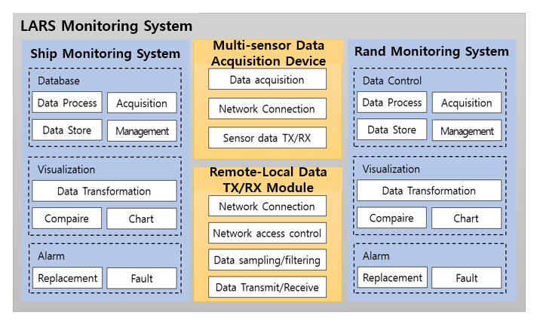
Fig. 1. Configuring the monitoring system

Acknowledgment
This research was financially supported by the Ministry of trade, Industry and Energy(MOTIE) of the Republic of Korea and Korea Institute for Advancement of Technology(KIAT) through the Encouragement Program for The Industry of Economic Cooperation Region (Grant Number : P0002161)

Recent Publications
- MYEONGSOO, C.; MINA, J. Ship to shore maritime communication for e-navigation using IEEE 802.16 e, ICT Convergence, Oct. 2013.[2] W. Andrew and C. Ember, Commercial applications of wireless sensor networks using zigbee. IEEE Communications Magazine, 2007.
- JUNG, Hyun-Joon; NA, Kyoung-Youn; YOON, Chang-Ho. The role of ICT in Korea’s economic growth: Productivity changes across industries since the 1990s. Telecommunications Policy, 2013, 37.4-5: 292-310.
- BRUCE, R. H.; AIKEN, J. The Undulating Oceanographic Recorder—a new instrument system for sampling plankton and recording physical variables in the euphotic zone from a ship underway. Marine Biology, 1975, 32.1: 85-97.
- ZHAO, C. H., et al. Analysis of tower crane monitoring and life prediction. IEIT Journal of Adaptive & Dynamic Computing, 2012, 2012.2: 12-16.
- YEO, Taein. A study on wear life prediction of disk brake pads. Transactions of KSAE, 2002, 10.4: 199-205.

Biography
Full name (As per the passport): HYUNWOO KIM
University/Industry/Organization name: Research Institute of Medium & Small Shipbuilding
Designation(Director/Prof/Assistant or Associate prof/Researcher/Student): Researcher
Country: Korea(South)
Mobile number (country code – number) : +82-10-5655-1687
Email: kimhw@rims.re.kr
Track number: TRACK 1-8
Category (Oral presentation/ Poster presentation/Young researcher forum/E-poster): Poster presentation
Research interest: Control, Robotics, Autonomous ship, prediction, Simulation etc.
Your profile page URL in your department: http://www.rims.re.kr/main/main.asp
Year of birth: 1982. 10. 13

