

Precision material deposition via a mobile rover for disaster scenarios
Alec John Burns, MEng, University of Liverpool, UK
Sebastiano Fichera, PhD, University of Liverpool, UK
Paolo Paoletti, PhD, University of Liverpool, UK

Abstract (300-word limit)

The most dangerous hazards in the aftermath of environmental disasters are typically linked to the damage that has occurred to structures. A material extrusion device capable of traversing highly irregular terrain, able to operate in hazardous or difficult to reach locations, and repair damage would largely mitigate many of the risks for survivors and relief workers.

In this work, we propose a platform capable of tackling such challenge: a Mobile Tracked Rover (MTR) that can travel on difficult terrains and deposit material where needed. The ability to deposit self-expanding material allows the MTR to achieve real-time climbing by creating its own support to overcome obstacles or bridge gaps. The proposed platform is also capable of depositing material accurately to perform effective damaged-structure reinforcement.

Targeted material deposition has been implemented with multiple materials and this platform has been tested for applications to disaster scenarios. One such material is polyurethane foam, which allows easy deposition, expansion and solidification in fast enough time to enable the MTR to use it as a real-time support for climbing. The amount of foam deposited can be controlled and multiple layers can be stacked on top of each other to significantly increase altitude. The high compressive strength of the solidified polyurethane foam is sufficient for temporary support structures, or structural reinforcement allowing the MTR to operate in support of disaster relief workers. The MTR is also capable of depositing clay alongside polyurethane foam, making it able to repair damaged masonry and thus further improving its usefulness in more general maintenance and repair scenarios.

Key words: Robotics; Material extrusion; autonomous systems; search and rescue.

Image
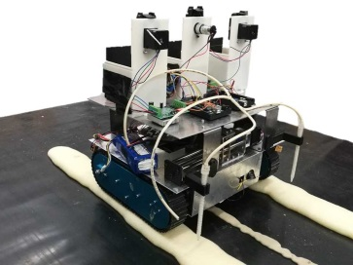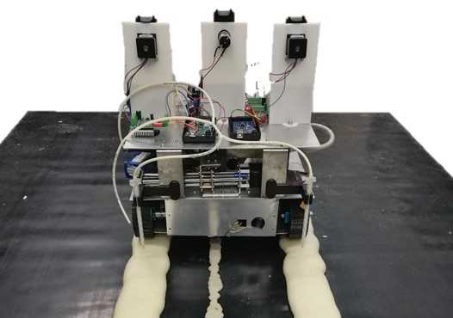
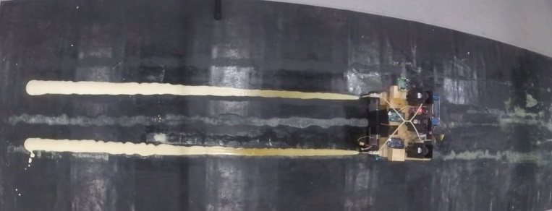
Recent Publications
- Kavanagh J.L., Burns A, Hazim S, Wood E, Martin S, Hignett S, Dennis D (2018) Challenging dyke ascent models using novel laboratory experiments: Implications for reinterpreting evidence of magma ascent and volcanism; Journal of Volcanology and Geothermal Research
- Paoletti P, Jones GW, Mahadevan L (2017) Grasping with a soft glove: intrinsic impedance control in pneumatic actuators; Journal of The Royal Society Interface, 14(128)
- Paoletti P, Mahadevan L (2014) A proprioceptive neuromechanical theory of crawling; Proceedings of the Royal Society B, 281, 20141092

Biography
Alec John Burns received his Bachelors Degree in Aerospace Engineering in 2016 from the University of Liverpool. From June 2015 to August 2015 he was a research assistant on a joint project between the Department of Earth, Ocean and Ecological Sciences and the Engineering Department at the University of Liverpool, working on fluid flow analysis for magma chambers. Currently he is pursuing his PhD at the University of Liverpool. His fields of interest include sensing, robotics and autonomous systems.

Presenting author details
Full name: Alec John Burns
University/Industry/Organization name: University Of Liverpool
Designation: PhD Student
Country: United Kingdom
Mobile number (country code – number) : +44 7540059035
Email: sgaburns@liv.ac.uk
Track number: https://robotics-mechatronics-ai.insightconferences.com/abstract-submission.php
Category: Oral presentation
Research interest: Robotics and Autonomous Systems

Year of birth:1995
Linked In/Facebook account:Alec John Burns

Note: Please fill up the Red mark fields so that it would be easier for us to cite your details in the conference particulars. (Please do not forget to fix your photo and Logo above the title)

