  SZABIST Karachi

Automatic Color Mixing Plant

Abstract

Colors plays an important role in our regular lives. There are multiple shades of a single color which varies their basic concentration. The mixing process of liquid is the most significant and demanded process in any industry. The main objective of industries is to improve the efficiency, increase the productivity rate, reduce errors and eliminate human efforts. In past, industries used to change the combination of color by changing their concentration manually. Minor adjustment in color combination can change the entire shades of color which causes complications in an industrial sectors. To overcome this problem, we have designed a prototype that will automate the mixing process. In this technologically advanced era, technology is playing a vital role in the development of various industries in which there is no need of human assistance to perform any task. Various type of mixing can be done, it can be either color mixing or any other liquid mixing. Color mixing is the process of developing new colors by using the combination of primary colors. It is either done manually or performed on machine with a lot of human effort. We have initiated a programmable logic control PLC based system that gives the desire color by mixing the primary colors with their specific ratios. A user friendly HMI has been designed to make the system more convenient and can be easily operated by a non-technical person. Availability of input colors are mentioned in our system. User can create any color combination with his own ratio of the three basic colors that need to be selected on HMI or user can select pre-defined output colors. To achieve the required concentration, our system is comprised in close loop that monitor the flow of basic color and the output is verified by industrial color detector sensor. This system can be implemented in many industries such as food industries, textile industries and paint industries etc. This process has vast applications in different areas of industrial sectors.

Key words: Industrial Automation, PLC, sensor, color, HMI, RYB

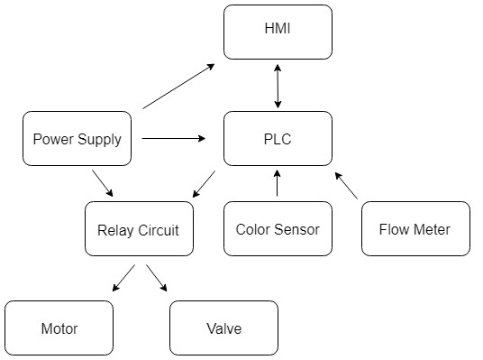
Figure no 1: Flow diagram
Recent Publications (minimum 5)
- Ezell, Barry, “Scenarios One and Two: Source to No 1PS to No 1 Tank to No 2 PS to No 2 tank (High level) for a Master-Slave SCADA System”, SCADA Consultants, SCADA Mail List, scada@gospel.iinet.au (August 1997).
- Knight, U. G. (2001). The Power System and its Operational and Control Infrastructure. Power Systems in Emergencies: From Contingency Planning to Crisis Management, 53-116.
- Basile, F., Chiacchio, P., & Gerbasio, D. (2013). On the implementation of industrial automation systems based on PLC. IEEE Transactions on Automation Science and Engineering, 10(4), 990-1003.
- Saloni, D. E., Lemaster, R. L., & Jackson, S. D. (2010). Process monitoring evaluation and implementation for the wood abrasive machining process. Sensors, 10(11), 10401-10412.
- Sanamdikar, S. T., & Vartak, C. (2013). Color making and mixing process using PLC. International Journal of Emerging Trends & Technology in Computer Science (IJETTCS), 2(5), 170-174.

Biography

Presenting author details
Full name (As per the passport): Sanjay Kumar
University/Industry/Organization name: SZABIST Karachi
Designation (Director/Prof/Assistant or Associate prof/Researcher/Student): Student
Country: Pakistan
Mobile number (country code – number): +92-333-3405135
Email: sanjay.kumar1995@outlook.com
Track number: https://robotics-mechatronics-ai.insightconferences.com/abstract-submission.php
(For track number follow this link)
Category (Oral presentation/ Poster presentation/Young researcher forum/E-poster): Oral Presentation
Research interest: Industrial Automation
Your profile page URL in your department:
Year of birth:
Linked In/Facebook/twitter account:

