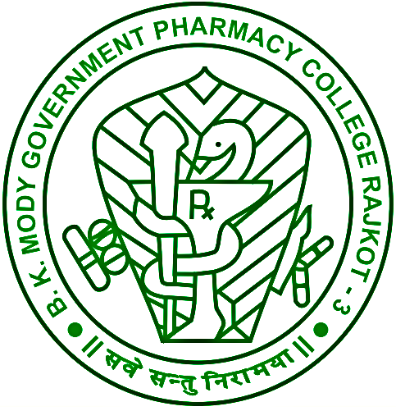

Title: Toxicity study of polyherbal formulation in Wistar rats
Divya Maheta*¹, Ravi Manek¹, and Sheth Devang¹
¹B. K. Mody Government Pharmacy College, Rajkot, Gujarat, 360003, India
divya.maheta95@gmail.com
The renowned eight herbs considered in the use of traditional system of medicine for the treatment of piles are the main constituents of the PILE RELIEF formulation (PRF). Every single herb is proven as a safest drug but the effects are yet not identified when they are used in combination with each other. Hence, the present investigation is carried out to elucidate toxicological profile of PRF in rats in terms of acute and sub-acute oral toxicity. The OECD guidelines 420 and 407 were used to perform acute and sub-acute oral toxicity study respectively. In case of acute toxicity study, single 2000 mg/kg oral dose of PRF was administered in female albino wistar rats, while for subacute oral toxicity study various dose like 50, 250 and 500 mg/kg daily for 28 days were administered in both male and female albino wistar rats. The effect of PRF on body weight, relative organ weights (liver, kidney, lung, heart, brain), biochemical (cholesterol, triglyceride, urea, creatinine, AST, ALT, bilirubin, protein, uricacid, RBS), hematological (RBC, WBC, HB, Monocytes, lymphocytes, eosinophils, PCV, MCV, MCH, MCHC, PLT) and histopathological parameters were characterized. No mortality or behavioral changes in rats treated with single dose of 2000mg/kg was observed so PRF is considered to be safe at this dose. No significant changes in body weight, relative organ weights, biochemical, hematological and histopathological parameters with three different dose levels were observed in sub-acute toxicity study for 28 days. The result clearly demonstrated the absence of acute and sub-acute oral toxicity of PRF in order to prove safety evidence for its use in animals. However, further animal and clinical experiments are needed for safety and efficacy of the PILE RELIEF.

Biography: I am Divya Pradipbhai Maheta currently studying in post graduate department of pharmacology at B. K. Mody Government Pharmacy College, Rajkot, India (Gujarat Technological University) which is only government pharmacy college of state. I have finished my graduation from same institute. During my graduation study, I have been invited as a speaker for international conference at U.S.A. and presented research poster at national level conference in INDIA. In the September 2017, I have served as a moderator and presented research poster in the conference at Dubai.
Presenting author:
Miss Divya Pradipbhai Maheta,
P.G. Research Scholar,
Department of Pharmacology,
B. K. Mody Government Pharmacy College,
Rajkot, Gujarat, 360003, India.
Contact: +919909920337.

