Antitumor and acute toxicity studies of 4-(pyridin-4-yl)-6-(thiophen-2-yl)pyrimidin-2(1H)-one against ehrlich ascites carcinoma and sarcoma-180.
Dinesh Kumar, Sri Sai College of Pharmacy, Manwala, Amritsar, Punjab, India.

Abstract (300 word limit)
In an effort to discover an effective and selective antitumour agent, 4,6-diarylpyrimidones as constrained chalcone analogues have been synthesised were evaluated agaisnt a panel of human cancer cell lines. Striking selectivity was displayed by the compounds against MiaPaca-2 (Breast) cell lines while PC-3 (prostate) and A-549 (lung) cell lines were almost resistant to the exposure of the test compounds. Compound SK – 25 exhibited remarkable cytotoxicity against MiaPaca-2 cell line with an IC₅₀ value of 1.95 μM and was found to induce appoptosis evidenced through phase contrast microscopy, DAPI staining, mitochondrial membrane potential loss. The cell phase distribution studies indicated that the apoptotic population increased from 1.79% in control sample to 30.33 % in sample treated with 20 μM compound SK-25. The antitumour efficacy of SK-25 was investigated on Ehrlich ascites tumour (solid), Sarcoma 180 (solid) tumour and Ehrlich ascites carcinoma. The compound was found to inhibit tumour development by 94.71% in Ehrlich ascites carcinoma (EAC), 59.06% in Ehrlich tumour (ET, solid) and 45.68% in Sarcoma-180 (solid) at 30 mg/kg dose. Additionally, SK-25 was established to be non-toxic at a maximum tolerated dose of 1000 mg/kg in acute oral toxicity in Swiss-albino mice. The current study provides insight for further investigation of the antitumour potential of the molecule.

Image
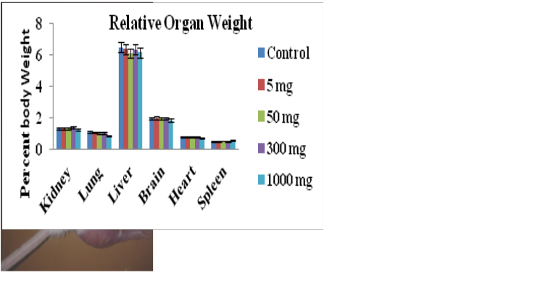
Recent Publications (minimum 5)
- Dinesh Kumar*, Pooja Sharma, Harmanpreet Singh, Kunal Nepali, Girish Kumar Gupta, Subheet Kumar Jain and Fidele Ntie-Kang; The value of pyrans as anticancer scaffolds in medicinal chemistry, RSC Adv., 2017, 7, 36977. I.F. 3.2.
- Dinesh Kumar and S K Jain; A Comprehensive Review of N- Heterocycles as Cytotoxic Agents. Curr. Med. Chem., 2016, 23(38), 4338-4394, I.F. 3.455.
- Dinesh Kumar, Kunal Nepali, PMS Bedi, Suresh Kumar, Fayaz Malik and Subheet Jain; 4,6-diaryl pyrimidones as constrained chalcone analogues: Design, Synthesis and Evaluation as anti-proliferative agents. Anticancer Agents Med. Chem., 2015, 15(6), 793-803, I. F. 2.72.
- Dinesh Kumar, Onkar Singh, Kunal Nepali, PMS Bedi, Arem Qayum, Shashank Singh and Subheet K. Jain; Naphthoflavones as Anti-proliferative Agents: Design, Synthesis and Biological Evaluation. Anticancer Agents Med. Chem., 2016, 16(7), 881-90, I.F. 2.72.
- Dinesh Kumar, Dinesh Kumar, Fayaz Malik, Preet Mohinder Singh Bedi, and Subheet Jain; 2,4-diarylpyrano[3,2-c]chromen-5(4H)-ones as coumarin-chalcone conjugates : Design, synthesis and biological evaluation as apoptosis inducing agents. Chem. Pharm. Bull. 2016, 64, 399–409, I.F. 1.228.
- Dinesh Kumar*, Gurpreet Singh, Pooja Sharma, Arem Qayum, Girish Mahajan, M.J. Mintoo, Shashank Kumar Singh Dilip Manikrao Mondhe , PMS Bedi, Subheet K Jain, Girish Kumar Gupta; 4-aryl/heteroaryl-4H-fused pyrans as Anti-proliferative Agents: Design, Synthesis and Biological Evaluation; Anticancer Agents Med. Chem., 2018 I.F. 2.72.

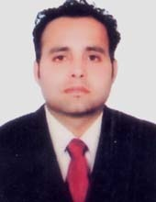
Mr. Dinesh Kumar did his graduation in pharmacy in 2005 from Punjab Technical University and grabbed 4th position in university. In 2008 he obtained his master degree in the field Pharmaceutical chemistry from the Department of Pharmaceutical sciences, Guru Nanak Dev University, Amritsar, Punjab, India. He received Ph.D. in pharmaceutical sciences from Guru Nanak Dev University, Amritsar where he worked on synthesis and evaluation of chaloconoid hybrids as potent anti-proliferative agents. In 2014 he joined as an Assistant professor in Department of Pharmaceutical Sciences, Guru Nanak Dev University, Amritsar. Currently he is working as director/principal in the department of Pharmaceutical science, Sri Sai College of Pharmacy, Manawala, Amritsar, Punjab, India. His research is focused on the synthesis and evaluation novel heterocyles and their application in medicinal chemistry.
Email: dineshkumargndu@gmail.com
Phone: +91-9988902489

Notes/Comments:
Dear Sir/Madam

Kindly provide an opportunity in the waive off in registration and accommodations fee as I belongs to the economical week country. Moreover, our organization have no policy to provide any funding for registration as well as travel grant .

