Pediatric Advanced Life Support Courses Augmented with Simulation Technology to Improve Participant Knowledge Retention and Skill Self Efficacy Over Time
Stacy M. Stellflug, PhD, APRN, FNP-BC

Abstract
Statement of Problem: Rural health care providers (HCPs) care for millions of Americans despite challenges. Pediatric Advanced Life Support (PALS), provides rural HCPs training in assessment and interventions for critically ill/injured pediatric patients (American Heart Association, 2010). The purpose of this study was to determine the effects of integration of simulation technology (ST) into PALS courses in a rural setting.

Design, Methods, and Theoretical Orientation: Participants were randomized to control or experimental PALS courses where the experimental group received PALS with ST and the control group received PALS with static manikins. Multiple level modeling (MLM) was used to examine participants time to task on pre-identified skills on PALS core case scenarios during testing on the last day of the course.
MLM was also used to examine the differences in PALS knowledge and skills self-efficacy (SEI) between control and experimental groups at course end and 6 months later. The theoretical foundation for this study was Kolb’s Experiential Learning Theory.

Findings: The experimental and control groups had similar scores on the PALS post course exam, however the skill performance of the experimental group on time-to-task in core case scenarios was better when compared to the control group. Both groups experienced a decrease in SEI and exam scores over time however the control group experienced a faster rate of decline in scores. Conclusions and Significance: Integration of ST into PALS may increase HCPs ability to recall valuable knowledge when seconds matter most. Further research in long-term recall of knowledge and assessment of skill following ST training is needed.

Image
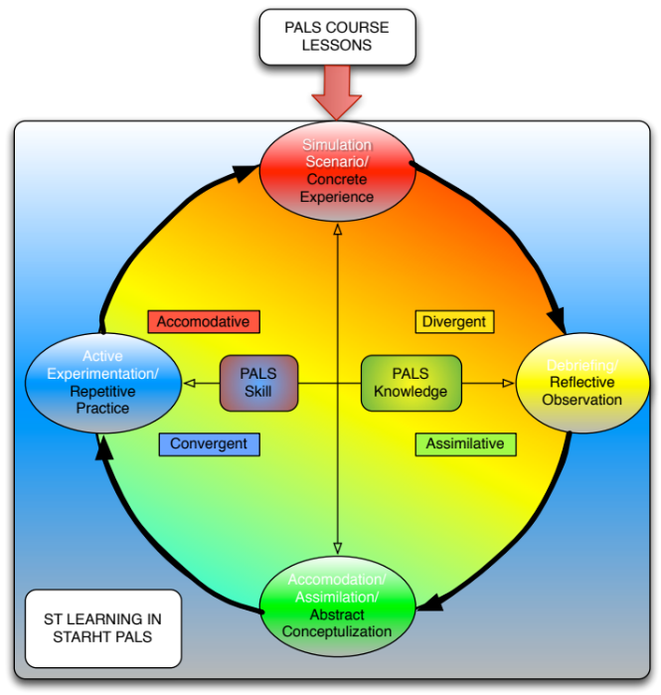
Figure 1: Simulation Technology in Pediatric Advanced Life Support Courses – Figure depicts the interrelationship between Kolb’s Experiential Learning Model and Simulation Technology as it occurred in a Pediatric Advanced Life Support Course.

Recent Publications
I have no publications to list at this time.

Biography
Stacy Stellflug is passionate about caring for children and has dedicated most of her nursing career to pediatrics. She especially passionate about pediatric trauma and critical care by providers outside of tertiary pediatric care centers. She has spent over 2000 hours training rural healthcare care providers and first responders in pediatric resuscitation and trauma care using simulation technology. As a new faculty member at Montana State University she is anxious to establish her program of research focused on improving pediatric morbidity and mortality in rural settings, like Montana.
Email: stacy.stellflug@montana.edu

Notes/Comments:

