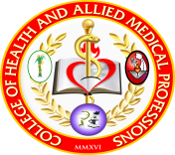


Experiences and Health Related Quality of Life among Women with Systemic Lupus Erythematosus in Iloilo Province

Louie P. Hijalda, Ph.D., RN

Nursing Program, University of San Agustin, General Luna Street, Iloilo City
Email address: lhijalda@usa.edu.ph

Background: Globally, the Lupus Foundation in America estimates that 1.5 million Americans and at least 5 million people worldwide suffer from SLE. In the Philippines, there is an estimated 443,891 among the population and the increasing number identified is getting more serious and is difficult to deal with.

Methodology: A descriptive phenomenology, qualitative research, with six participants involved. The guide questions were divided into four aspects: physical, psychological, social and spiritual lived experiences and health related quality of life. The rigor and validity of the study was achieved through engagement with the data, verification with feedback, use of extracts from verbatim account and peer debriefing. The data analysis involved the use of Colaizzi methodological approach.

Results: Main themes surfaced as similar among participants in their journey towards independence, acceptance, family support and faith and trust to God. At first, they really had a hard time accepting their disease condition but later on, they come to adapt to its changes and keep moving forward and learned lessons from it. They spend their time thinking about how to live their life normally. Medications and therapies were essential parts and the prolonged compliance to medications entailed side effects which the client cope up.

Conclusion: Participants made strategies on how to control, ease or relieve the suffering brought about by their physical, psychological, social and spiritual distress. Their faith, hope and trust in God even strengthened after knowing the disease.

Keywords: Systemic lupus erythematosus, health related quality of life, Iloilo province

About the Author:

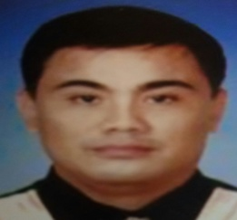
Louie Pinuela Hijalda, Ph.D., RN, is currently a clinical instructor at the University of San Agustin, College of Health and Allied Medical Profession. A member of the Department of Science and Technology – Western Visayas Human Resource Development Committee (DOST–WVHRDC) and University of San Agustin – Research Ethics Review Committee.

