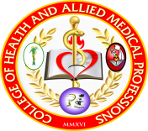


Gugma sang isa ka Iloy: The Other End of Parenting Experience
by Illongga Mothers with Empty Nest Syndrome

Louie P. Hijalda, Ph.D., RN

Nursing Program, University of San Agustin, General Luna Street, Iloilo City 5000
Email address; lhijalda@usa.edu.ph

Background. Mention the term empty nest and one’s mind immediately conjures up a picture of an empty house. The mother-child relationship has now evolved into that of an adult to adult relationship.For others, they feel that change is happening more rapidly than ever before and further watching their youngest child move out of the house was difficult for mothers especially in letting go and moving on.

Methodology. Descriptive phenomenology of Husserl was used.The saturation point was based in the participant`s answer. Purposeful sampling was utilized to select participants, informed consents were discussed and in-depth face to face semi-structured interview was used. Colaizzi methodological approach was used for analysis. The anonymity and confidentiality of information was upheld.

Results. Several themes and supports emerged in relation to their experiences. Emotional support in the provision of caring, empathy and love; informational support by comparing their experiences to others and appraisal support from constant communication of information that is relevant to self-evaluation. The participant’s spirituality was also well defined and had adjusted their selves very well.

Conclusions. The empty nest syndrome gave them mixed feelings and a challenge yet Ilongga mothers’ accommodated themselves with supports and resiliency to achieved condition of wellness in letting go and moving on.

Keywords: Empty nest, mother-child relationship, support, Filipino perspective

About the Author:

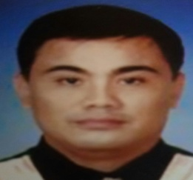
Louie Pinuela Hijalda, Ph.D., RN, is currently a clinical instructor at the University of San Agustin, College of Health and Allied Medical Profession. A member of the Department of Science and Technology – Western Visayas Human Resource Development Committee (DOST–WVHRDC) and University of San Agustin – Research Ethics Review Committee.

